New APX support in OpenJDK :-

=========================

Umbrella JBS: <https://bugs.openjdk.org/browse/JDK-8329030>

Supported features:-

* CPU ID Feature Detection
* VM Startup validation for EGPR state save restoration.
* RA support for EGPRs
* ASSEMBLER support
  + REX2
  + EEVEX
* Zero Upper setCC – save explicit zero extension instruction after setcc.
* New Push Pop with PPX and Push2 / Pop2 instructions support.
* NDD Support
* Condition ISA extensions.
* JMPABS support

Validation:-

* Assembler tool for validating REX2 and EEVEX instruction against GCC encoding.
* JTREG tests validation using SDE.

**Conditional ISA**

* Conditional move
* Conditional compare
* Condition test

A) Conditional Moves:

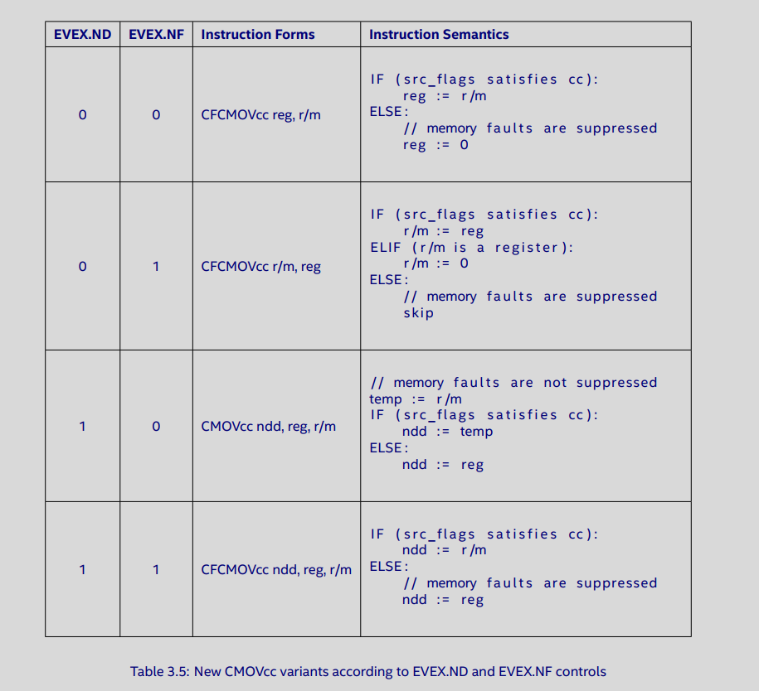

Out of the above 4 variants on CMOVcc with NDD is useful in the JVM context, conditionally faulting moves suppress memory faults. Java being a memory-safe language already injects NULL pointer checks before each array element or instance field access.

Example 1:

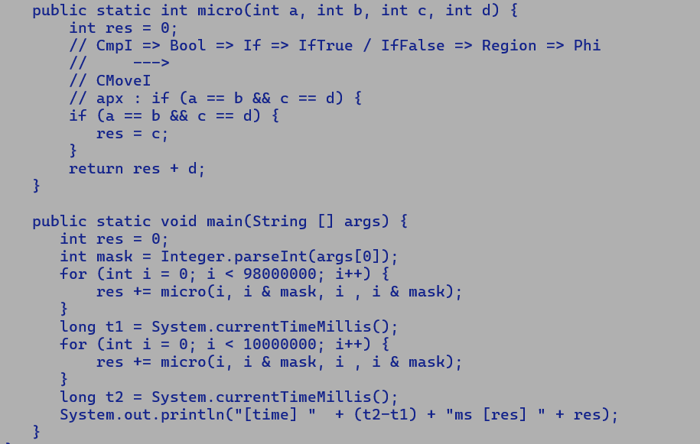

Analysis:

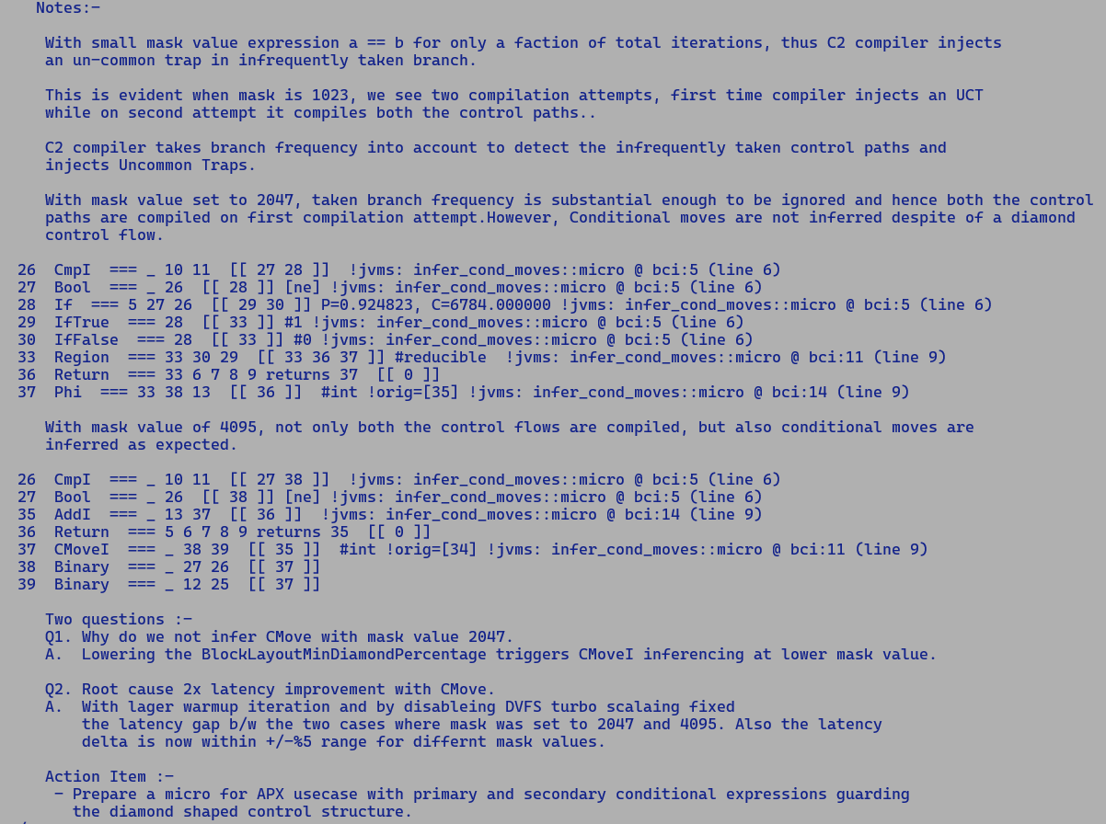

Example 2:

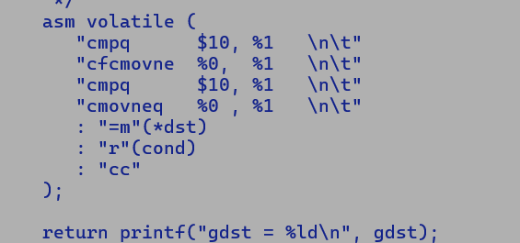

Analysis:

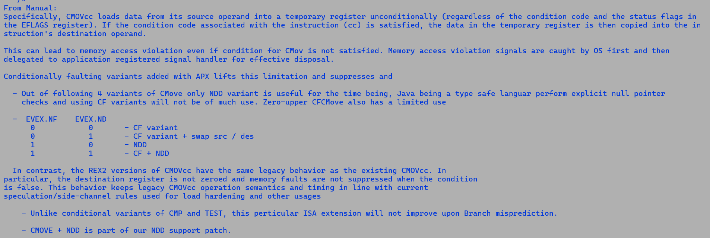

B) Conditional compare: -

Anatomy of CCMP instruction: -

- DFV (returned if SRC.FLAG != EVEX.SFLAGS), CCMPNEQ -> NE is encoded into EVEX.SFLAGS bits, DFV need to be set explicitly.

- OP1

- OP2

- DST.FLAGS = OP1 - OP2 [EFLAGS set according to the subtraction operation]

if (SRC.FLAT == EVEX.SFLAGS) {

DST.FLAGS = OP1. CMP OP2.

} else {

DST.FLAGS = DFV

}

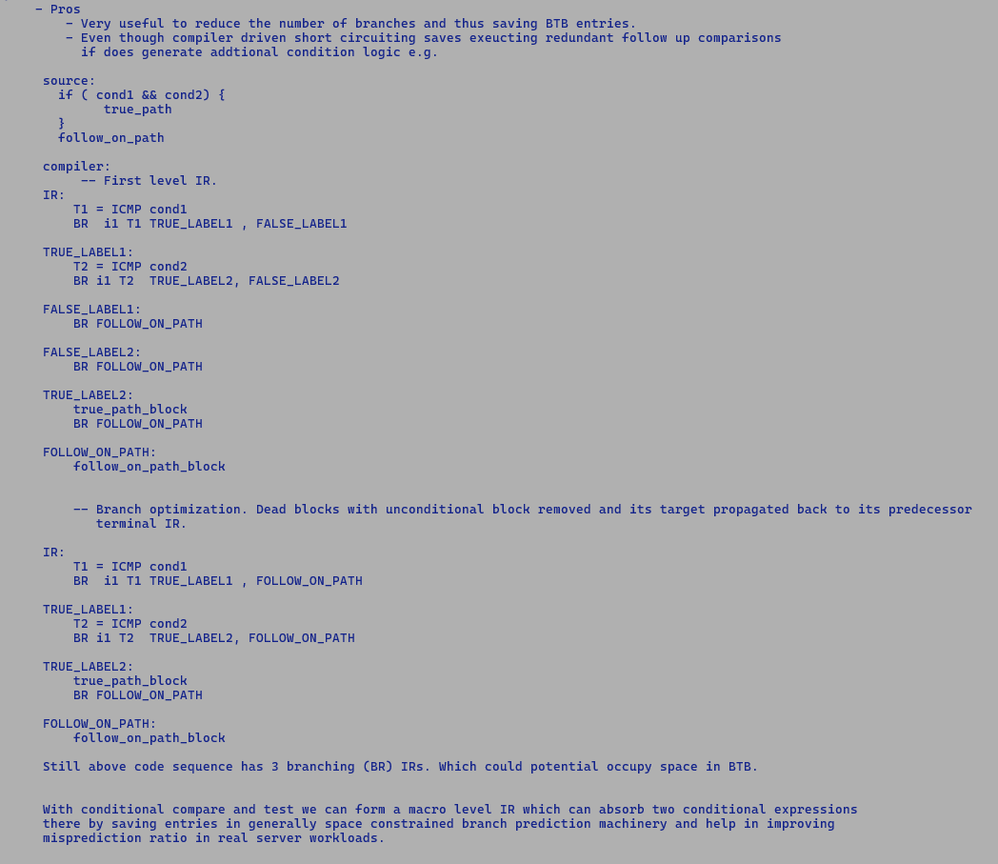

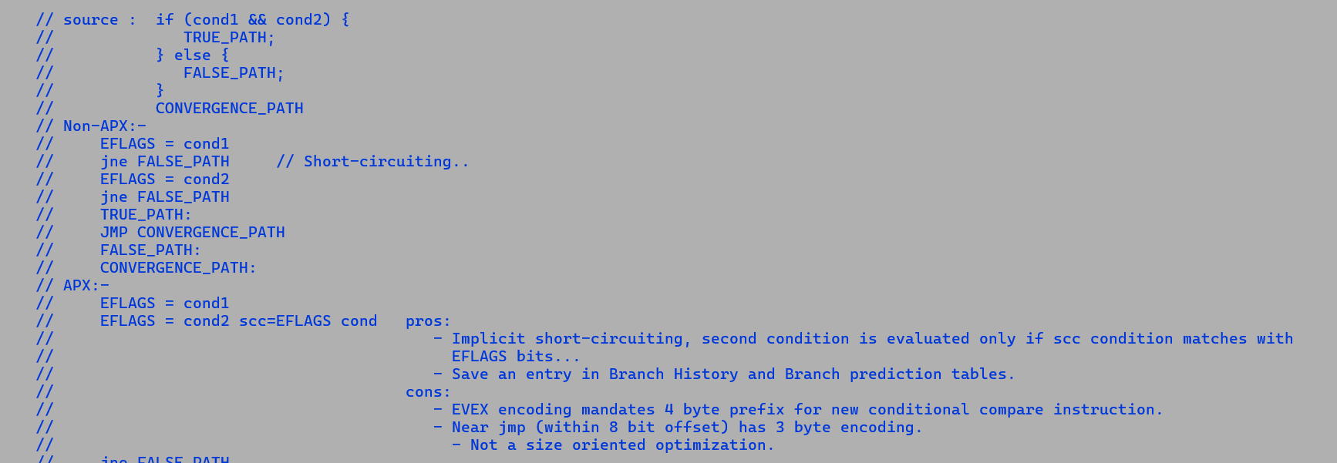

C kernel and expected Inline ASM sequence

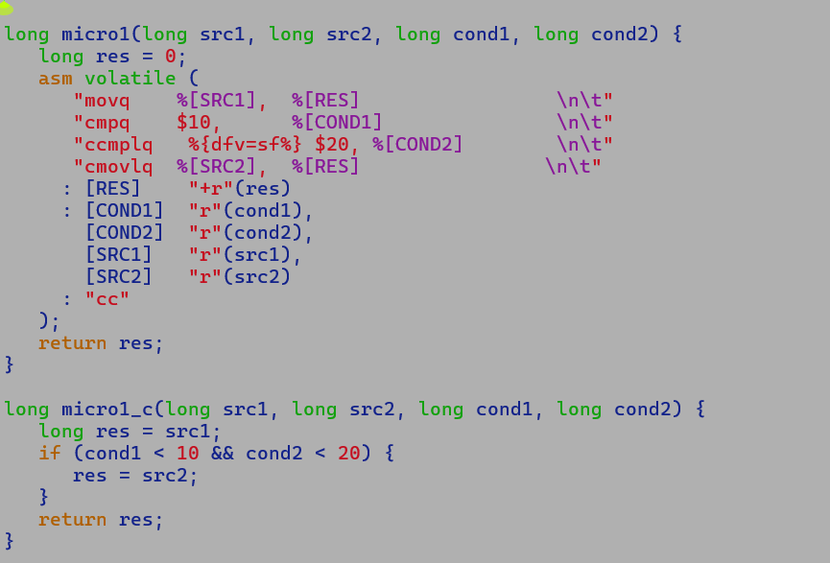

[1] https://godbolt.org/z/Ks47ev1oY

[2] https://godbolt.org/z/YWf5nsv5j

Example 1:

**Source:-**

res = src1;

if (c1 == 1 || c2 == 2) {

res = src2;

}

return res;

**C2 SoN IR:-**

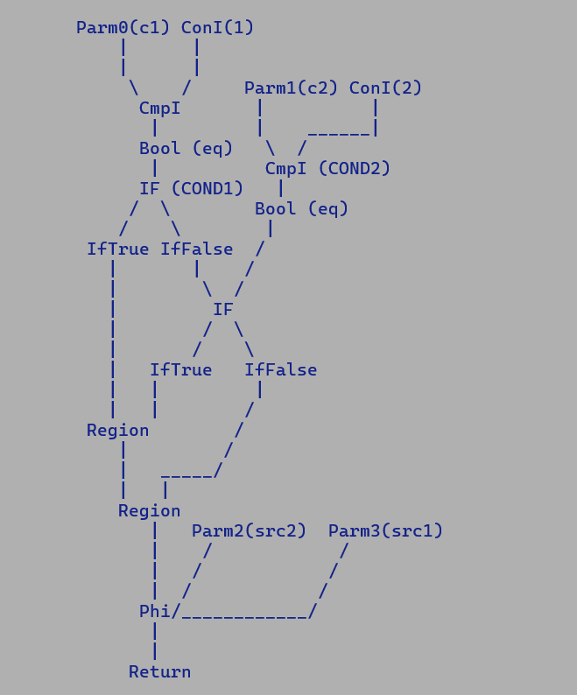

Short-circuiting:-

COND1 || COND2

* If COND1 is TRUE then COND2 need not be executed.
* In terms of CCMP, we fold the result of the former comparison with subsequent compare to save costly branch prediction resources as intermediate JMP is absorbed. Hence, to emulate short-circuiting, EVEX.SFLAGS should be set to the inverse of source flags and DFV should be the same as SRC.FLAGS.
* Thus, if COND1 is true then we skip executing COND2 part of CCMP instruction and pass the flags modified by COND1 as it is to consumer instruction.

All the following conditions must be satisfied to infer a CCMP IR pattern.

* COND1.FP == COND2
* COND1.TP.TARGET == COND2.TP.TARGET

By setting DFV as DST.FLAGS we ensure that the consumer of flags is agnostic to control flow modification i.e. flags modified by COND1 execution must match with CCMP default flags value after failed SRF.FLAG check since EVEX.SFLAGS == ~COND1.PREDICATE hence, we will not execute COND2 and pass unmodified flags.

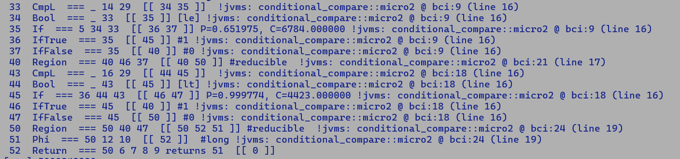

In actual C2 IR, we flip the COND1 predicate, but COND1.FP.TARGET == COND2.TP.TARGET thus

We can fold COND1 with COND2.

Q. What happens when CMP instruction is executed ?

A. It subtracts OPR2 from OPR1 and sets the EFLAGS accordingly.

EFLAGS = OPR1 – OPR2

Q. Which are the flag consuming instructions ?

A. Jcc, CMovcc, setcc. These instructions looks for specific flag bits and take the actions (branch selection, move execution or set lower byte) accordingly.

Q. Two branches originating from different conditional statements have same landing pad, does it mean that execution of flag-consuming instruction will be same through both control flows ?

A. No, different condition instructions may modify the flags differently based on their respective operand values, which is why CCMP is equipped with DFV and implicit EVEX.SFLAGS. All we make sure is that CCMP effectively captures the cascading effect of FLAGS modification.

Rough algorithm: -

Attributes per CCmpNode

DVF = EFLAGS setting when SRC.FLAGS does not comply with EVEX.SFLAGS

EVEX.SFLAGS = FLAG settings to be matched against incoming flags (SRC.FLAGS)

The entire graph skeleton must match.

When C2 == C1.FALSE

EVEX.SFLAGS = NOT C1. PRED

EVEX.DFV = C2.PRED.

ELSE

Assert (C2 == C1.TRUE)

EVEX.SFLAGS = C1.PRED

EVEX.DFV = C2.PRED

Since we are folding the conditional expression, DFV should contain the FLAGS setting of C2 to preserve the invariants of the subsequent Bool node.



C1 : Bool C2

CCMP CMP C1 -> Bool (NE)



CCMP**NE** C2 -> Bool (E)



CMOVEGT

Bool Here , EVEX.SFLAGS = NE/E and EVEX.DFV = E



IF considering control flow positioning of C2 w.r.t C1.



IFTrue IFFalse



Region



**Side notes on Branch predictors**

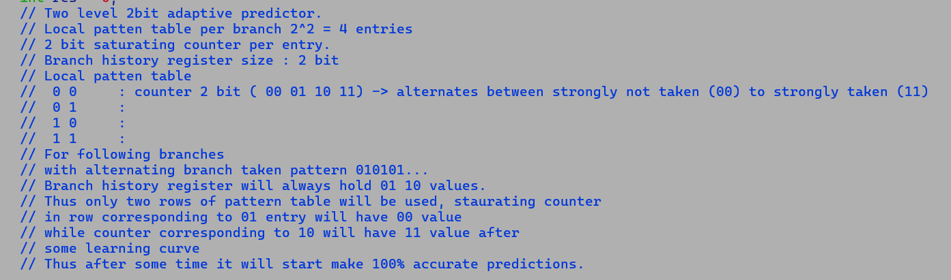

TAGE – TAgged GEometric history length predictor

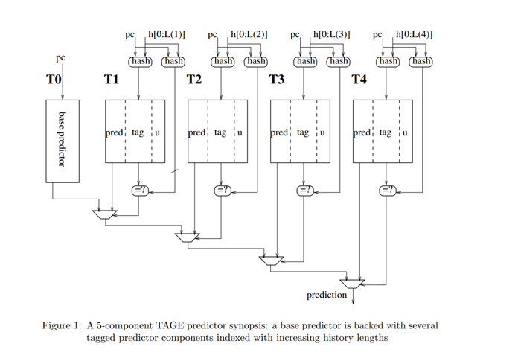



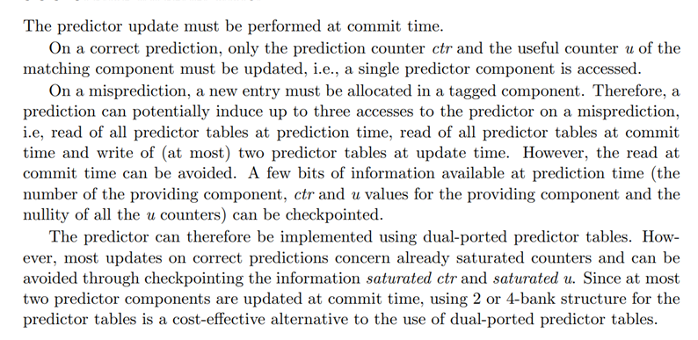

Example 2:

Source:-

res = src1;

if (c1 == 1 && c2 == 2) {

res = src2;

}

return res;

**C2 SoN IR:-**

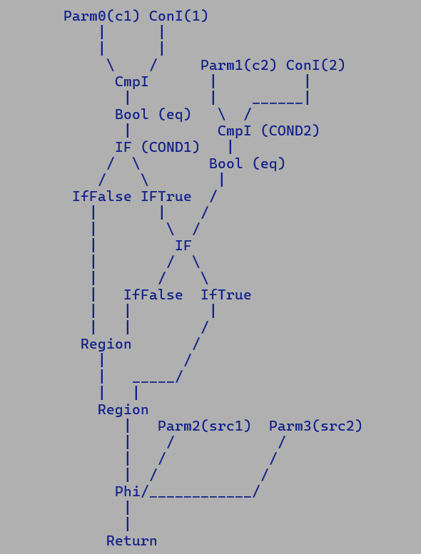

Short-circuiting:-

o COND1 && COND2

Pre-conditions:-

- COND1.FP.TARGET == COND2.FP.TARGET

- COND1.TP == COND2

Settings for CCMP:-

- CCMP.EXEX.DFV = COND2.PRED

- CCMP.EVEX.SFLAGS = COND1.PREDICATE

Constraints limiting the scope of optimization:-

* Un-common traps injected based on branch profiles can distort the graph structures, thereby limiting CCMP inferencing.
* UCT injection is performed while parsing if* bytecode[s]
* Parsing sequentially walks over bytecode blocks and generates the IR graph one bytecode at a time.
* Thus, at the time of UCT injection we do not have a view of upcoming converging control flows.
* Existing Conditional move detection is also impacted by similar problems.

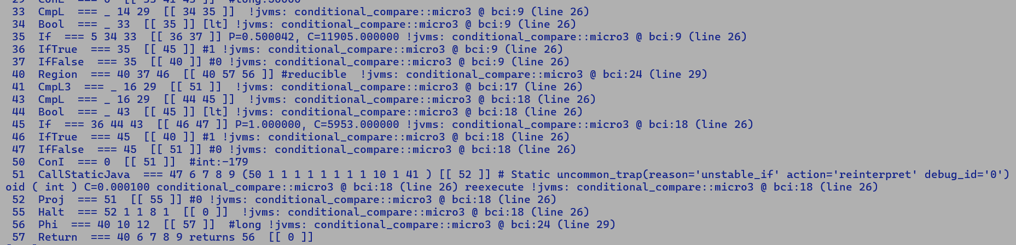

If [cond1]



IFTrue IFFalse



If [cond2]



IFTrue IFFalse



COND1.FP.TARGET != COND2.FP.TARGET hence we cannot infer CCMP in this case.

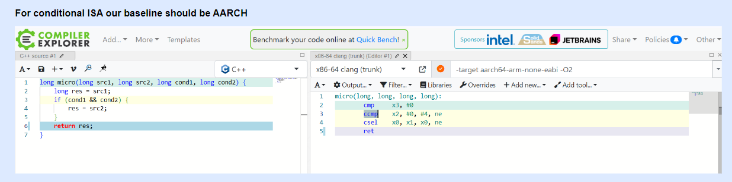

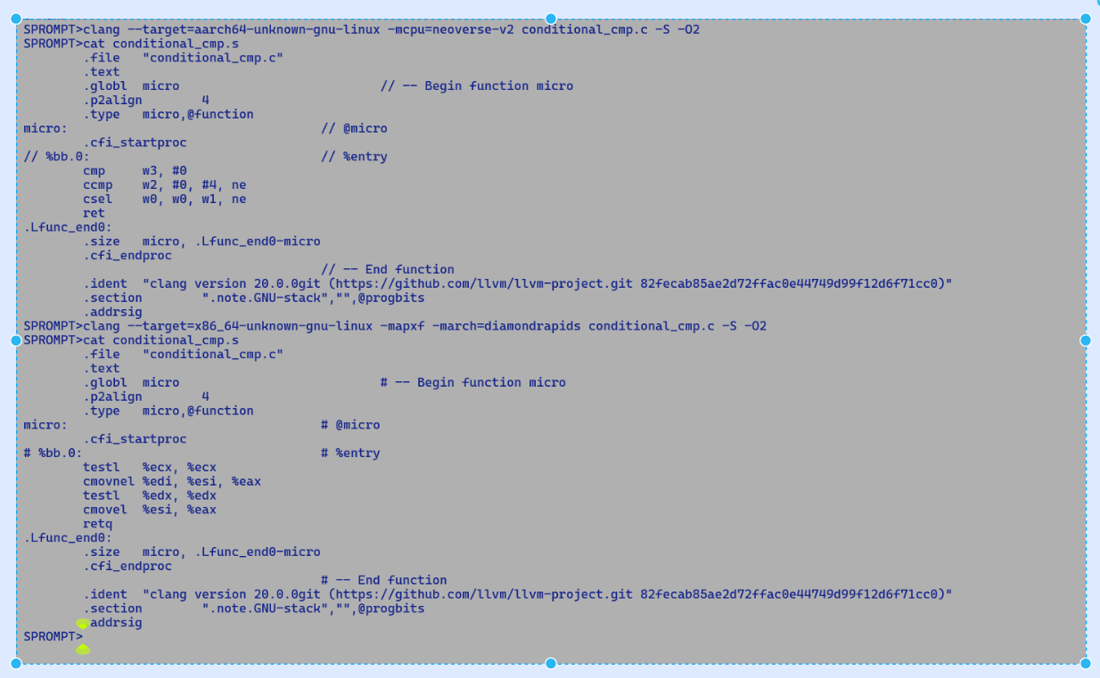

instruct vcmov8F_reg(legVec dst, legVec src1, legVec src2, immI8 cop, cmpOp_vcmppd copnd) %{

predicate(Matcher::vector_length(n) == 8);

match(Set dst (CMoveVF (Binary copnd cop) (Binary src1 src2)));

effect(TEMP dst, USE src1, USE src2);

format %{ "cmpps.$copnd $dst, $src1, $src2 ! vcmovevf, cond=$cop\n\t"

"blendvps $dst,$src1,$src2,$dst ! vcmovevf\n\t"

%}

ins_encode %{

assert(UseAVX > 0, "required");

int vlen_enc = Assembler::AVX_256bit;

int cond = (Assembler::Condition)($copnd$$cmpcode);

__ vcmpps($dst$$XMMRegister, $src1$$XMMRegister, $src2$$XMMRegister, cond, vlen_enc);

__ vblendvps($dst$$XMMRegister, $src1$$XMMRegister, $src2$$XMMRegister, $dst$$XMMRegister, vlen_enc);

%}

ins_pipe( pipe_slow );

%}

instruct vcmov4D_reg(legVec dst, legVec src1, legVec src2, immI8 cop, cmpOp_vcmppd copnd) %{

predicate(Matcher::vector_length(n) == 4);

match(Set dst (CMoveVD (Binary copnd cop) (Binary src1 src2)));

effect(TEMP dst, USE src1, USE src2);

format %{ "cmppd.$copnd $dst, $src1, $src2 ! vcmovevd, cond=$cop\n\t"

"vblendvpd $dst,$src1,$src2,$dst ! vcmovevd\n\t"

%}

ins_encode %{

assert(UseAVX > 0, "required");

int vlen_enc = Assembler::AVX_256bit;

int cond = (Assembler::Condition)($copnd$$cmpcode);

__ vcmppd($dst$$XMMRegister, $src1$$XMMRegister, $src2$$XMMRegister, cond, vlen_enc);

__ vblendvpd($dst$$XMMRegister, $src1$$XMMRegister, $src2$$XMMRegister, $dst$$XMMRegister, vlen_enc);

%}

ins_pipe( pipe_slow );

%}

**FIXUPS for floating point flags consuming CMoves.**

public class cmove_with_fixup {

public static long micro(long a, long b, float c, float d) {

// UCF, unordered compare flag, applicable to only NE and EQ predicates,

// since NaN == NaN is false, and NaN != NaN is true.

// For other perdicates like, < > unordered / ordered comparison

// does not effect the flag consumer, ie. 2.0f > 2.0f will set

// same flags as NaN > NaN.

// While we need special fixups for predicates where unordered and

// ordered comparisons effect flags differently, i.e.

// NaN == NaN is flase and hile 2.0f == 2.0f is true.

// return c > d ? a : b;

/*

10 cmpF_cc_reg_CF === _ 12 13 [[ 11 ]]

11 cmovL_regU === _ 10 14 15 [[ 2 ]] be !jvms: cmove_with_fixup::micro @ bci:13 (line 13)

*/

// return c != d ? a : b;

/*

10 cmpF_cc_reg_CF === _ 11 12 [[ 9 ]]

9 cmovL_regUCF2_ne === _ 10 13 14 [[ 2 ]] ne !jvms: cmove_with_fixup::micro @ bci:13 (line 18)

instruct cmovL_regUCF2_ne(cmpOpUCF2 cop, rFlagsRegUCF cr, rRegL dst, rRegL src) %{

predicate(!UseAPX && n->in(1)->in(1)->as_Bool()->_test._test == BoolTest::ne);

match(Set dst (CMoveL (Binary cop cr) (Binary dst src)));

ins_cost(200); // XXX

format %{ "cmovpq $dst, $src\n\t"

"cmovneq $dst, $src" %}

ins_encode %{

__ cmovq(Assembler::parity, $dst$$Register, $src$$Register);

__ cmovq(Assembler::notEqual, $dst$$Register, $src$$Register);

%}

ins_pipe(pipe_cmov_reg);

%}

For != comparison, since NaN != NaN is true hence to maintain sacrosanctity

of flags as seen by consumer we first emit a cmove for parity flag as

ordered comparison would have generated a false value here, if parity flag

is not set this mean comparison was ordered and hence next cmove is based

on NE flag settings.

*/

//return c == d ? a : b;

/*

9 cmovL_regUCF2_ne === _ 10 13 14 [[ 2 ]] ne !jvms: cmove_with_fixup::micro @ bci:13 (line 43)

10 cmpF_cc_reg_CF === _ 11 12 [[ 9 ]]

for <= operator, NaN <= NaN is indeed false and we don't need any special fixup like == or !=

where result are flipped and counter intutive i.e. NaN == NaN is false and NaN != NaN is true.

*/

return c <= d ? a : b;

}

public static void main(String [] args) {

long res = 0;

for (int i = 0; i < 100000; i++) {

//res += micro(10, 20, 1.0f, ((i & 1) == 0) ? 1.0f : 0.0f);

res += micro(10, 20, ((i & 1) == 0) ? Float.NaN : 2.0f, ((i & 1) == 0) ? Float.NaN : 3.0f);

}

System.out.println("[res] " + res);

}

}

**APX Validation Bugs:-**

1)

APX – Safepoint Polling Issue - Integrated into JDK-mainline

Reproducible with

* -XX:+SafepointALot
* EGPR allocation sequence
* TestLongVect.java

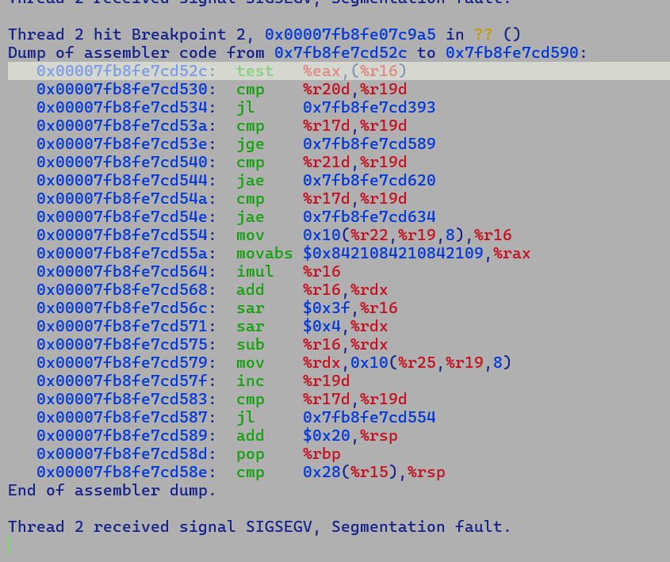

Problem relates to missing handling of REX2 encoding during safepoint polling condition NativeInstruction access.

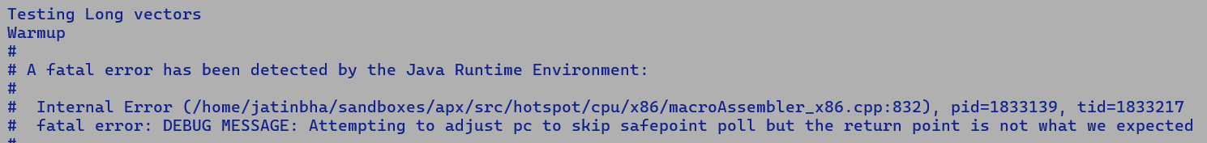

Missing REX2 case handling, fixed the crash.

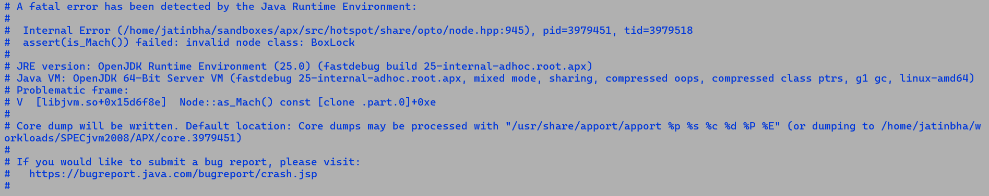

2)

Crash during PhaseOutput while estimating BoxLockNode size - Fixed and regressed

LEA Size with REX prefix

REX (1) + Opcode (1) + ModRM (1) + SIB (1) + DISP32 (4) + IMM(0)

= 8

Size with non-REX prefix

Opcode(1) + ModRM (1) + SIB(1) + 1 DISP8 (1)

3)

SPECjvm2008 – sunflow – SIGSEGV - Root causing in progress.

* Reproducible with C1 only compilation (-XX:TieredStopAtLevel=3).
  + JIT code is free from EGPRs
* Works fine with Interpreter (-Xint)
* Interpreter to/from C1 compiler call adapter code is fine.
  + It simply pushes the argument from/to Interpreter stack to/from GRPs as per calling convention.

4)

Iteration 1 (1 operation) begins: Tue Jan 28 13:41:07 IST 2025

$$ TID: 29 ICOUNT: 26429240

$$ TID: 27 ICOUNT: 219556556

$$ TID: 28 ICOUNT: 63373096

$$ TID: 26 ICOUNT: 60978424

# A fatal error has been detected by the Java Runtime Environment:

# Internal Error (/home/jatinbha/sandboxes/apx/src/hotspot/share/runtime/stackValue.cpp:136), pid=1656547, tid=1667839

# assert(oopDesc::is_oop_or_null(val)) failed: bad oop found at 0x00007f9992b09728 in_cont: 0 compressed: 0

# JRE version: OpenJDK Runtime Environment (25.0) (fastdebug build 25-internal-adhoc.root.apx)

# Java VM: OpenJDK 64-Bit Server VM (fastdebug 25-internal-adhoc.root.apx, mixed mode, sharing, compressed oops, compressed class ptrs, g1 gc, linux-amd64)

# Problematic frame:

**# V [libjvm.so+0x19695b8] StackValue::create_stack_value_from_oop_location(stackChunkOop, void*)+0x488**

#

# Core dump will be written. Default location: Core dumps may be processed with "/usr/share/apport/apport %p %s %c %d %P %E" (or dumping to /home/jatinbha/workloads/SPECjvm2008/APX/core.1656547)

# An error report file with more information is saved as:

# /home/jatinbha/workloads/SPECjvm2008/APX/hs_err_pid1656547.log

CPROMPT>java -XX:+PreserveFramePointer -XX:CompileCommand=Print,test::micro -Xbatch -XX:-TieredCompilation -XX:-TraceDeoptimization -XX:-EliminateAllocations -XX:+DoEscapeAnalysis -XX:+PrintEliminateAllocations -cp . test

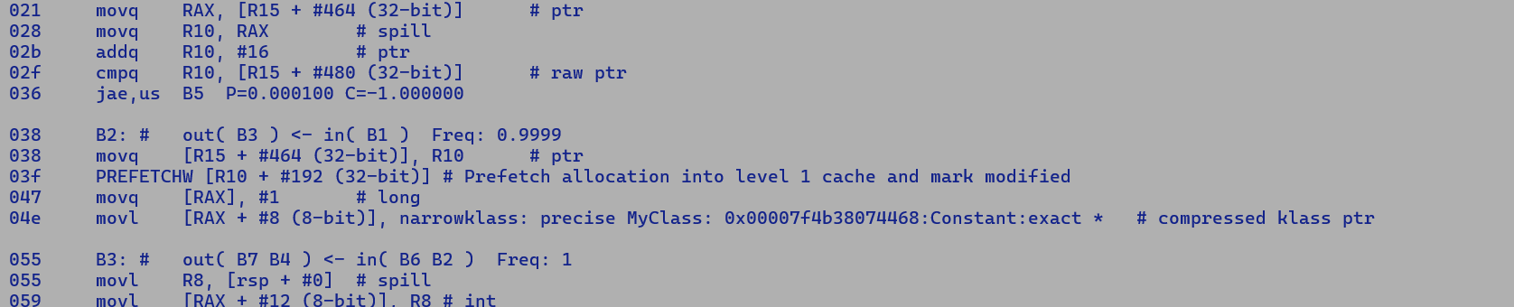



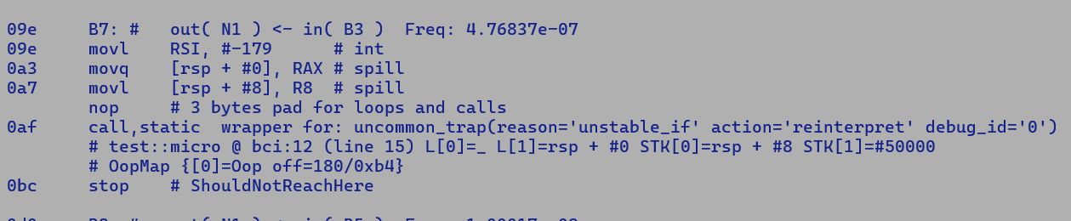



Without Preserve Frame pointer , spilling happens in RBP and it get recorded as carrying a valid oop.

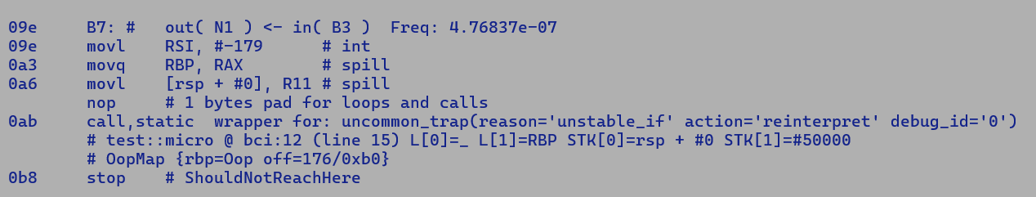



All the caller saved registers carrying oop values are spilled before the call to uncommon trap, thus for top level frame oop will be always held in stack location or an RBP, more detailed comments refer [Dependencies.docx](https://intel-my.sharepoint.com/:w:/r/personal/jatin_bhateja_intel_com/Documents/My%20Folder/Books/Java/Work/valhalla/Dependencies.docx?d=w247cb81c77ea48dbaf5bfb131ebf0b1a&csf=1&web=1&e=LlIYrc) page 16.

With EA allocations are eliminated but compiler does book keep a SafepointScalarizeObjectNode used for reconstruction of eliminated object, this auxiliary structure record the starting index field values tied to SafePoint (Call) and also records the eliminated object class type. During final code emission, SafepointSalarObjectNode and associated field values are serialized as ScopeValues into debug stream, thus during de-optimization, runtime first allocates a new instance of desired class type and then initializes it fields by using corresponding LocationValues, both register and stack LocationValues are in essence memory locations holding the field values.

java -XX:+PreserveFramePointer -XX:CompileCommand=Print,test::micro -Xbatch -XX:-TieredCompilation -XX:-TraceDeoptimization -XX:+EliminateAllocations -XX:+DoEscapeAnalysis -XX:+PrintEliminateAllocations -cp . test

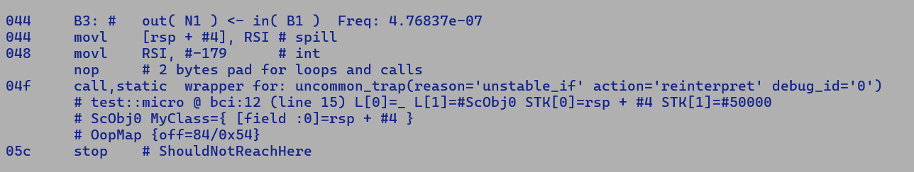



OopMaps - Used for root set enumeration by GC.

SafepointScalarObjectNode – Used for object reconstruction during Deoptimization.

class MyClass {

int field;

MyClass(int field) {

this.field = field;

}

int multAndGet(int val) {

return val * field;

}

public String toString() {

return "field := " + field;

}

}

class MyClassWrapper {

MyClass field;

MyClassWrapper(int field) {

this.field = new MyClass(field);

}

int multAndGet(int val) {

return field.multAndGet(val);

}

public String toString() {

return "MyClass [ " + field + " ] ";

}

}

public class test {

public static int micro(int ctr) {

MyClassWrapper obj = new MyClassWrapper(ctr);

if (ctr > 50000) {

// Usage of obj.field with UCT.

// With EA field value will be forwarded making allocations redundant.

throw new RuntimeException("Deoptimizing : " + obj);

}

return obj.multAndGet(10);

}

public static void main(String [] args) {

int res = 0;

for (int i = 0; i < 100000; i++) {

res += micro(i);

}

System.out.println("[res] " + res);

}

}

Following dump show two safepoint scalar object tied to UCT call, both are needed for MyClassWrapper rematerialization.

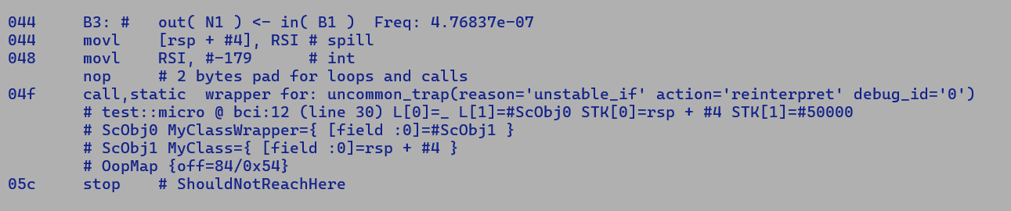

**JTREG hotspot compiler validation with SDE:-**

**Test report is stored in build/linux-x86_64-server-fastdebug/test-results/jtreg_test_hotspot_jtreg_compiler**

**==============================**

**Test summary**

**==============================**

**TEST TOTAL PASS FAIL ERROR**

**>> jtreg:test/hotspot/jtreg/compiler 1792 727 14 1051 <<**

1051 tests timeout with default 480s time out.

Run took almost entire weekend.

Validation with static allocation order changes to ensure EGPR registers are preferred while allocations.

05/02/2005

APX JTREG Validation analysis

* Test/hotspot/jtreg/compiler/c2
* 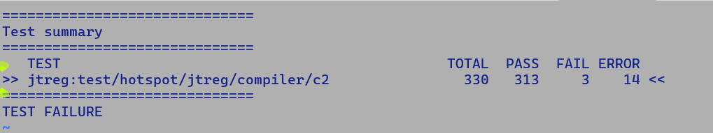
* Other Errors
  + compiler/c2/Test6866651.java
    - TIMEOUT
  + compiler/c2/TestMergeStores.java#id0
    - TIMEOUT
  + compiler/c2/TestMergeStores.java#id1
    - TIMEOUT
  + compiler/c2/TestShiftRightAndAccumulate.java#id0
    - TIMEOUT
  + compiler/c2/TestShiftRightAndAccumulate.java#id1
    - TIMEOUT
  + compiler/c2/TestStressRecompilation.java
    - TIMEOUT
  + compiler/c2/TestUnsignedByteCompare1.java
    - TIMEOUT
  + compiler/c2/irTests/DeMorganLawLongTests.java

No valid oop at address#

# A fatal error has been detected by the Java Runtime Environment:

#

# Internal Error (/home/jatinbha/sandboxes/apx/src/hotspot/share/runtime/stackValue.cpp:141), pid=4081152, tid=4081166

# assert(oopDesc::is_oop_or_null(val)) failed: bad oop found at 0x00007f88f59bbd78 in_cont: 0 compressed: 0

#

* + compiler/c2/irTests/DivLNodeIdealizationTests.java

#

#A fatal error has been detected by the Java Runtime Environment:

#

# Internal Error (/home/jatinbha/sandboxes/apx/src/hotspot/share/oops/compressedOops.inline.hpp:87), pid=4083246, tid=4084086

# assert(Universe::is_in_heap(v)) failed: object not in heap 0x00000000000007d0

#

# JRE version: OpenJDK Runtime Environment (25.0) (fastdebug build 25-internal-adhoc.root.apx)

# Java VM: OpenJDK 64-Bit Server VM (fastdebug 25-internal-adhoc.root.apx, mixed mode, tiered, compressed oops, compressed class ptrs, g1 gc, linux-amd64)

# Problematic frame:

# V [libjvm.so+0xb5f851] CompressedOops::decode_not_null(oop)+0x71

* + compiler/c2/irTests/ModINodeIdealizationTests.java

----------stdout:(15/1111)----------

#

# A fatal error has been detected by the Java Runtime Environment:

#

# Internal Error (/home/jatinbha/sandboxes/apx/src/hotspot/share/oops/compressedOops.inline.hpp:87), pid=4086138, tid=4086966

# assert(Universe::is_in_heap(v)) failed: object not in heap 0x000000004382a44c

#

# JRE version: OpenJDK Runtime Environment (25.0) (fastdebug build 25-internal-adhoc.root.apx)

# Java VM: OpenJDK 64-Bit Server VM (fastdebug 25-internal-adhoc.root.apx, mixed mode, tiered, compressed oops, compressed class ptrs, g1 gc, linux-amd64)

# Problematic frame:

# V [libjvm.so+0xb5f851] CompressedOops::decode_not_null(oop)+0x71

* + compiler/c2/irTests/OrINodeIdealizationTests.java

#

# A fatal error has been detected by the Java Runtime Environment:

#

# Internal Error (/home/jatinbha/sandboxes/apx/src/hotspot/share/oops/compressedOops.inline.hpp:87), pid=4088258, tid=4088912

# assert(Universe::is_in_heap(v)) failed: object not in heap 0x00000000000007e8

#

# JRE version: OpenJDK Runtime Environment (25.0) (fastdebug build 25-internal-adhoc.root.apx)

# Java VM: OpenJDK 64-Bit Server VM (fastdebug 25-internal-adhoc.root.apx, mixed mode, tiered, compressed oops, compressed class ptrs, g1 gc, linux-amd64)

# Problematic frame:

# V [libjvm.so+0xb5f851] CompressedOops::decode_not_null(oop)+0x71

* + compiler/c2/irTests/RShiftINodeIdealizationTests.java

----------stdout:(15/1191)----------

No valid oop at address#

# A fatal error has been detected by the Java Runtime Environment:

#

# Internal Error (/home/jatinbha/sandboxes/apx/src/hotspot/share/runtime/stackValue.cpp:141), pid=4089186, tid=4089201

# assert(oopDesc::is_oop_or_null(val)) failed: bad oop found at 0x00007f16a0e32a18 in_cont: 0 compressed: 0

#

# JRE version: OpenJDK Runtime Environment (25.0) (fastdebug build 25-internal-adhoc.root.apx)

* + compiler/c2/irTests/TestAutoVectorization2DArray.java

----------stdout:(15/1111)----------

#

# A fatal error has been detected by the Java Runtime Environment:

#

# Internal Error (/home/jatinbha/sandboxes/apx/src/hotspot/share/oops/compressedOops.inline.hpp:87), pid=4093523, tid=4094085

# assert(Universe::is_in_heap(v)) failed: object not in heap 0x0000000000000fa0

#

# JRE version: OpenJDK Runtime Environment (25.0) (fastdebug build 25-internal-adhoc.root.apx)

# Java VM: OpenJDK 64-Bit Server VM (fastdebug 25-internal-adhoc.root.apx, mixed mode, tiered, compressed oops, compressed class ptrs, g1 gc, linux-amd64)

# Problematic frame:

# V [libjvm.so+0xb5f851] CompressedOops::decode_not_null(oop)+0x71

* + compiler/c2/irTests/TestVectorizationMismatchedAccess.java

TIMEOUT

NDD

# parm0: rsi:rsi = long

# parm1: rdx:rdx = long

# parm2: rcx:rcx = long

#

# long/half ( long, half, long, half, long, half )

#

000 N1: # out( B1 ) <- in( B1 ) Freq: 1

000 B1: # out( N1 ) <- BLOCK HEAD IS JUNK Freq: 1

000 # stack bang (96 bytes)

pushq rbp # Save rbp

subq rsp, #16 # Create frame

01a imulq RDX, RCX # long

01e leaq RAX, [RSI + RDX]

022 addq rsp, 16 # Destroy frame

popq rbp

cmpq rsp, poll_offset[r15_thread]

ja #safepoint_stub # Safepoint: poll for GC

031 ret

------------------------ OptoAssembly for Compile_id = 3 -----------------------

#

# long/half ( long, half, long, half, long, half )

#

000 N1: # out( B1 ) <- in( B1 ) Freq: 1

000 B1: # out( N1 ) <- BLOCK HEAD IS JUNK Freq: 1

000 # stack bang (96 bytes)

pushq rbp # Save rbp

subq rsp, #16 # Create frame

01a eimulq R10, RDX, RCX # long ndd

020 eaddq RAX, RSI, R10 # long ndd

026 addq rsp, 16 # Destroy frame

popq rbp

cmpq rsp, poll_offset[r15_thread]

ja #safepoint_stub # Safepoint: poll for GC

Two Suggestions

* Change static allocation order to comply with GPR calling convention.
* Assembly level optimization
  + Extended EVEX to REX decoding when DST encoding matches with SRC encodings.
  + Inject GPR to GPR move to breck bulky 4-byte EEVEX prefix if all the operands are from legacy GPR set.
  + GPR to GPR moves are eliminated in ROB and are not dispatched to execution ports.
* Some Fine tuning in Allocation algorithm needed.

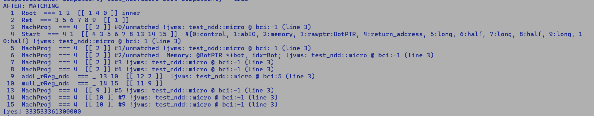

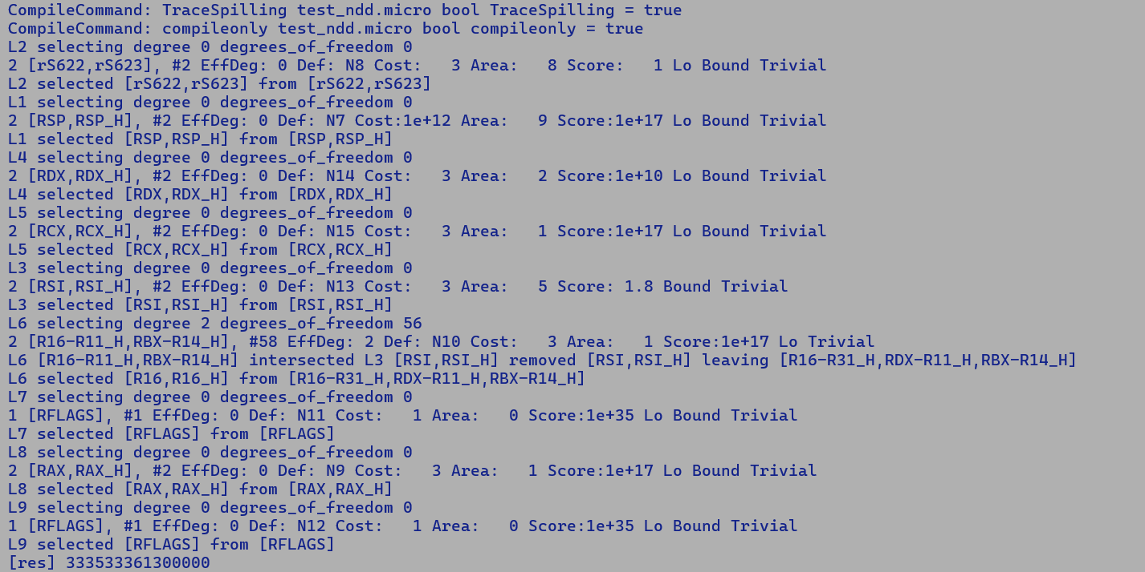

CPROMPT>sde64 -dmr -icount -ptr_raise -- java -Xbatch -XX:-TieredCompilation -XX:CompileOnly=test_ndd::micro -XX:CompileCommand=PrintIdealPhase,test_ndd::micro,MATCHING -XX:CompileCommand=TraceSpilling,test_ndd::micro -XX:CompileCommand=Print,test_ndd::micro -cp . test_ndd

$$ TID: 9 ICOUNT: 3107603

$$ TID: 12 ICOUNT: 2556735

$$ TID: 11 ICOUNT: 2656942

$$ TID: 8 ICOUNT: 2666251

$$ TID: 10 ICOUNT: 3198773

$$ TID: 7 ICOUNT: 3191368

CompileCommand: PrintIdealPhase test_ndd.micro const char* PrintIdealPhase = 'MATCHING'

CompileCommand: TraceSpilling test_ndd.micro bool TraceSpilling = true

CompileCommand: print test_ndd.micro bool print = true

CompileCommand: compileonly test_ndd.micro bool compileonly = true

AFTER: MATCHING

1 Root === 1 2 [[ 1 4 0 ]] inner

2 Ret === 3 5 6 7 8 9 [[ 1 ]]

3 MachProj === 4 [[ 2 ]] #0/unmatched !jvms: test_ndd::micro @ bci:-1 (line 3)

4 Start === 4 1 [[ 4 3 5 6 7 8 13 14 15 ]] #{0:control, 1:abIO, 2:memory, 3:rawptr:BotPTR, 4:return_address, 5:long, 6:half, 7:long, 8:half, 9:long, 10:half} !jvms: test_ndd::micro @ bci:-1 (line 3)

5 MachProj === 4 [[ 2 ]] #1/unmatched !jvms: test_ndd::micro @ bci:-1 (line 3)

6 MachProj === 4 [[ 2 ]] #2/unmatched Memory: @BotPTR *+bot, idx=Bot; !jvms: test_ndd::micro @ bci:-1 (line 3)

7 MachProj === 4 [[ 2 ]] #3 !jvms: test_ndd::micro @ bci:-1 (line 3)

8 MachProj === 4 [[ 2 ]] #4 !jvms: test_ndd::micro @ bci:-1 (line 3)

9 addL_rReg_ndd === _ 13 10 [[ 12 2 ]] !jvms: test_ndd::micro @ bci:5 (line 3)

10 mulL_rReg_ndd === _ 14 15 [[ 11 9 ]]

13 MachProj === 4 [[ 9 ]] #5 !jvms: test_ndd::micro @ bci:-1 (line 3)

14 MachProj === 4 [[ 10 ]] #7 !jvms: test_ndd::micro @ bci:-1 (line 3)

15 MachProj === 4 [[ 10 ]] #9 !jvms: test_ndd::micro @ bci:-1 (line 3)

L2 selecting degree 0 degrees_of_freedom 0

2 [rS622,rS623], #2 EffDeg: 0 Def: N8 Cost: 3 Area: 8 Score: 1 Lo Bound Trivial

L2 selected [rS622,rS623] from [rS622,rS623]

L1 selecting degree 0 degrees_of_freedom 0

2 [RSP,RSP_H], #2 EffDeg: 0 Def: N7 Cost:1e+12 Area: 9 Score:1e+17 Lo Bound Trivial

L1 selected [RSP,RSP_H] from [RSP,RSP_H]

L4 selecting degree 0 degrees_of_freedom 0

2 [RDX,RDX_H], #2 EffDeg: 0 Def: N14 Cost: 3 Area: 2 Score:1e+10 Lo Bound Trivial

L4 selected [RDX,RDX_H] from [RDX,RDX_H]

L5 selecting degree 0 degrees_of_freedom 0

2 [RCX,RCX_H], #2 EffDeg: 0 Def: N15 Cost: 3 Area: 1 Score:1e+17 Lo Bound Trivial

L5 selected [RCX,RCX_H] from [RCX,RCX_H]

L3 selecting degree 0 degrees_of_freedom 0

2 [RSI,RSI_H], #2 EffDeg: 0 Def: N13 Cost: 3 Area: 5 Score: 1.8 Bound Trivial

L3 selected [RSI,RSI_H] from [RSI,RSI_H]

L6 selecting degree 2 degrees_of_freedom 56

2 [R16-R11_H,RBX-R14_H], #58 EffDeg: 2 Def: N10 Cost: 3 Area: 1 Score:1e+17 Lo Trivial

L6 [R16-R11_H,RBX-R14_H] intersected L3 [RSI,RSI_H] removed [RSI,RSI_H] leaving [R16-R31_H,RDX-R11_H,RBX-R14_H]

L6 selected [R16,R16_H] from [R16-R31_H,RDX-R11_H,RBX-R14_H]

L7 selecting degree 0 degrees_of_freedom 0

1 [RFLAGS], #1 EffDeg: 0 Def: N11 Cost: 1 Area: 0 Score:1e+35 Lo Bound Trivial

L7 selected [RFLAGS] from [RFLAGS]

L8 selecting degree 0 degrees_of_freedom 0

2 [RAX,RAX_H], #2 EffDeg: 0 Def: N9 Cost: 3 Area: 1 Score:1e+17 Lo Bound Trivial

L8 selected [RAX,RAX_H] from [RAX,RAX_H]

L9 selecting degree 0 degrees_of_freedom 0

1 [RFLAGS], #1 EffDeg: 0 Def: N12 Cost: 1 Area: 0 Score:1e+35 Lo Bound Trivial

L9 selected [RFLAGS] from [RFLAGS]

============================= C2-compiled nmethod ==============================

#r032 rsi:rsi : parm 0: long

#r034 rdx:rdx : parm 2: long

#r036 rcx:rcx : parm 4: long

# -- Old rsp -- Framesize: 32 --

#r623 rsp+28: in_preserve

#r622 rsp+24: return address

#r621 rsp+20: in_preserve

#r620 rsp+16: saved fp register

#r619 rsp+12: pad2, stack alignment

#r618 rsp+ 8: pad2, stack alignment

#r617 rsp+ 4: Fixed slot 1

#r616 rsp+ 0: Fixed slot 0

#

----------------------- MetaData before Compile_id = 3 ------------------------

{method}

- this oop: 0x00007fbc75400388

- method holder: 'test_ndd'

- constants: 0x00007fbc75400040 constant pool [52]/operands[5] {0x00007fbc75400040} for 'test_ndd' cache=0x00007fbc754005f0

- access: 0x9 public static

- flags: 0x4080 queued_for_compilation has_loops_flag_init

- name: 'micro'

- signature: '(JJJ)J'

- max stack: 7

- max locals: 6

- size of params: 6

- method size: 14

- vtable index: -2

- i2i entry: 0x00007fbd244d8f60

- adapters: AHE@0x00007fbd30342af0: 0xbebebe i2c: 0x00007fbd245f1200 c2i: 0x00007fbd245f12e4 c2iUV: 0x00007fbd245f12c3 c2iNCI: 0x00007fbd245f131f

- compiled entry 0x00007fbd245f12e4

- code size: 7

- code start: 0x00007fbc75400378

- code end (excl): 0x00007fbc7540037f

- method data: 0x00007fbc75400690

- checked ex length: 0

- linenumber start: 0x00007fbc7540037f

- localvar length: 0

------------------------ OptoAssembly for Compile_id = 3 -----------------------

#

# long/half ( long, half, long, half, long, half )

#

000 N1: # out( B1 ) <- in( B1 ) Freq: 1

000 B1: # out( N1 ) <- BLOCK HEAD IS JUNK Freq: 1

000 # stack bang (96 bytes)

pushq rbp # Save rbp

subq rsp, #16 # Create frame

01a eimulq R16, RDX, RCX # long ndd

020 eaddq RAX, RSI, R16 # long ndd

026 addq rsp, 16 # Destroy frame

popq rbp

cmpq rsp, poll_offset[r15_thread]

ja #safepoint_stub # Safepoint: poll for GC

035 ret

[Verified Entry Point]

# {method} {0x00007fbc75400388} 'micro' '(JJJ)J' in 'test_ndd'

# parm0: rsi:rsi = long

# parm1: rdx:rdx = long

# parm2: rcx:rcx = long



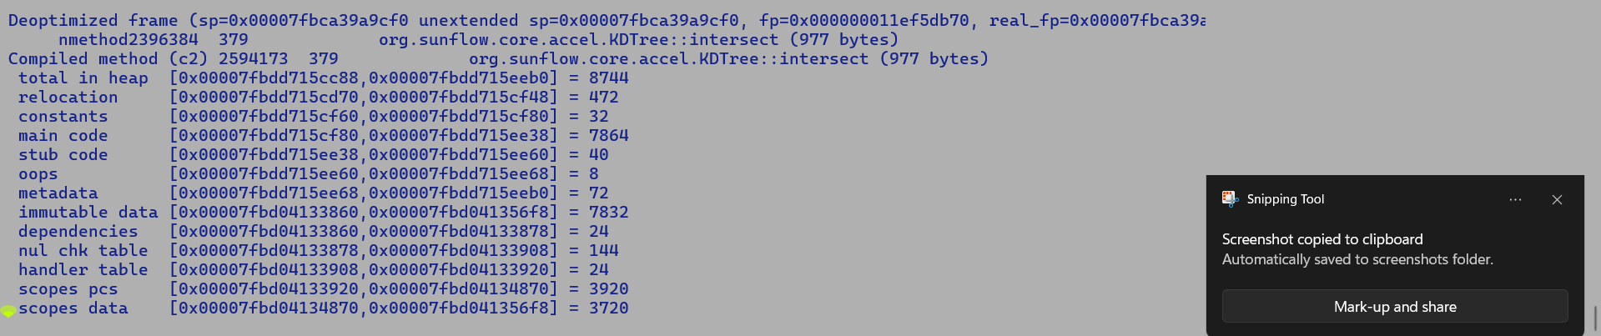

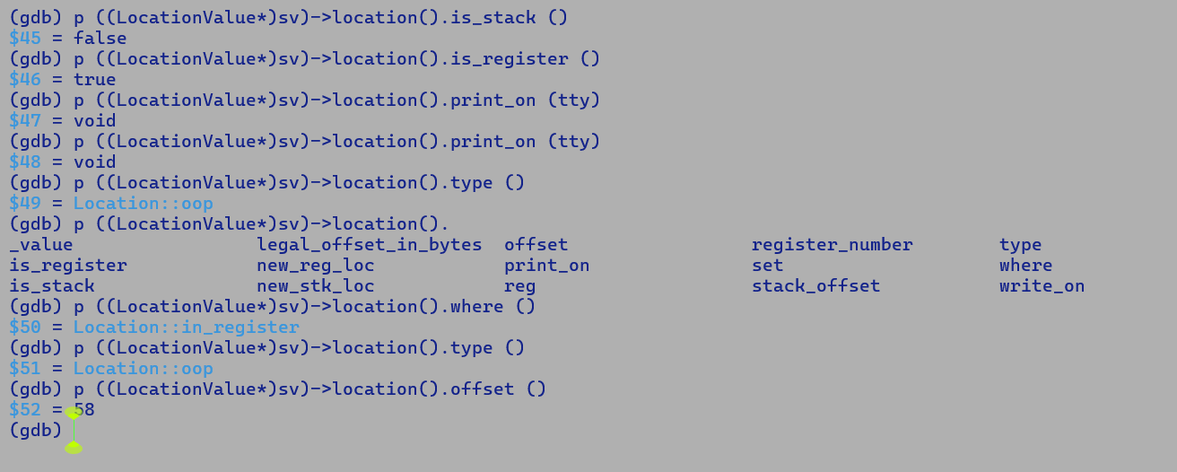

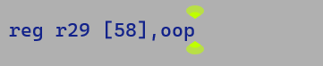

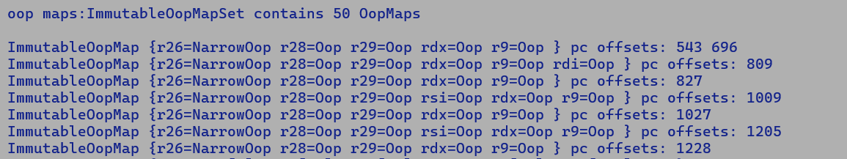

(gdb) bt

#0 0x00007fbdfce96c8a in Dependencies::DepStream::initial_asserts (this=0x7fbca39a5d20, byte_limit=24)

at /home/jatinbha/sandboxes/apx/src/hotspot/share/code/dependencies.cpp:893

#1 0x00007fbdfcd8cd6a in Dependencies::DepStream::DepStream (this=0x7fbca39a5d20, code=0x7fbdd715cc88)

at /home/jatinbha/sandboxes/apx/src/hotspot/share/code/dependencies.hpp:604

#2 0x00007fbdfd6d2f7b in nmethod::print_dependencies_on (this=0x7fbdd715cc88, out=0x7fbde4000b60)

at /home/jatinbha/sandboxes/apx/src/hotspot/share/code/nmethod.cpp:3140

#3 0x00007fbdfd6cdae3 in nmethod::print_nmethod (this=0x7fbdd715cc88, printmethod=96)

at /home/jatinbha/sandboxes/apx/src/hotspot/share/code/nmethod.cpp:1696

#4 <function called from gdb>

#5 0x00007fbdfce96c8a in Dependencies::DepStream::initial_asserts (this=0x7fbca39a5fd0, byte_limit=24)

at /home/jatinbha/sandboxes/apx/src/hotspot/share/code/dependencies.cpp:893

#6 0x00007fbdfcd8cd6a in Dependencies::DepStream::DepStream (this=0x7fbca39a5fd0, code=0x7fbdd715cc88)

at /home/jatinbha/sandboxes/apx/src/hotspot/share/code/dependencies.hpp:604

#7 0x00007fbdfd6d2f7b in nmethod::print_dependencies_on (this=0x7fbdd715cc88, out=0x7fbde4000b60)

at /home/jatinbha/sandboxes/apx/src/hotspot/share/code/nmethod.cpp:3140

#8 0x00007fbdfd6cdae3 in nmethod::print_nmethod (this=0x7fbdd715cc88, printmethod=96)

at /home/jatinbha/sandboxes/apx/src/hotspot/share/code/nmethod.cpp:1696

#9 <function called from gdb>

#10 0x00007fbdfd9d13a2 in StackValue::create_stack_value_from_oop_location (chunk=0x0, addr=0x7fbca39a95a0)

at /home/jatinbha/sandboxes/apx/src/hotspot/share/runtime/stackValue.cpp:141

**#11 0x00007fbdfd9d2895 in StackValue::create_stack_value<RegisterMap> (sv=0x7fbc9000c8d0, value_addr=0x7fbca39a95a0 "\002", reg_map=0x7fbc9000b308)**

**at /home/jatinbha/sandboxes/apx/src/hotspot/share/runtime/stackValue.cpp:207**

**#12 0x00007fbdfd9d1f6d in StackValue::create_stack_value<RegisterMap> (fr=0x7fbc9000b2c8, reg_map=0x7fbc9000b308, sv=0x7fbc9000c8d0)**

**at /home/jatinbha/sandboxes/apx/src/hotspot/share/runtime/stackValue.cpp:48**

**#13 0x00007fbdfdb9b5a3 in compiledVFrame::create_stack_value (this=0x7fbc9000b2c0, sv=0x7fbc9000c8d0)**

**at /home/jatinbha/sandboxes/apx/src/hotspot/share/runtime/vframe_hp.cpp:225**

**#14 0x00007fbdfdb9a8b9 in compiledVFrame::locals (this=0x7fbc9000b2c0) at** /home/jatinbha/sandboxes/apx/src/hotspot/share/runtime/vframe_hp.cpp:61

#15 0x00007fbdfdb979d0 in vframeArrayElement::fill_in (this=0x7fbc900079f0, vf=0x7fbc9000b2c0, realloc_failures=false)

at /home/jatinbha/sandboxes/apx/src/hotspot/share/runtime/vframeArray.cpp:123

#16 0x00007fbdfdb99737 in vframeArray::fill_in (this=0x7fbc90006610, thread=0x7fbc9c038bc0, frame_size=26, chunk=0x7fbd0415f2e0, reg_map=0x7fbca39a6a40,

realloc_failures=false) at /home/jatinbha/sandboxes/apx/src/hotspot/share/runtime/vframeArray.cpp:529

#17 0x00007fbdfdb996a1 in vframeArray::allocate (thread=0x7fbc9c038bc0, frame_size=26, chunk=0x7fbd0415f2e0, reg_map=0x7fbca39a6a40, sender=...,

caller=..., self=..., realloc_failures=false) at /home/jatinbha/sandboxes/apx/src/hotspot/share/runtime/vframeArray.cpp:516

#18 0x00007fbdfce89755 in Deoptimization::create_vframeArray (thread=0x7fbc9c038bc0, fr=..., reg_map=0x7fbca39a6a40, chunk=0x7fbd0415f2e0,

realloc_failures=false) at /home/jatinbha/sandboxes/apx/src/hotspot/share/runtime/deoptimization.cpp:1696

#19 0x00007fbdfce85303 in Deoptimization::fetch_unroll_info_helper (current=0x7fbc9c038bc0, exec_mode=0)

at /home/jatinbha/sandboxes/apx/src/hotspot/share/runtime/deoptimization.cpp:566

#20 0x00007fbdfce83af4 in Deoptimization::fetch_unroll_info (current=0x7fbc9c038bc0, exec_mode=0)

at /home/jatinbha/sandboxes/apx/src/hotspot/share/runtime/deoptimization.cpp:297

#21 0x00007fbdd701705f in ?? ()

Register Save Sequence

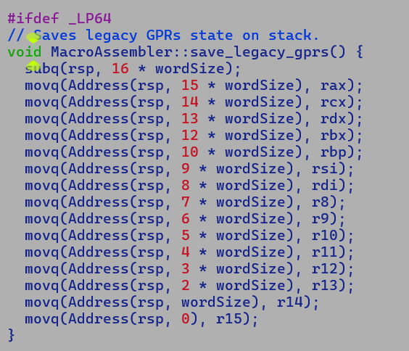

--------------🡪 100000

RAX

… ^

… | delta

R13 |

R14 v

R15 Stack grows downwards

--------------🡪 RSP | 10000 - delta

|

v

To access an argument an offset is added to RBP as arguments were pushed over stack by caller.

To access a local variable an offset is subtracted from RBP as space for locals were reserved by callee in function prologue.

JVM does not strictly comply with stack layout of XSAVE area.

enum layout {

…..

r31_off = xmm_off + (XSAVE_AREA_EGPRS - XSAVE_AREA_BEGIN)/BytesPerInt,

r31H_off,

r30_off, r30H_off,

r29_off, r29H_off,

r28_off, r28H_off,

r27_off, r27H_off,

r26_off, r26H_off,

r25_off, r25H_off,

r24_off, r24H_off,

r23_off, r23H_off,

r22_off, r22H_off,

r21_off, r21H_off,

r20_off, r20H_off,

r19_off, r19H_off,

r18_off, r18H_off,

r17_off, r17H_off,

r16_off, r16H_off,

…..

r15_off, r15H_off,

r14_off, r14H_off,

r13_off, r13H_off,

r12_off, r12H_off,

r11_off, r11H_off,

r10_off, r10H_off,

r9_off, r9H_off,

r8_off, r8H_off,

rdi_off, rdiH_off,

rsi_off, rsiH_off,

ignore_off, ignoreH_off, // extra copy of rbp

rsp_off, rspH_off,

rbx_off, rbxH_off,

rdx_off, rdxH_off,

rcx_off, rcxH_off,

rax_off, raxH_off,

}

During Register Save operation, we dump the contents of EGPRs at consecutive stack locations, a runtime client like de-optimizer then accesses the contents of EGPRs from these stack slots, RegisterSaver pushes the EGPRs in increasing order of register number, i.e. R16 to R31, thus address of stack slot holding R16 is greater than the one holding R17, this is because with each push operation stack grows downwards from higher address to lower address. EGPR contents are accessed by adding a positive offset to stack pointer RSP, thus an offset of R16 will be greater than R17 and so on so forth.

The layout of offset declaration for various EGPRs in the enum must comply with actual order in which registers are pushed over stack.

Latest Validation compiler/c2 : 13/2/2025

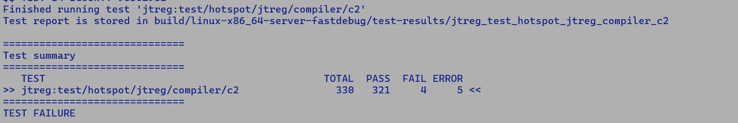

Latest Validation of APX

Test Folder: compiler/c2

Failures

# newfailures.txt

compiler/c2/irTests/gc/ReferenceClearTests.java

compiler/c2/irTests/gc/ReferenceRefersToTests.java

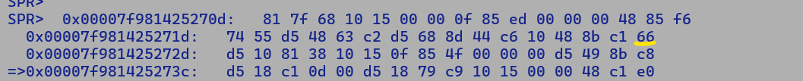

**RA extension for EEVEX for REX demotions applicable to NDD support: -**

C2 Register Allocation Support For Two Address Instruction is split across the following 5 stages:-

1. Selection pattern

match addI_reg (rRegI dst, rRegI src) {

Set dst (AddI dst, src)

}

* Two address instructions are the ones where dst operand is the same as the first source operand.
* Matcher generates a MachNode with 3 MachOperands in the above case.

1. RA-IFG construction.
   1. Inserts an interference edge b/w two_add operand and all other inputs.
   2. Inserts an interference edge b/w instruction and defining node of two_add operand if two_add operand is live beyond the instruction, i.e. was part of live out set at the time of creating interferences for add machine node.
2. RA-PhaseAggressive coalescing
   1. Injects a two_add MachSpillCopyNode before the add to break the live range of two_add operand.
3. RA-Split
   1. Unifies the live range of def operand of MachSpillCopyNode with the def operand of Add MachNode.
4. RA-PhaseCoalEascing
   1. Coalesce the live range of src operand of MachSpillCopyNode with def of MachNode if the two live ranges do not intersect.
   2. This will happen if the src operand is not used beyond the Add IR.

Thus, compiler explicitly unifies the live range of two_add operand and its def if their live range do not interfere and do not just rely on colour biasing.

Q How is NDD instruction different from TwoAddr instruction?

A. While the number of MachOperands associated with a TwoAddr MachNode are same for both the variants, RA explicitly unifies the live range of TwoAdd operand with the def operand which ensure allocation of same register to both of them, there by removing redundant copy spill instruction before the two address instruction.

Q. What is the need for EVEX to REX / REX2 demotion?

A. NDD instruction uses a bulky 4-byte prefix; thus, even though we save GPR2GPR copy spill, which is generally absorbed during the Register Renaming stage and is never issued to OOO execution port, we increase the overall code size which, as a side effect, may impact inlining decisions.

Thus, EVEX to REX / REX2 demotion is a technique to counter redundant code size increase if one of the two source operands is not live beyond the instruction. There are multiple approaches to address this

1. Once RA determines non-intersecting live ranges of source and definition operand of an NDD MachNode, it can bias the colour to register mask (which by the way is statically associated with operands of a matcher pattern) of legacy register class, to ensure emission of REX encoding rather than giving allocator a freedom to pick any colour from EGPR register class as it will need additional byte for REX2 encoding.
2. An explicit pass in allocation before PhaseCoaleascing to unify the live range of non-intersecting source and definition operand of an NDD MachNode, RA is then free to assign any colour to this live range, during code emission make changes in the assembler layer to emit REX/REX2 flavour of such instructions.
3. Design an RA-only solution that replaces the NDD MachNode having a non-intersecting source and definition live range with a compatible two-address MachNode; this is similar to an existing RA optimization that replaces MEM2REG SPILL + Operation with a compatible CICS instruction, i.e. use memory operand flavour of an instruction.

AVX10 Support:-

1. CPUID detection.
   * Identify AVX10 capability level.
     + 1 (GNR), 2 (DMR+)
   * AVX10 Vector length support
     + 128, 256, 512
2. XSAVE CR0 check to enable state management of following architectural registers

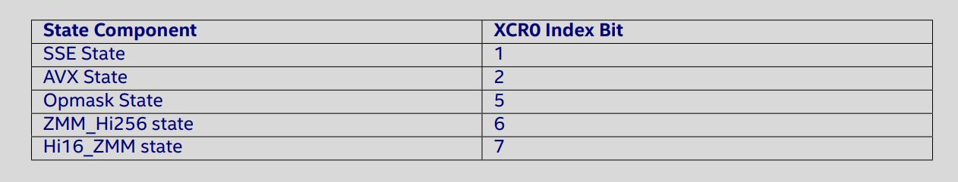

1. Encoding extensions
   1. Embedded rounding control for AVX10.2 256.
      1. In order to support embedded rounding capabilities for YMM/256 bit Intel® AVX10.2 instructions, the EVEX.U bit is repurposed. It’s current assignment is set to always be ”1”. For Intel® AVX10.2, an EVEX.U bit value of ”0” combined with an
      2. EVEX.b value of ”1” will enable embedded rounding for supported YMM/256 bit instructions in any Intel® AVX10 ISA version 2 or greater.

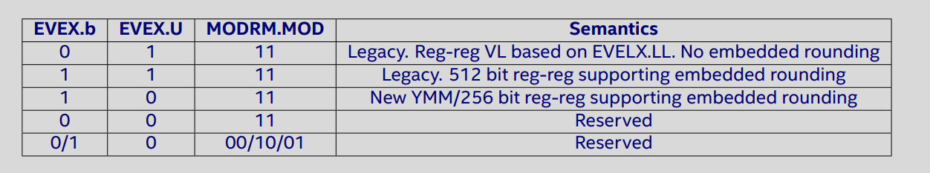

Applicable to following instructions

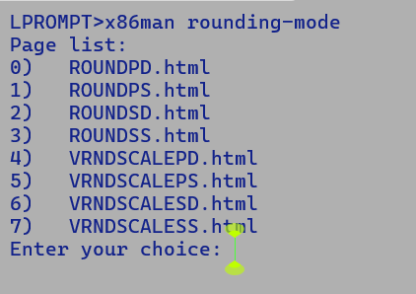

1. Existing Math.round API uses a different scheme for rounding as it semantics are different for C rounding API for a value of 0.5, API expects to return a value 1.0 while C-API returns 0.0

To support this we change the MXCSR rounding policy to round towards -inf and add 0.5 to VAL followed by a

floating point truncating case to integer and special cases for NaN, +/- Inf and +/-0.0.

RES = CVTTPS2DQ VAL + 0.5

1. Auto-vectorized Math.ceil/floor/rint API uses VRNDSCALEPD for 512-bit vectors. Corresponding 256 bit vector selection patterns can be extended after above encoding extension support.

Q. What is the benefit of using new AVX10 ISA for 256-bit vector operations?

A. An AVX2 instruction functionally equivalent to an AVX10-256 instruction will not be able to access vector registers in higher register bank due to limitations of VEX encoding. This is main reason to favour AVX10-256 ISA which support EVEX encoding and can not only access YMM16-31 register but also embedded opmask register K0-K7.

1. New Instruction support: -
   1. AI use case (after FP16 support) – priority medium
      1. FP8: E5M2 and E4M3 (EXMY, X-mantissa bits, Y-exponent bits)
      2. Conversion to and from FP8, BF8.
   2. Media Acceleration – priority low / zero.
      1. We do not have any Java SE API which makes use of existing MPSADBW
   3. Min/Max NI – priority high
      1. ARM’s fmin/fmax already comply with IEEE semantics.
      2. We currently emit a bulky instruction sequence based on VBLEND to handle NaN and 0.0 values.



commit 0357665ebe2058b174438033acdaf25a16fd50b0

Author: Jatin Bhateja <jatin.bhateja@intel.com>

Date: Wed Mar 6 13:45:32 2019 -0800

Float/Double min/max implementation for x86

* 1. Saturating conversion instruction. – priority high
     1. Existing CVTTP[DS]2[DQ]Q instructions return a 2^W -1 value if post truncation results overruns corresponding fixed point format delimiting values.
     2. Due to this we currently introduce special handling for NAN and Inf values.

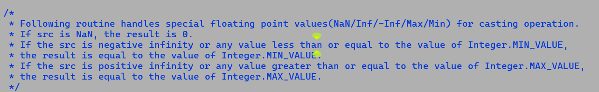

* + 1. New instruction being saturating in covers above special handling
       1. Conversion from FP32 to SIGNED BYTE, SHORT seems to be a low latency and shorted path length options.

Both c and d qualify as ARM parity optimizations and will optimize bulky handling for floating point to integral conversions and frequently used min/max operations.

* 1. Zero extending partial copy instruction: VMOVD , VMOVW – priory low / medium
     1. Currently, XMM to XMM copy instruction copies entire 128-bit vector from source to destination.
     2. Existing instructions are VEX encoded, with 2-byte prefix.
     3. VEX encoding ensure to zero out upper vector bits from MAX_BITS : 128, thus prevent cycle to preserve the upper bits of the vector.
     4. We already use VMOVW to move FP16 scalar values b/w GPR and XMM registers.
     5. Zero extension may save cycles due to false dependencies in VEX variant of ROUNDSS instruction

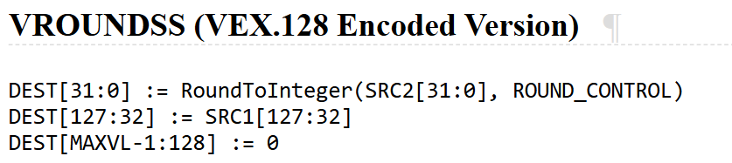

* + 1. Since the instruction clears upper bits (64:32] of XMM register hence it needs to be dispatched to the EXECUTION ports since RENAMING simply assigns PHY registers, however, if it’s handled as a special case of zeroing idiom then we may save issuance to backend.
    2. Cons:
       1. Instruction needs a bulky 4-byte EVEX prefix.
       2. We may not see any perceptible performance improvements by saving additional merging cycle due to false dependency.
  1. SM4: Java SE does not support a provider for SM4 encryption. Priority – low

* 1. MOVRS: Move with Read shared hints.
  2. BF16 instructions.
     1. Full blown ISA extension like FP16.
     2. To be addresses after FP16 support.
     3. Very appealing for Java AI use case with VAPI.
  3. New V[U]COMXSD instruction compares the lower double-precision values from two floating point register set a different set of EFLAGS bit allowing greater number of comparisons w.r.t [U]COMISD.

V[U]COMXSD

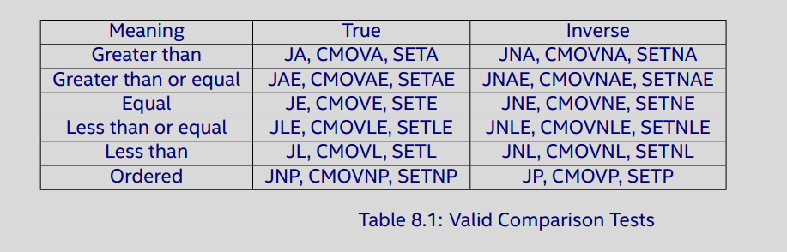

[U]COMISD

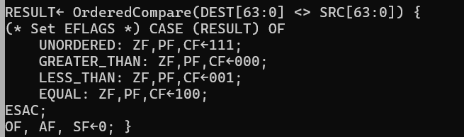

* 1. Conversion instruction b/w FP16, INT8 , BFP8 (E5M2) , FP8 (E4M3) types.
  2. FP16 VNNI instruction computes FP16 Dot product and accumulates as FP32 granularity.
  3. 10.2 extensions for 256-bit extensions of various (100+) AVX512 instructions.
  4. Saturating conversions instruction returns delimiting values if a floating-point exact value cannot be represented in the fixed format, if the value is inexact, it's first rounded to representation balance using RNE or MXCSR.RC settings.
     1. These instructions directly map to Java’s F2I D2L semantics for which the compiler emits special handling for NaN/Inf etc…. currently if a converted result is larger than the maximum signed doubleword
     2. Integer, the floating-point invalid exception is raised, and if this exception is masked, the indefinite integer value (80000000H) is returned.

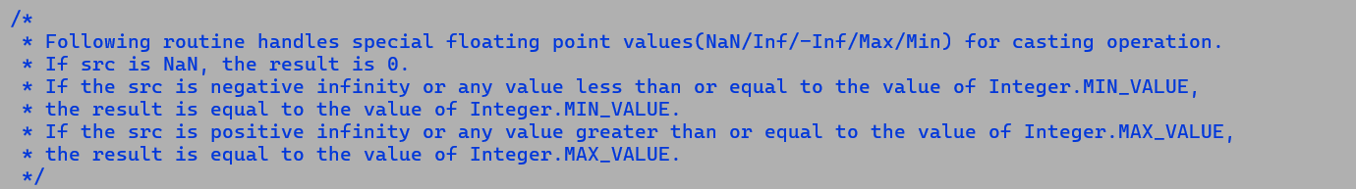

* + 1. These instructions will optimize the comparison operations.

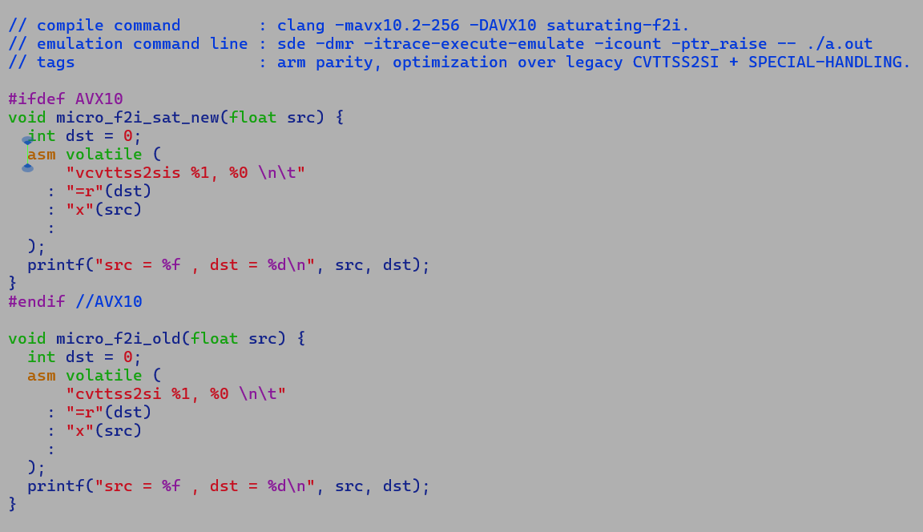

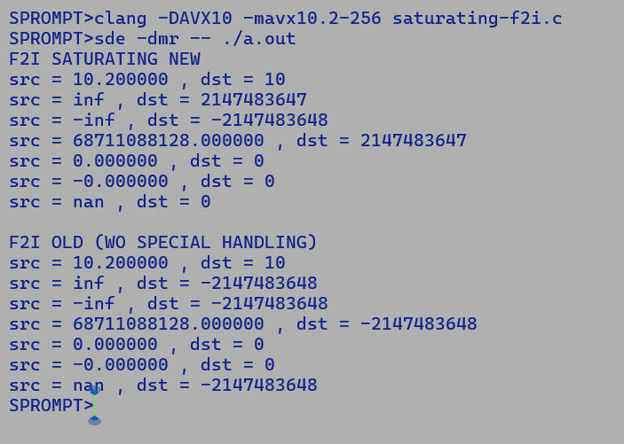

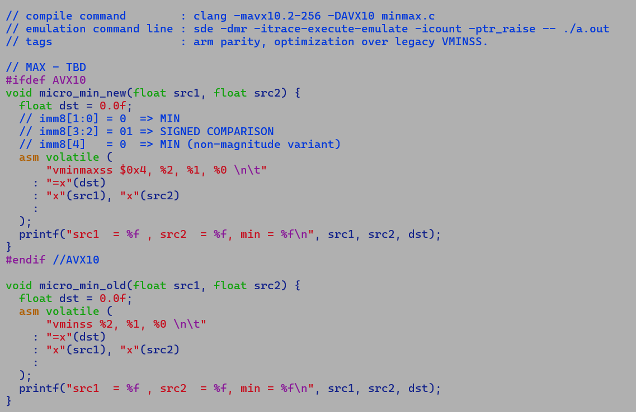

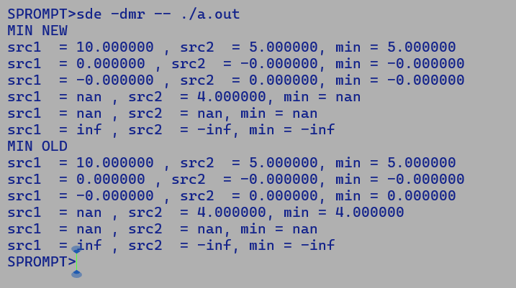

Quick Re-cap for XSAVE save restoration semantics: -

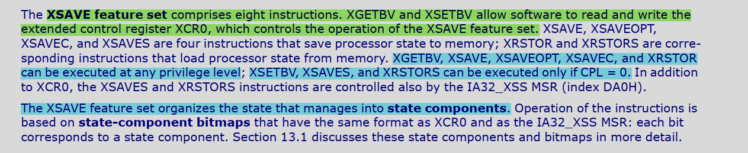

* AVX10.1 – 512 || AVX10.2-512 are compatible with current AVX512 in terms of save / restore state components.
* AVX10.2-256 has the following state components
  + 32 - 256-bit Vectors.
  + 8 opmask register (32-bit should suffice since max vector size is 256-bit, AVX512 has 64-bit opmask registers, but this may result in a different XSAVE area layout and 10.2 specifications are not clear on this)
  + AVX
  + SSE
  + X87

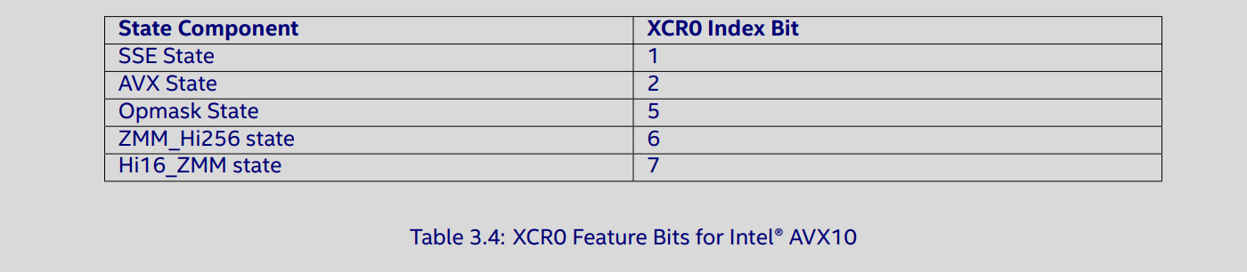

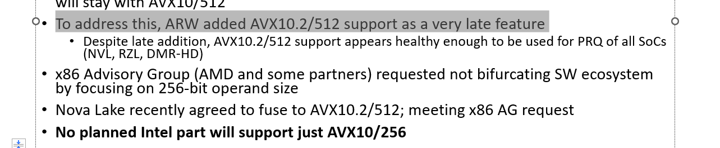

To be prioritized after latest specification release.

* AVX10.2 – 450 Page document reviewed, and action items identified. - DONE
* PoC implementation for CPUID in place, missing XSAVE checks - DONE (PARTIALLY)
  + supports_evex (CPU_EVEX | CPU_AVX10)
  + supports_avx512vl (CPU_AVX512 | CPU_AVX10)
  + …
  + All support APIs for avx512 should take into account CPU_AVX10
  + Remove 512 reference altogether
* If OSXSAVE bit is set, ring-3 application can access XCR0 using xgerbv instruction.
  + Enable XSAVE based state restoration for AVX10.
* Enable all GNR AVX512-F feature under supports_avx10.
* ~~Encoding diversion to support embedded rounding for AVX10.2 - 256~~
* New ISA support:-
  + Priority 1
    - PR to support AVX10-[512] which will streamline the feature detection.
    - There is no change in instruction encoding, all existing AVX512 instructions will work as its on AVX10 targets.
  + Priority 2 (ARM parity) - C-micro developed and tested using SDE
    - VPMAXMIN
    - VCVTTPS2DQS
    - VCVTTSS2SIS
    - VCVTTPD2QQS
    - VCVTTSD2QQS
  + Priority 3 (AI enablement)
    - FP8 conversion to / from FP16 and FP32
  + Priority 4 (BF16 support) – After FP16 feature support.
    - Several new extensions to ISA, full blown extension.
    - Bfloat16.java and associated operation APIs.
    - VectorAPI – extension

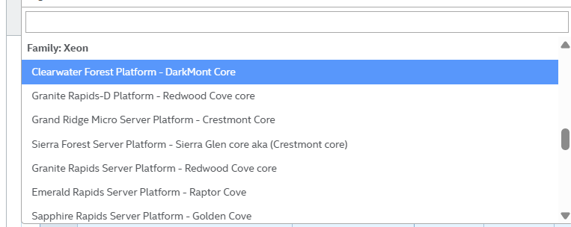

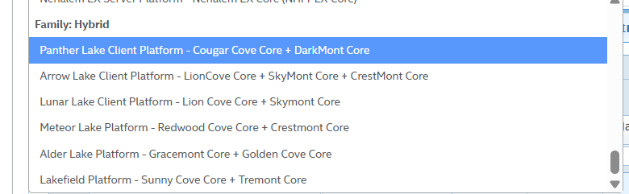

Future AVX10 hybrid

Hybrid:-

Novalake E-core – Artic Wolf (ARW) , P-core (Panther Cove)

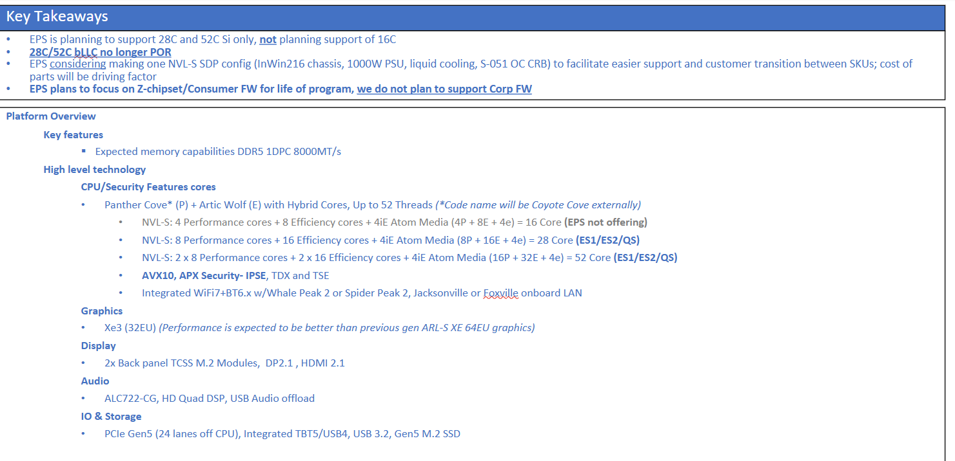

<https://intel.sharepoint.com/:p:/r/sites/DSE/_layouts/15/Doc.aspx?sourcedoc=%7B7BF77F95-9226-4EA0-AB91-DDCAFF581F92%7D&file=Nova%20Lake-S%20Customer%20Review-WW45%20Edit.pptx&action=edit&mobileredirect=true&DefaultItemOpen=1>

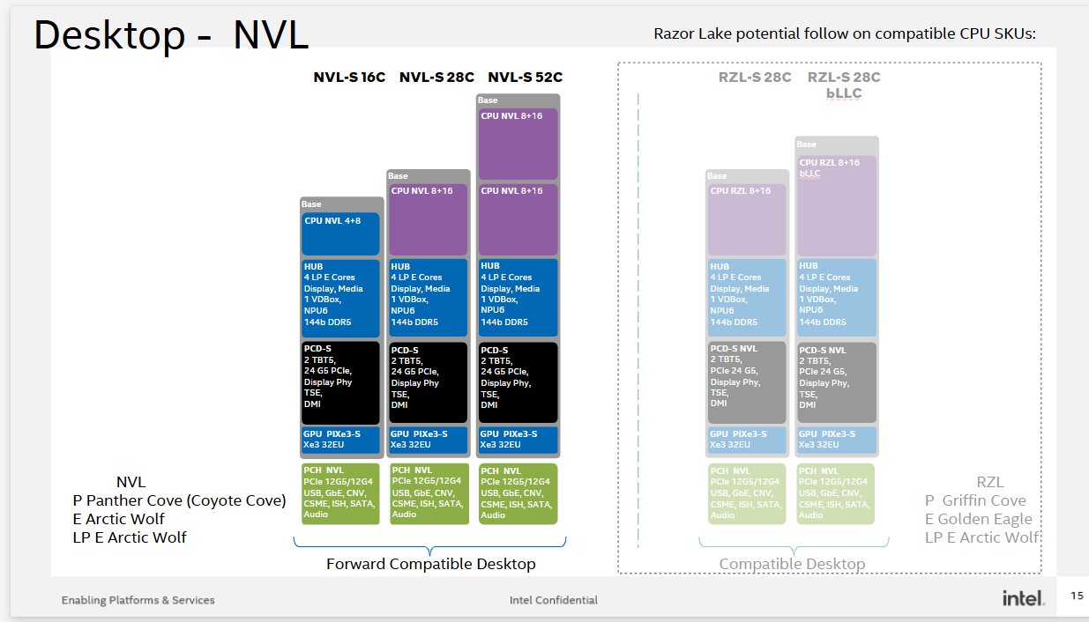



<https://intel.sharepoint.com/:p:/r/sites/DSE/_layouts/15/Doc.aspx?sourcedoc=%7B6BA24EDE-46B7-4F7A-8044-3DD07DC91900%7D&file=NVL-S%20Forecast%20Collection%20Ordering%20Guide%20WW52.pptx&action=edit&mobileredirect=true>

Xeon:-

Program Name Product Name CPU cores

BirchStream Granite Rapids P-core (Redwood-cove)

BirchStream Clearwater Forest E-core (Darkmont) [no-AVX10]

OakStream Diamond Rapids P-core (Panther-cove) [AVX10.2]

OakStream Rogue River Forest (cancelled) E-core (GLE - golden eagle) [AVX10.2]

Compatible compiler options

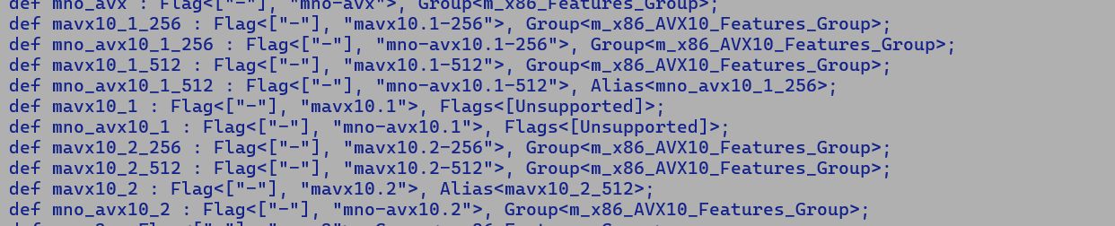

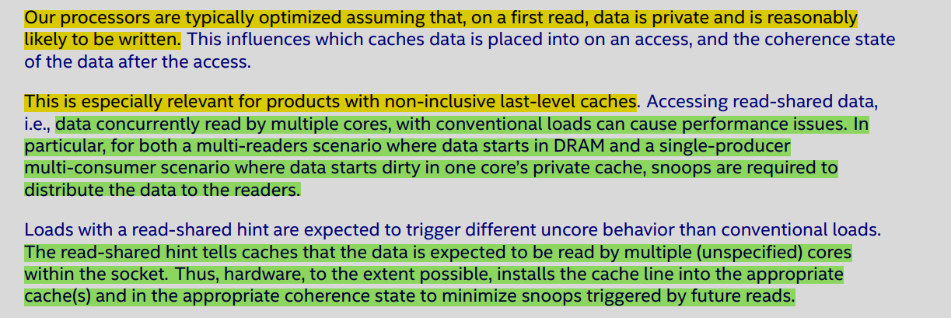

* Snoop filters part of Caching Agents keeps track of caches lines in L1/L2 (private caches) of other cores within a socket.
* Influences the placement of cache line holding the READ shared hint location into the optimum cache level.
* A true sharing or a false sharing scenario where which suffer due to cache line ping-pong on account of RFO will be costlier for cache lines with READ shared hint locations.
* Manual clearly states that it meant to optimize multiple reader scenarios.
* Priority TBD after more use case explorations.

TODO:-

* Consider repurposing UseAVX or create a new VM flag for UseAVX10Level=1,2,…..
* AVX10 adds a new version scheme where in features part of level N are guaranteed to be present in level N.
  + AVX3Threshold was added to counter the performance drop due to frequency throttling issues associated with AVX512.

JVMCI-

Quick code pointers.

HotspotJVMCIBackendFactory

Requirements

* We definitely need explicit flags for CPU_AVX10_VERSION1 and CPU_AVX10_VERSION2
* JVMCI uses JNI to store the address of _features flag.
* In addition it maintain the flags' orderings consistency with VM feature flags enum, this makes feature detection seamless and set bit query over _feature flags.
* Problem
  + _featrues flags is a 64 bit field, and we have exhausted 63 bits and are left with just one spare bit.

APX Latest Validation

==============================

Test summary

==============================

TEST TOTAL PASS FAIL ERROR SKIP

>> jtreg:test/hotspot/jtreg/compiler/c2 359 329 6 7 17 <<

==============================

TEST FAILURE

SPR>cat /home/jatinbha/sandboxes/jdk/build/linux-x86_64-server-fastdebug/test-results/jtreg_test_hotspot_jtreg_compiler_c2/text/newfailures.txt

# newfailures.txt

compiler/c2/cr6340864/TestLongVect.java ROOT CAUSED: Shared with Vamsi

compiler/c2/cr7192963/TestLongVect.java ROOT CAUSED : Shared with Vamsi

compiler/c2/irTests/TestFPComparison.java Partially ROOT CAUSED : two cmove and ucomisd encodings are correct, failure occurs after NDD patch.

compiler/c2/irTests/TestSuperwordFailsUnrolling.java ROOT CAUSED: assertion failure in kmove montgoMerryAVX512

compiler/c2/irTests/gc/ReferenceClearTests.java

compiler/c2/irTests/gc/ReferenceRefersToTests.java

SPR>cat /home/jatinbha/sandboxes/jdk/build/linux-x86_64-server-fastdebug/test-results/jtreg_test_hotspot_jtreg_compiler_c2/text/other_errors.txt

# other_errors.txt

compiler/c2/Test6866651.java

compiler/c2/TestMergeStores.java#id0

compiler/c2/TestMergeStores.java#id1

compiler/c2/TestMergeStores.java#id2

compiler/c2/TestShiftRightAndAccumulate.java#id0

compiler/c2/TestShiftRightAndAccumulate.java#id1

compiler/c2/TestUnsignedByteCompare1.java

Two new failures after first NDD patch integration.

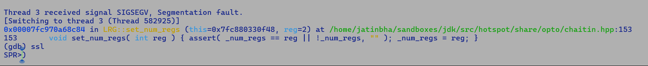

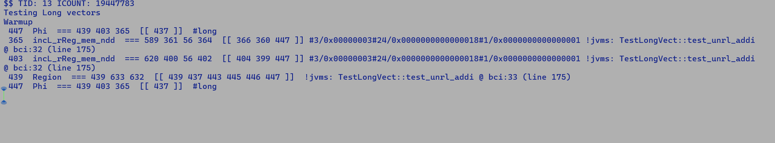

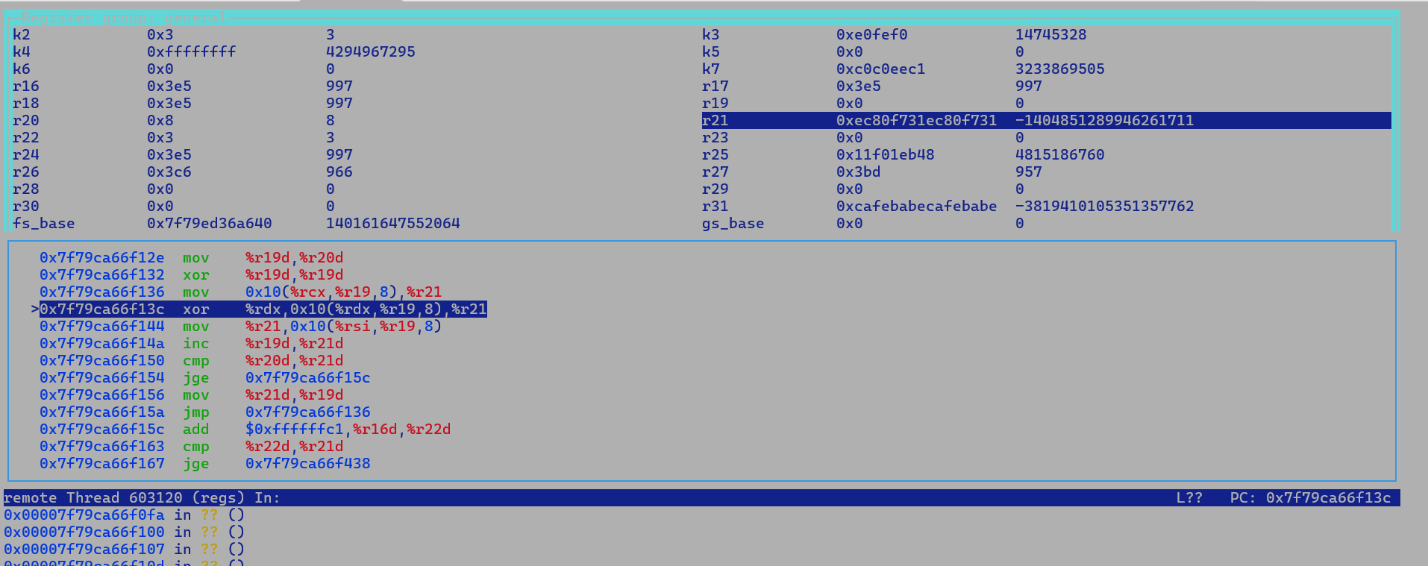

**Barrier optimization (ZGC with APX):-**

1. **There is scope for optimization in the write barrier. By dedicating one of the new 16 EGPRs as scratch register, we can save an expensive push and pop per write barrier.**
2. **At the minimum, we can emit pushp and popp with PPX hints, which forwards the register value being pushed if not modified.**

**The following sequence is part of the fast path. **

1. With EGPR, we have an additional 16 registers at our disposal. its ok to reserve a few as scratch registers (R28-R31) and move them out of the RA allocation set; these scratch registers can be used to optimize push-pop sequence after measuring performance impact.
2. ZBarrierSetAssembler::store_barrier_medium also has spill sequence, which can benefit from PPX hints.

ZGC does not uses compressed oop pointers, so no StoreN / LoadN

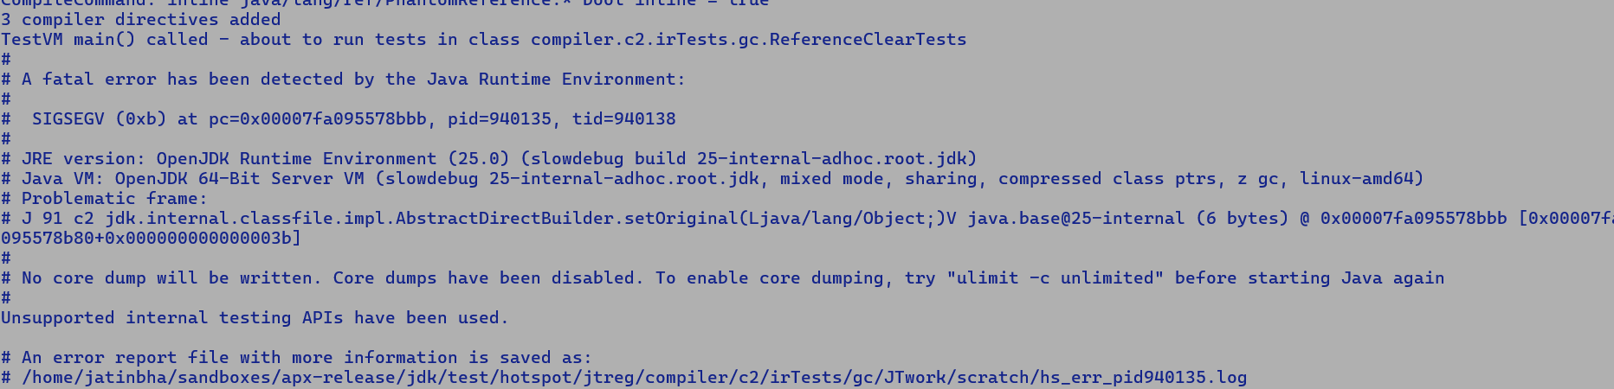

AbstractDirectBuilder<M>

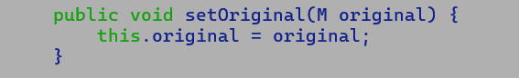

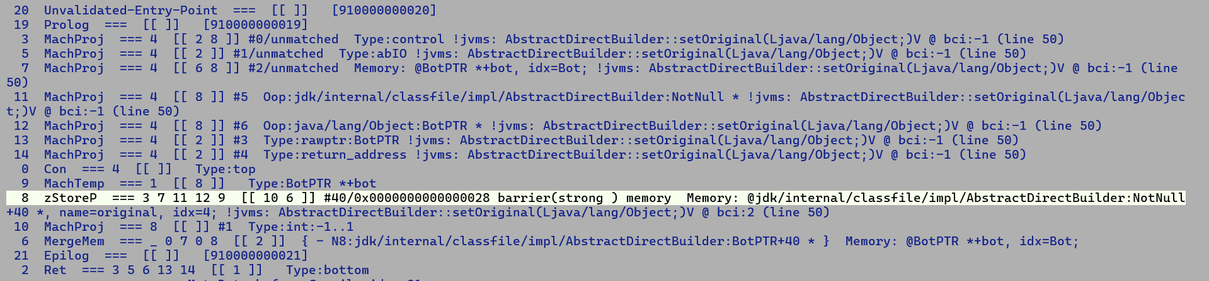

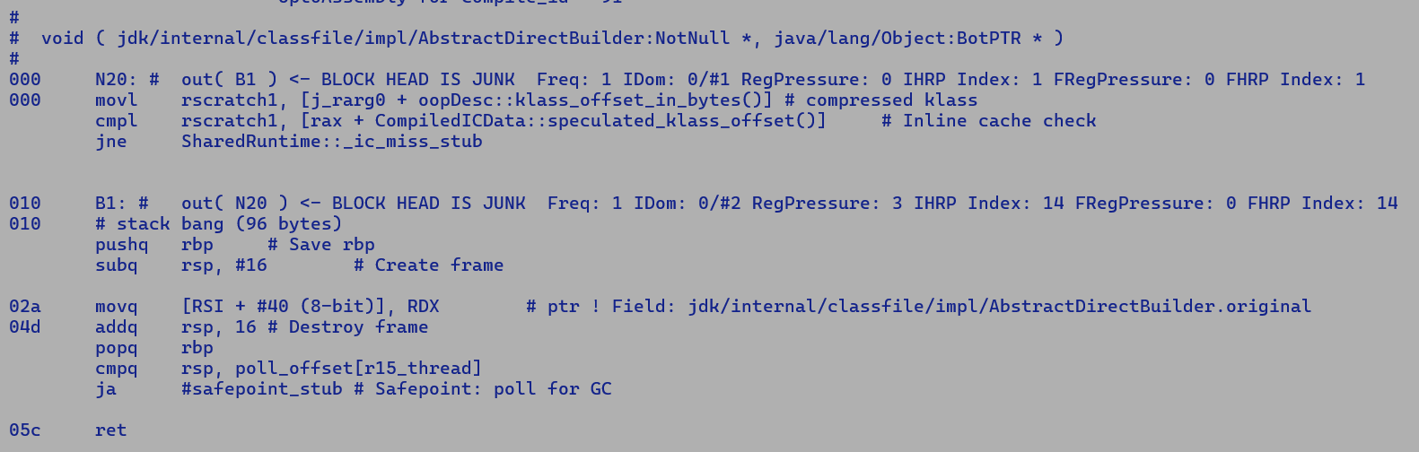

SPR

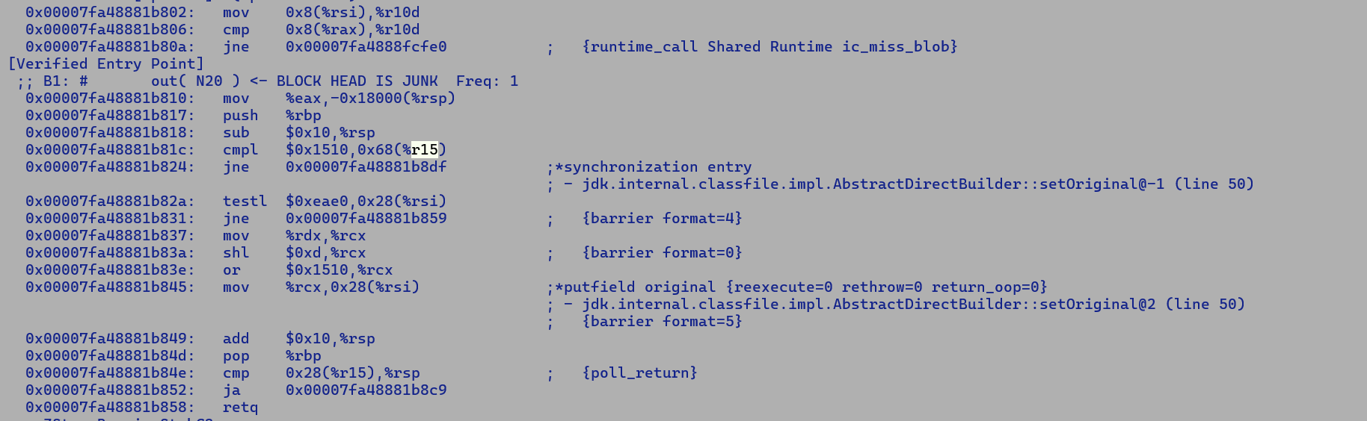

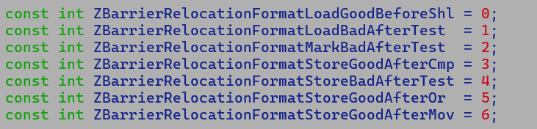

After* Relocation has -ve offset, most of the time patch is performed for immediate value, hence backward patching is agnostic to upfront REX2/EEVEX prefix, while Before* relocation need to accommodate additional prefix bytes for REX2/EEVEX.

0000000000000000 <micro>:

0: 55 push %rbp

1: 48 89 e5 mov %rsp,%rbp

4: 49 c1 e7 0a shl $0xa,%r15

8: d5 18 c1 e1 0a shl $0xa,%r17

=>0x00007fa095578bbb: d5 18 c1 0d 00 d5 18 81 c8 10 15 00 00 d5 48 89

Patching for GoodBeforeShl has offset 3. In this case, we incorrectly patch the ModRM byte (e1) with a shift value of 0d; instead, the byte after 00 should have been patched.

Post fix

0x00007f10f18daeb0: ; {barrier format=4}

0x00007f10f18daeb0: 000f 8526 | 0000 00d5 | 488b c2d5 | 18c1 e00d

0x00007f10f18daec0: ; {barrier format=0}

0x00007f10f18daec0: d518 81c8 | 1015 0000

Root cause: Failing compiler/c2/irTests/TestFPComparison.java

OptoAssembly:-

Without APX

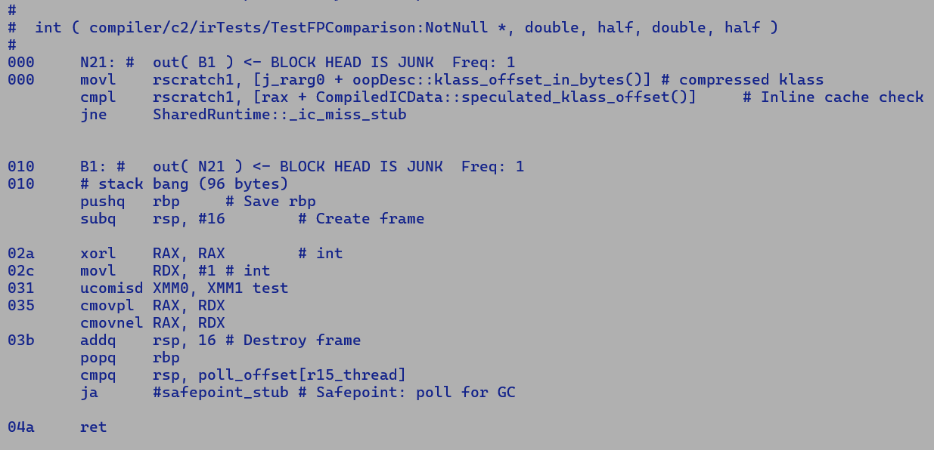

With APX

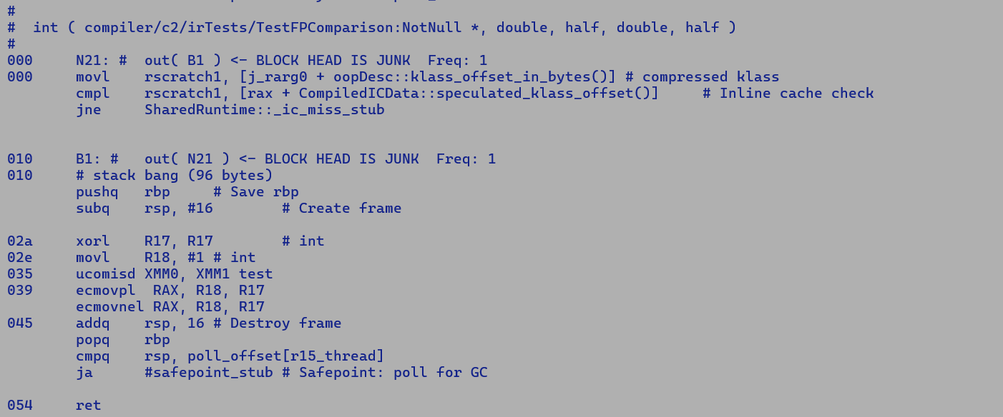

test/hotspot/jtreg/compiler/c2/irTests/TestSuperwordFailsUnrolling.java

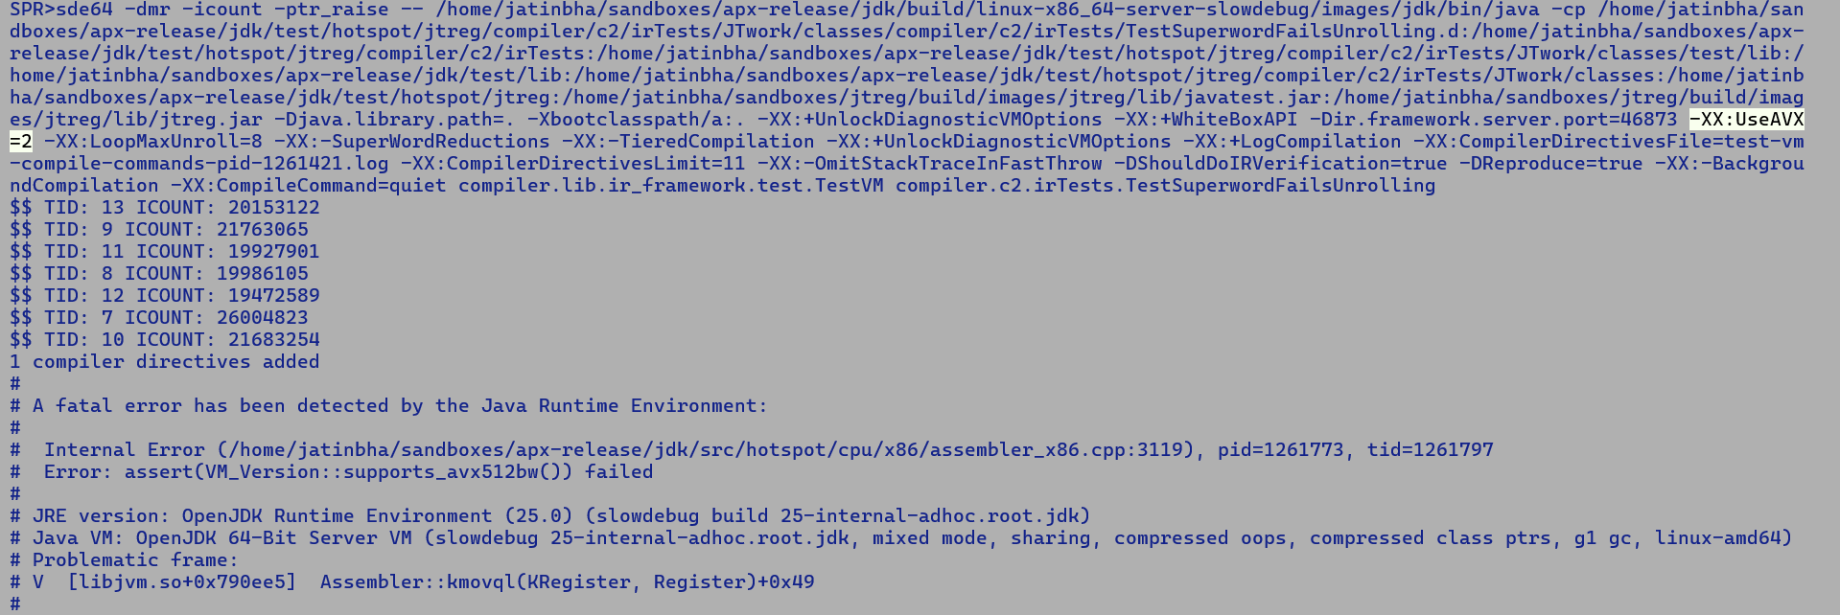

Latest APX Validation 7/4/2025

**# other_errors.txt**

compiler/c2/TestMergeStores.java#id0

compiler/c2/TestMergeStores.java#id1

compiler/c2/TestMergeStores.java#id2

All above timeout with TIMEOUT_FACTOR=20.

**newfailures.txt**

compiler/c2/cr6340864/TestLongVect.java - Root caused, sent to Vamsi

compiler/c2/cr7192963/TestLongVect.java - Root caused, sent to Vamsi

compiler/c2/irTests/TestFPComparison.java - Partially root caused, incorrectness,

NDD, verified that CMOV encoding

looks correct.

compiler/c2/irTests/TestSuperwordFailsUnrolling.java - Root caused, assertion failures due

to missing feature, occurring after

latest AVX2 montgomerry patch on DMR.

No longer failing:-

compiler/c2/irTests/gc/ReferenceClearTests.java - ZGC relocation issue fixed, to be checked in

compiler/c2/irTests/gc/ReferenceRefersToTests.java - ZGC relocation issue fixed, to be checked in.

9/4/2025

Latest validation on jtreg/compiler

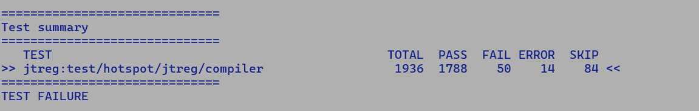

SPR>cat APX_VALIDATION_TB_ANALYZED/test-results/jtreg_test_hotspot_jtreg_compiler/text/newfailures.txt

# newfailures.txt

Known Root Caused

==================

compiler/c2/cr6340864/TestLongVect.java - ndd

compiler/c2/cr7192963/TestLongVect.java - ndd

compiler/c2/irTests/TestFPComparison.java - incorretness, encoding is correct.

compiler/c2/irTests/TestSuperwordFailsUnrolling.java - assetion failure, montogomerry

compiler/intrinsics/string/TestStringLatin1IndexOfChar.java - assetion failure, montogomerry

compiler/floatingpoint/TestSubNodeFloatDoubleNegation.java - strict IR validtion check

compiler/intrinsics/bmi/verifycode/AndnTestI.java - hard coded encoding checks

compiler/intrinsics/bmi/verifycode/AndnTestL.java - hard coded encoding checks

compiler/intrinsics/bmi/verifycode/BzhiTestI2L.java - hard coded encoding checks

compiler/intrinsics/bmi/verifycode/LZcntTestL.java - hard coded encoding checks

compiler/intrinsics/bmi/verifycode/TZcntTestL.java - hard coded encoding checks

compiler/intrinsics/zip/TestFpRegsABI.java - strict check in test does not account for addtional byte of REX2 prefix, # assert(max_size >= actual_size) failed: Expected stub size (23) must be larger than or equal to actual stub size (24).

compiler/vectorization/runner/BasicLongOpTest.java - looks related to known xor ndd encoding issue, auto-vectorize code does have scalar peel using ndd.

compiler/vectorapi/TestMaskedMacroLogicVector.java - looks related to known xor ndd encoding issue, vector api fallback code uses scalar code.

compiler/vectorization/runner/ArrayTypeConvertTest.java - c2 stub code does not account for additional REX2 byte. # assert(max_size >= actual_size) failed: Expected stub size (23) must be larger than or equal to actual stub size (24)

Timeouts

=========

compiler/loopopts/superword/TestDependencyOffsets.java#avx1-v016-A

compiler/loopopts/superword/TestDependencyOffsets.java#avx1-v016-U

compiler/loopopts/superword/TestDependencyOffsets.java#avx1-v032-A

compiler/loopopts/superword/TestDependencyOffsets.java#avx1-v032-U

compiler/loopopts/superword/TestDependencyOffsets.java#avx2-v016-A

compiler/loopopts/superword/TestDependencyOffsets.java#avx2-v016-U

compiler/loopopts/superword/TestDependencyOffsets.java#avx2-v032-A

compiler/loopopts/superword/TestDependencyOffsets.java#avx2-v032-U

compiler/loopopts/superword/TestDependencyOffsets.java#avx512-v032-A

compiler/loopopts/superword/TestDependencyOffsets.java#avx512-v032-U

compiler/loopopts/superword/TestDependencyOffsets.java#avx512-v064-A

compiler/loopopts/superword/TestDependencyOffsets.java#avx512-v064-U

compiler/loopopts/superword/TestDependencyOffsets.java#avx512bw-v032-A

compiler/loopopts/superword/TestDependencyOffsets.java#avx512bw-v032-U

compiler/loopopts/superword/TestDependencyOffsets.java#avx512bw-v064-A

compiler/loopopts/superword/TestDependencyOffsets.java#avx512bw-v064-U

compiler/loopopts/superword/TestDependencyOffsets.java#sse4-v004-A

compiler/loopopts/superword/TestDependencyOffsets.java#sse4-v004-U

compiler/loopopts/superword/TestDependencyOffsets.java#sse4-v008-A

compiler/loopopts/superword/TestDependencyOffsets.java#sse4-v008-U

compiler/loopopts/superword/TestDependencyOffsets.java#sse4-v016-A

compiler/loopopts/superword/TestDependencyOffsets.java#sse4-v016-U

compiler/loopopts/superword/TestDependencyOffsets.java#vanilla-A

compiler/loopopts/superword/TestDependencyOffsets.java#vanilla-U

TB analyzed

=============

compiler/arguments/TestCodeEntryAlignment.java

compiler/arraycopy/stress/TestStressArrayCopy.java

compiler/blackhole/BlackholeIntrinsicTest.java

compiler/gcbarriers/UnsafeIntrinsicsTest.java#ZDebug

compiler/intrinsics/chacha/TestChaCha20.java

compiler/intrinsics/klass/CastNullCheckDroppingsTest.java

compiler/jvmci/TestInvalidJVMCIOption.java

compiler/loopopts/TestRangeCheckPredicatesControl.java

compiler/stringopts/TestStringObjectInitialization.java

compiler/uncommontrap/TestDeoptOOM.java#Z

compiler/vectorapi/reshape/TestVectorCastAVX2.java

SPR>

Check out TAGe in details before CCMP..

Debugging ZGC barrier relocation bug:-

======================================

Q Why do we perform ZGC barrier patching?

A. To optimize comparison against the global metadata state, which is finalized before the start of different ZGC phases, e.g. MarkYoungM0, MarkYoungM1, etc.

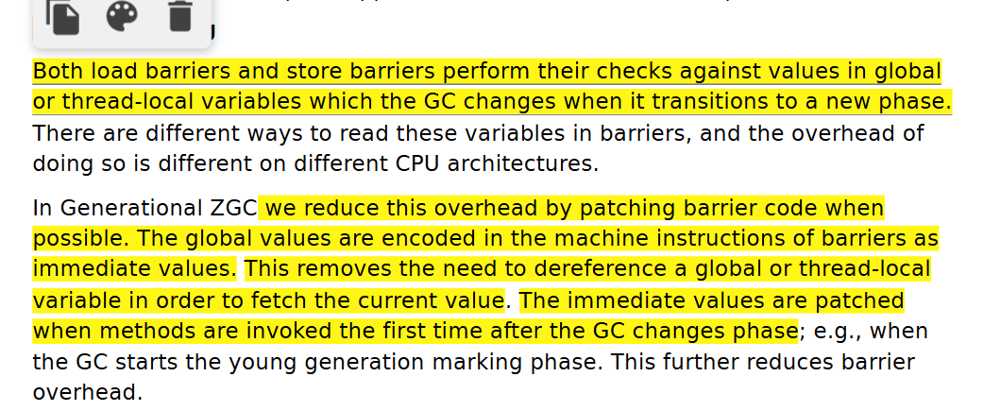

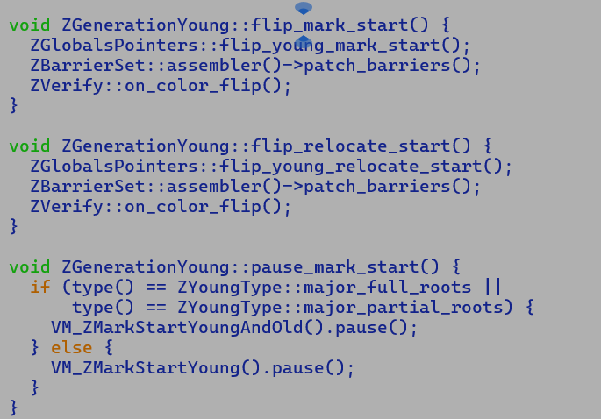

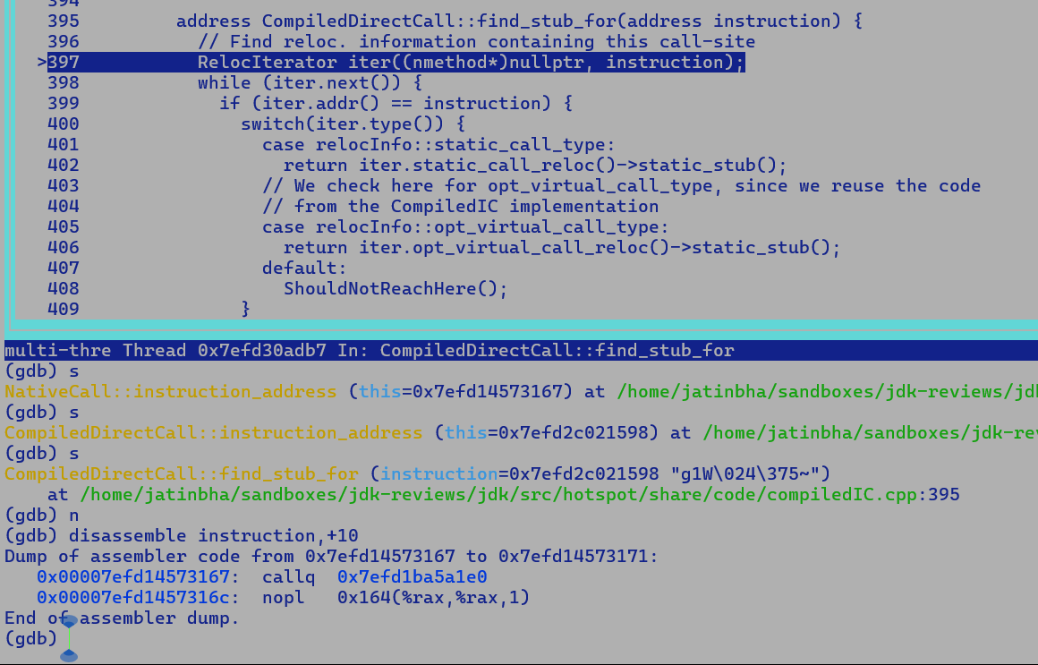

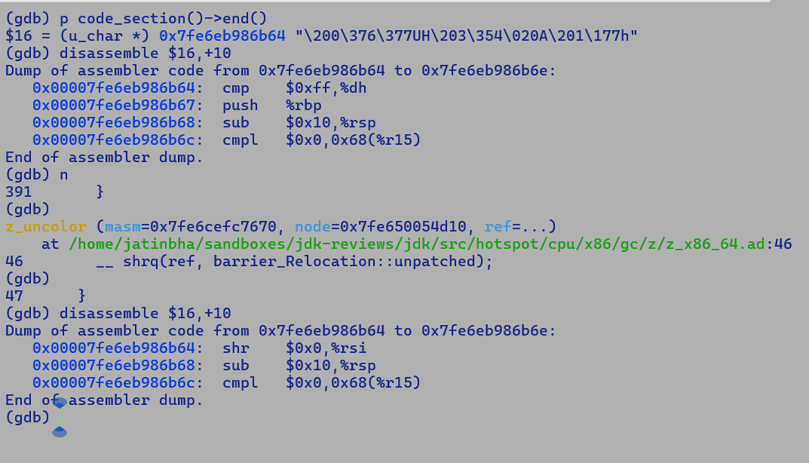

* relocInfo is mapped with the instruction start PC.

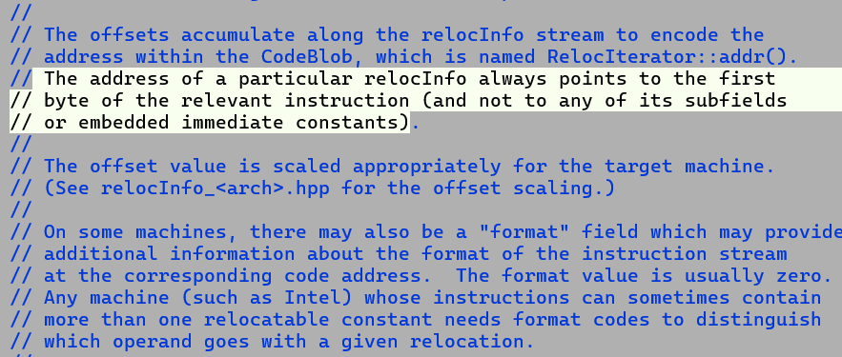

Most of the assembler instructions operating on an address records the starting address of the encoding using InstructionMark.

Q. Why do relocations not record the actual address of patch site which could be b/w start of successive instructions?

A. This is for convenience sake, as we can access the prefix / primary opcode that allows performing additional validation of instructions to be relocated. Also, RelocationIterator returns the list of relocations corresponding to a given instruction starting address, there could be multiple relocations for a given instruction eg, an instruction may patch both immediate and address value, to perform a quick search on all the relocations corresponding to that instruction, relocInfo records the starting address along with additional relocation specific info.

[PREFIX][OPCODE][MODRM][SIB][DISP][IMM32]

e.g.

CompiledIC used for inline caching of mono-morphic, bi-morphic and mega-morphic inline call sites uses virtual_Call_Relocation structures.

Post-compilation:-

ADDR1: mov <receiver_object> <rsi>

ADDR2: call <virtual_call_resolution_stub>

Runtime data structure CompiledIC 1:1 mapping with call site address.

CompiledIC

==============

Receiver_Klass , virtual_function_pointer

At runtime, VM extract the actual receiver address from the move instruction by accessing the virtual_call_Relocation corresponding the the call site.

It then extracts the Klass* pointer from receiver oop and uses it to search the CompiledIC table and patches the actual virtual_function_pointer as the target of the call size.

Size of the CompiledIC table is 2 entries for C2 while Graal can accommodate bigger inline caches. In case of C2, if no match is found in the inline cache then call site is marked as call mega morphic and virtual dispatch based on vtable is performed.

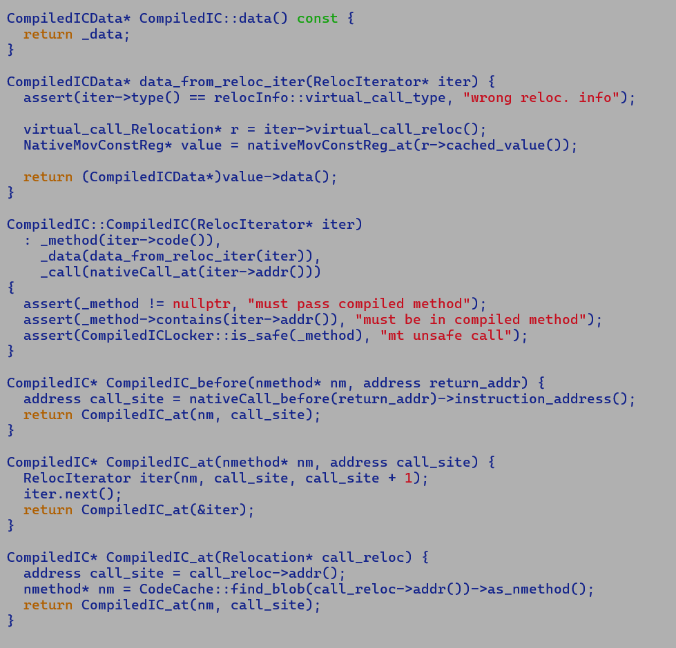

Problem

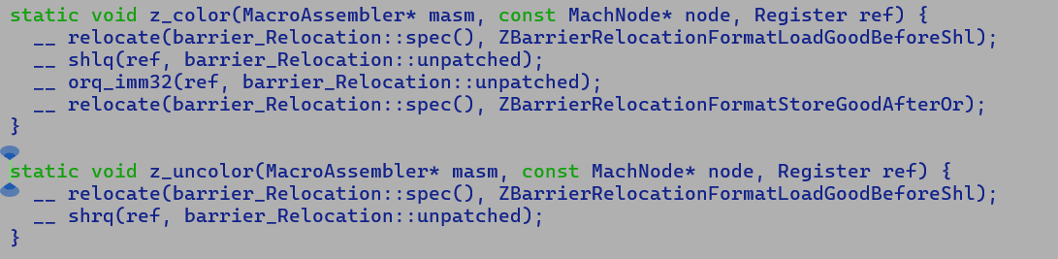

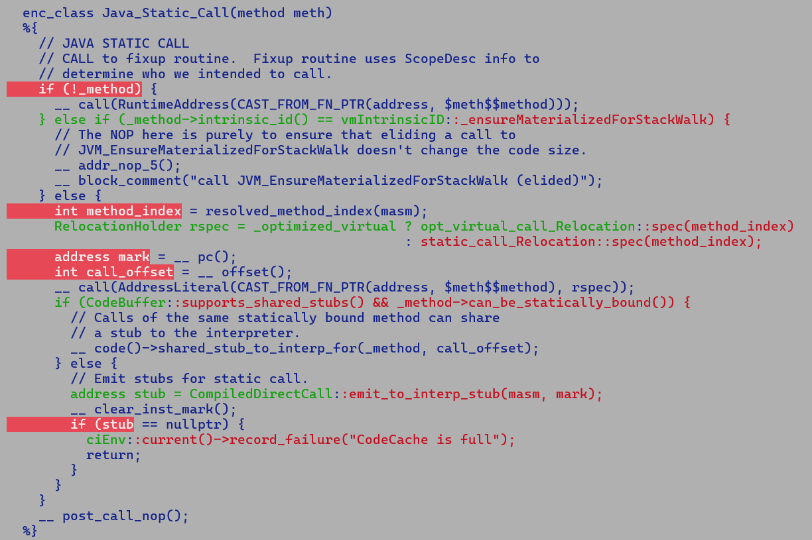



For uncolor primitive, earlier relocation was bookkeeping the starting address of shr instruction, since destination of SHR could be an EGPR, thereby adding additional byte of REX2 prefix to instruction encoding, hence a static offset of 3 used to get the to patch site of immediate operand of shrq was not accounting addition REX2 byte.

Moving the relocation beyond the shrq and then adding a -ve offset looked reasonable, but it results into assertion failure if subsequent instruction is a call with no relocation information, as marked in yellow in above the static call JIT sequence. In such a case find_stub finds an unexpected stub against the starting address of call instruction.

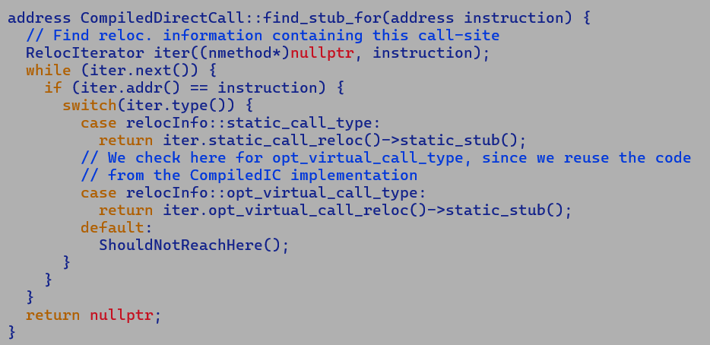

Two solutions: -

1. Dean Long's suggestion to record the patch site instead of the starting address of the instruction.

While we still need to create a relocation against the shrq instruction address starting address we can bookkeep the patch site address or offset from the start of the instruction by specializing a new relocation for ZGC barriers.

But there is complexity involved here, offset may be 3 or 4 depending on the destination register encoding and not existence of APX feature.

Thus, we will need to check the REG encoding before bookkeeping the patch site address or offset from the start of the instruction.

1. Insert a NOP after shrq instruction and continue record the relocation from end of shr instruction which is agnostic to REX/REX2 encoding and by adding a -ve offset we can get the patch site immediate operand. i.e.

shrq

relocation()

nop();

This way, even if subsequent instruction is a call without any relocation information runtime will not pick incorrect barrier relocation for it since there is a gap of one byte b/w shqr and the starting address of the callsite.

Note: Problem is mainly centred around uncolor and not color primitive as it has an OR instruction after it..

Graal Handling of ZGC Barriers: -

---------------------------------

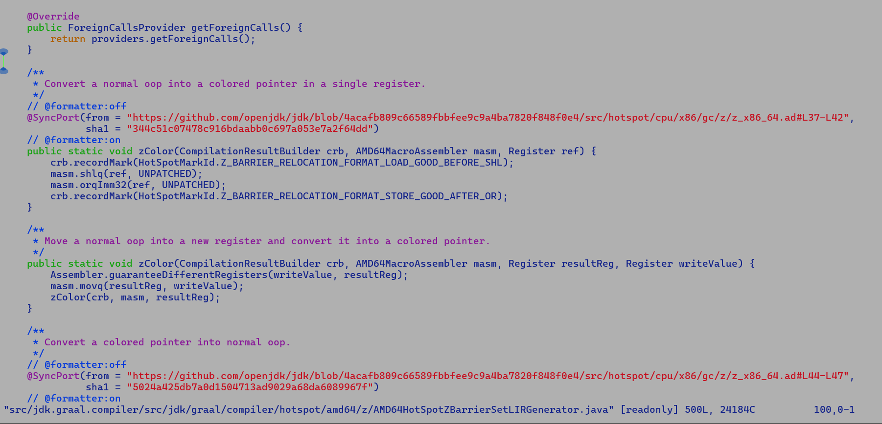

ZGC Barriers are in sync with C2 barriers. there are hard-coded checks in the Graal codebase that compute the SHA1 hash of the barrier code at a predefined changelist and compare it against the golden hash value.

Since SyncPort checks are against predefined changelist hence we will need to update the graal ZGC barrier, once we move to a recent JDK change list.

Latest APX validation with NDD demotion patch and static EGPR allocation order changes.

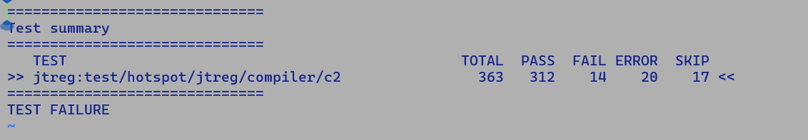

Other Failures:

# other_errors.txt

compiler/c2/Test6905845.java

compiler/c2/Test7024475.java

compiler/c2/Test7047069.java

compiler/c2/TestCastX2NotProcessedIGVN.java

compiler/c2/TestMergeStores.java#id0

compiler/c2/TestMergeStores.java#id1

compiler/c2/TestMergeStores.java#id2

compiler/c2/TestShiftRightAndAccumulate.java#id0

compiler/c2/TestShiftRightAndAccumulate.java#id1

compiler/c2/TestUnsignedByteCompare1.java

compiler/c2/cr6340864/TestIntVect.java

compiler/c2/cr6340864/TestLongVect.java

compiler/c2/irTests/TestLSMMissedEmptyLoop.java

compiler/c2/irTests/TestVectorConditionalMove.java

compiler/c2/irTests/TestVectorizationMismatchedAccess.java

compiler/c2/irTests/TestVectorizationNotRun.java

compiler/c2/irTests/scalarReplacement/AllocationMergesTests.java

compiler/c2/irTests/scalarReplacement/ScalarReplacementWithGCBarrierTests.java

All marked in YELLOW TIMEOUTs

Newfailues:

compiler/c2/Test6603011.java

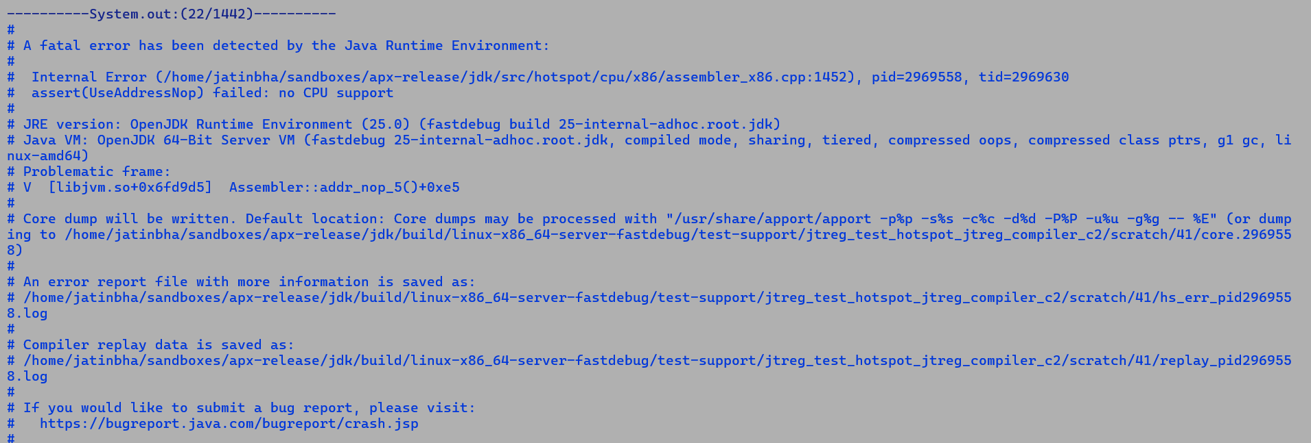

compiler/c2/Test6792161.java

* Same error as above…

compiler/c2/Test6877254.java

* Same error as above…

compiler/c2/Test7125879.java

* Same error as above…

compiler/c2/TestPrintIdealNodeCount.java

* Same error as above…

compiler/c2/TestStressRecompilation.java

* Same error as above…

compiler/c2/TestUnsignedByteCompare.java

* Same error as above…

compiler/c2/TestVerifyGraphEdges.java

* Same error as above…

compiler/c2/TestVerifyIterativeGVN.java

* Same error as above…

compiler/c2/cr6663854/Test6663854.java

* Same error as above…

compiler/c2/cr6711117/Test.java

* Same error as above…

compiler/c2/cr6712835/Test6712835.java

* Same error as above…

compiler/c2/cr6714694/Tester.java

* Same error as above…

compiler/c2/irTests/TestFPComparison.java

* Known issue fixed by 8356281

**ZGC optimization opportunity.**

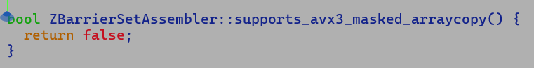

Since ZGC is a fully concurrent, generational, parallel, mark and sweep collector that runs alongside mutator threads, hence its sensitive to frequency drops due to AVX3 array copy stubs, which existed in Xeons before SPR.

We need to re-evaluate this on SPR+ systems.

* Applications using ZGC don’t benefit from AVX512 optimized reference array copy optimization.

if ((!is_oop || bs->supports_avx3_masked_arraycopy()) && VM_Version::supports_avx512vlbw() && VM_Version::supports_bmi2() && MaxVectorSize >= 32) {

return generate_conjoint_copy_avx3_masked(stub_id, entry, nooverlap_target);

}

**TestFPComparison.java failure analysis.**

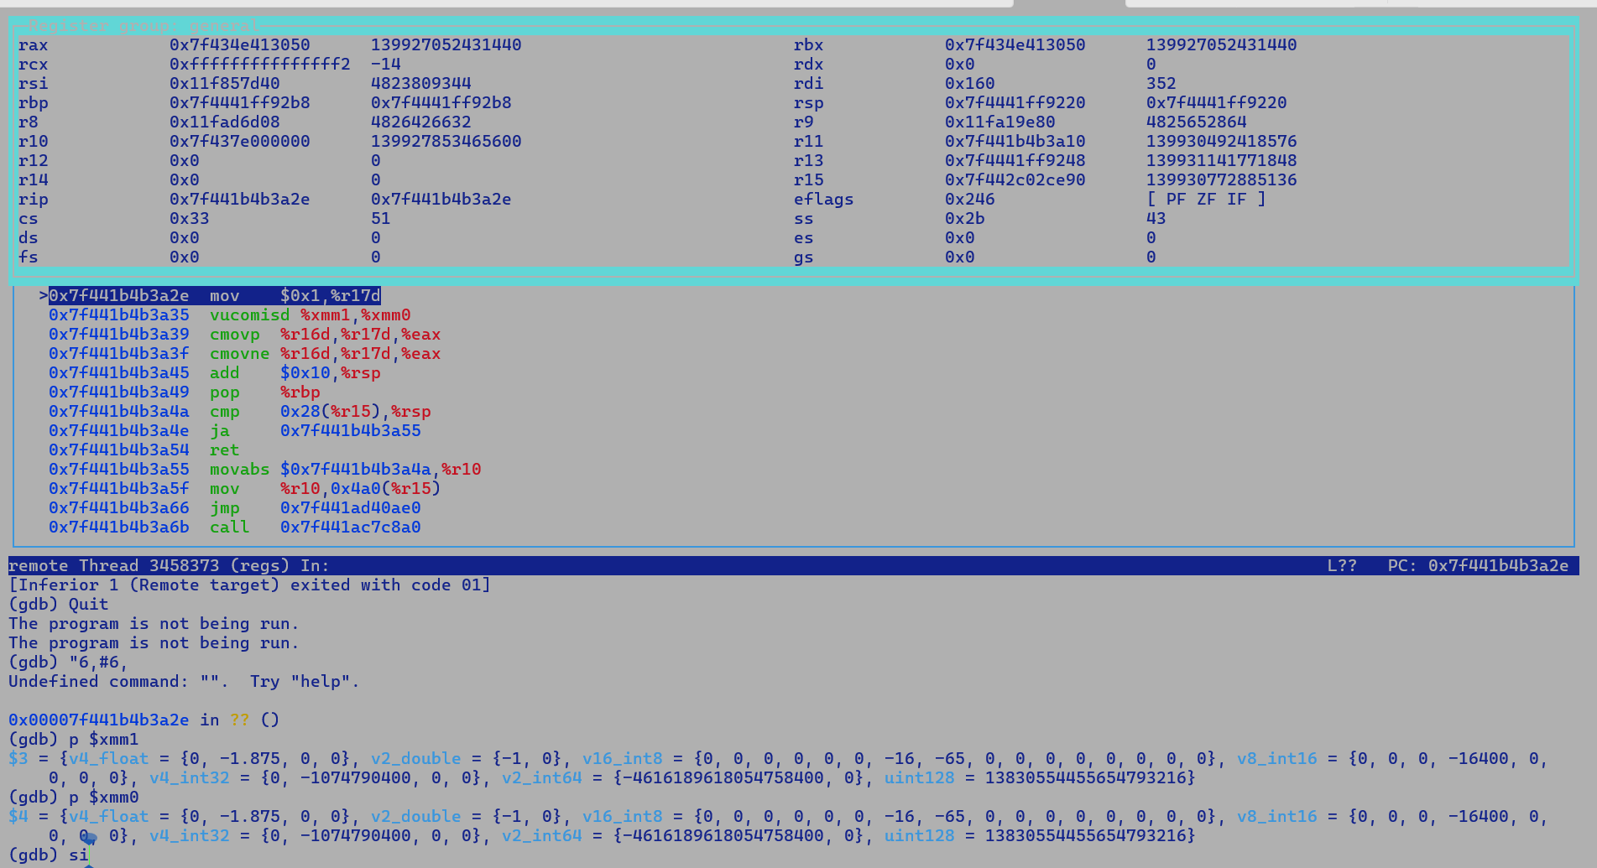

public static int micro(int a, int b, float c, float d) {

// UCF, unordered compare flag, applicable to only NE and EQ predicates,

// since NaN == NaN is false, and NaN != NaN is true.

// For other predicates like, < > unordered / ordered comparison

// does not effect the flag consumer, ie. 2.0f > 2.0f will set

// same flags as NaN > NaN.

// While we need special fixups for predicates where unordered and

// ordered comparisons effect flags differently, i.e.

// NaN == NaN is false and while 2.0f == 2.0f is true.

// return c > d ? a : b;

/*

10 cmpF_cc_reg_CF === _ 12 13 [[ 11 ]]

11 cmovL_regU === _ 10 14 15 [[ 2 ]] be !jvms: cmove_with_fixup::micro @ bci:13 (line 13)

*/

// return c != d ? a : b;

/*

10 cmpF_cc_reg_CF === _ 11 12 [[ 9 ]]

9 cmovL_regUCF2_ne === _ 10 13 14 [[ 2 ]] ne !jvms: cmove_with_fixup::micro @ bci:13 (line 18)

instruct cmovL_regUCF2_ne(cmpOpUCF2 cop, rFlagsRegUCF cr, rRegL dst, rRegL src) %{

predicate(!UseAPX && n->in(1)->in(1)->as_Bool()->_test._test == BoolTest::ne);

match(Set dst (CMoveL (Binary cop cr) (Binary dst src)));

ins_cost(200); // XXX

format %{ "cmovpq $dst, $src\n\t"

"cmovneq $dst, $src" %}

ins_encode %{

__ cmovq(Assembler::parity, $dst$$Register, $src$$Register);

__ cmovq(Assembler::notEqual, $dst$$Register, $src$$Register);

%}

ins_pipe(pipe_cmov_reg);

%}

For != comparison, since NaN != NaN is true hence to maintain sacrosanctity

of flags as seen by consumer we first emit a cmove for parity flag as

ordered comparison would have generated a false value here, if parity flag

is not set this mean comparison was ordered and hence next cmove is based

on NE flag settings.

*/

//return c == d ? a : b;

/*

9 cmovL_regUCF2_ne === _ 10 13 14 [[ 2 ]] ne !jvms: cmove_with_fixup::micro @ bci:13 (line 43)

10 cmpF_cc_reg_CF === _ 11 12 [[ 9 ]]

for <= operator, NaN <= NaN is indeed false and we don't need any special fixup like == or !=

where result are flipped and counter intuitive i.e. NaN == NaN is false and NaN != NaN is true.

UNORDERED: ZF,PF,CF := 111;

GREATER_THAN: ZF,PF,CF := 000;

LESS_THAN: ZF,PF,CF := 001;

EQUAL: ZF,PF,CF := 100;

To execute a cmove, predicate must be true, for equality operator ==, since NaN == NaN is false

hence predicate will be false for these values and conditional move should not be executed

We cannot check for noParity to detect this condition as parity is not set for GT, LT and EQ

case also.

Hence, the following is incorrect floating equality comparison logic, since for non-equal non-nan

Values we may incorrectly update dst.

if (parity == false) {

dst = src

} else if (zf == true) {

dst = dst

}

Equality comparison involving at least one NaN will always be false irrespective of operand flipping.

Similarly, equality comparison involving non NAN equal values will always be true irrespective of operand flipping.

Instruction sequence of following existing patten will enforce cmove when parity flag is set, i.e. if any

of the operand is a NaN value, which is incorrect.

// Since (x == y) == !(x != y), we can flip the sense of the test by flipping the

// inputs of the CMove

instruct cmovI_regUCF2_eq(cmpOpUCF2 cop, rFlagsRegUCF cr, rRegI dst, rRegI src) %{

predicate(!UseAPX && n->in(1)->in(1)->as_Bool()->_test._test == BoolTest::eq);

match(Set dst (CMoveI (Binary cop cr) (Binary src dst)));

ins_cost(200); // XXX

format %{ "cmovpl $dst, $src\n\t"

"cmovnel $dst, $src" %}

ins_encode %{

__ cmovl(Assembler::parity, $dst$$Register, $src$$Register);

__ cmovl(Assembler::notEqual, $dst$$Register, $src$$Register);

%}

ins_pipe(pipe_cmov_reg);

%}

Because we always flip the comparison predicate to a canonical form during parsing, hence eq becomes neq.

Negating the predicate involves flipping the true and false control path edges since condition is now

reversed.

Hence following transformations are equivalent.

if (c == d) { fcmp results into 0 , ifne false_path, compiler use either fcmpg or fcmpl here if subsiquent

true_path instruction is ifne

} else {

false_path

}

=====

if (c != d) { we choose the true path if fcmp results in a non zero results, here if c == d then fcmp

false_path results into zero value, if c < d then -1 otherwise 1 i.e c > d, we take the true path

} else { if c > d or c < d, NaN != NaN is true and NaN != non-NAN is also true, ie. result of fcmp is zero

true_path so with fcmpl/g and ifne we will always take a false path for unordered and ordered comparison

} failure, in case of non-equality condition an unordered comparison always results into a true value

i.e.

if PARITY flag is set then conditional cmove based on non-equality check should always execute.

However, to exeucte a conditional move for non-equality comparison of non-NAN operand

ZERO_FLAG must not be set.

This explanation goes in line with following JIT sequence emitted for cmovL_regUCF2_ne matcher pattern.

__ cmovq(Assembler::parity, $dst$$Register, $src$$Register);

__ cmovq(Assembler::notEqual, $dst$$Register, $src$$Register);

For, equality check, we consider following premises / lemmas

1) NaN == NaN is false

2) non-NAN == NaN is false

3) non-NAN == non-NAN if true in case both operands are equal else false.

thus,

fcmp F1 F2

- 0 if both the operands are non-NAN values and are equal.

- 1/-1 if F1 > F2 or F1 < F2, or one of operand is NaN then

fcmpl will results into -1 and fcmpg will result into 1.

fcmpg F1 F2

ifne false_path

true_path:

...

goto exit_path

false_path:

...

exit_path:

Thus a conditional move which is based on equality comparison should execute only

iff both the operands are non-values and are exactly equal.

So following JIT sequence emitted for cmovI_regUCF2_eq matcher pattern is incorrect

__ cmovl(Assembler::parity, $dst$$Register, $src$$Register);

__ cmovl(Assembler::notEqual, $dst$$Register, $src$$Register);

Since PARITY flag is set if either of the operand is NaN value.

As per following comment on the eq matcher pattern

// Since (x == y) == !(x != y), we can flip the sense of the test by flipping the

If we flip the inputs we have following cases

fcmp F1 F2 0 if F1 == F2, 1 if F1 > F2 and -1 if F1 < F2

Thus, if F1 and F2 are equal then flipping operands does not disturb the semantics.

if F1 > F2, then for equality comparions, results is 1 and flipped operand will return a -1

Thus, following bytecode is agnostic to operand flipping, since if F1 != F2 then result will be

1 or -1 and in both the cases we choose the false_path.

fcmp F1 F2

ifne false_path

true_path:

...

goto exit_path

false_path:

...

exit_path:

*/

return c == d ? a : b;

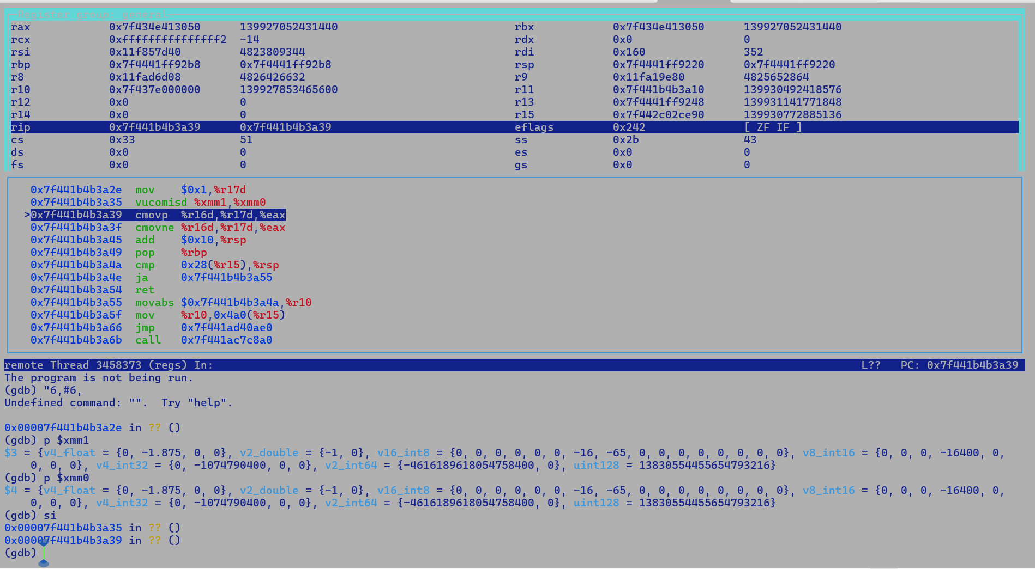



For APX extended CMOVE

If PREDICATE is TRUE

DST = SRC2

Else

DST = SRC1

For non-APX CMOVe

DST = DST

If PREDICATE is TRUE

DST = SRC

Because the instruction sequence

at compiler.lib.ir_framework.test.TestVM.main(TestVM.java:168)

Caused by: java.lang.reflect.InvocationTargetException

at java.base/jdk.internal.reflect.DirectMethodHandleAccessor.invoke(DirectMethodHandleAccessor.java:119)

at java.base/java.lang.reflect.Method.invoke(Method.java:565)

at compiler.lib.ir_framework.test.CustomRunTest.invokeTest(CustomRunTest.java:159)

... 5 more

Caused by: java.lang.RuntimeException: x = -1.0 y = NaN expected: 1 but was: 0

at jdk.test.lib.Asserts.fail(Asserts.java:715)

at jdk.test.lib.Asserts.assertEquals(Asserts.java:208)

at compiler.c2.irTests.TestFPComparison.runTests(TestFPComparison.java:283)

at java.base/jdk.internal.reflect.DirectMethodHandleAccessor.invoke(DirectMethodHandleAccessor.java:104)

... 7 more

For two_add instruction if dst is used as a source in the matcher pattern then allocator emits a source preserving copyspill prior to the cmove. This is needed to preserve the source value if it has live range beyond the cmove instruction other wise dst update may kill source value.

Correct logic for eq base cmove operation

For, equality check, we consider the following premises/lemmas

1) NaN == NaN is false

2) non-NAN == NaN is false

3) non-NAN == non-NAN if true in case both operands are equal else false.

Thus,

fcmp F1 F2

- 0 if both the operands are non-NAN values and are equal.

- 1/-1 if F1 > F2 or F1 < F2, or one of operand is NaN then

fcmpl will results into -1 and fcmpg will result into 1.

fcmpg F1 F2

ifne false_path

true_path:

...

goto exit_path

false_path:

...

exit_path:

dst = CMove SRC if noParaity and true equality bit is set i.e. none of the operands is a NaN value.

No PF and ZF.

For non-equality-based CMove

Since NaN != Nan and Nan != Non-NaN is true hence with NAN input we always take a true path.

So Dst = CMove SRC if parity or no ZF flag i.e. NE.

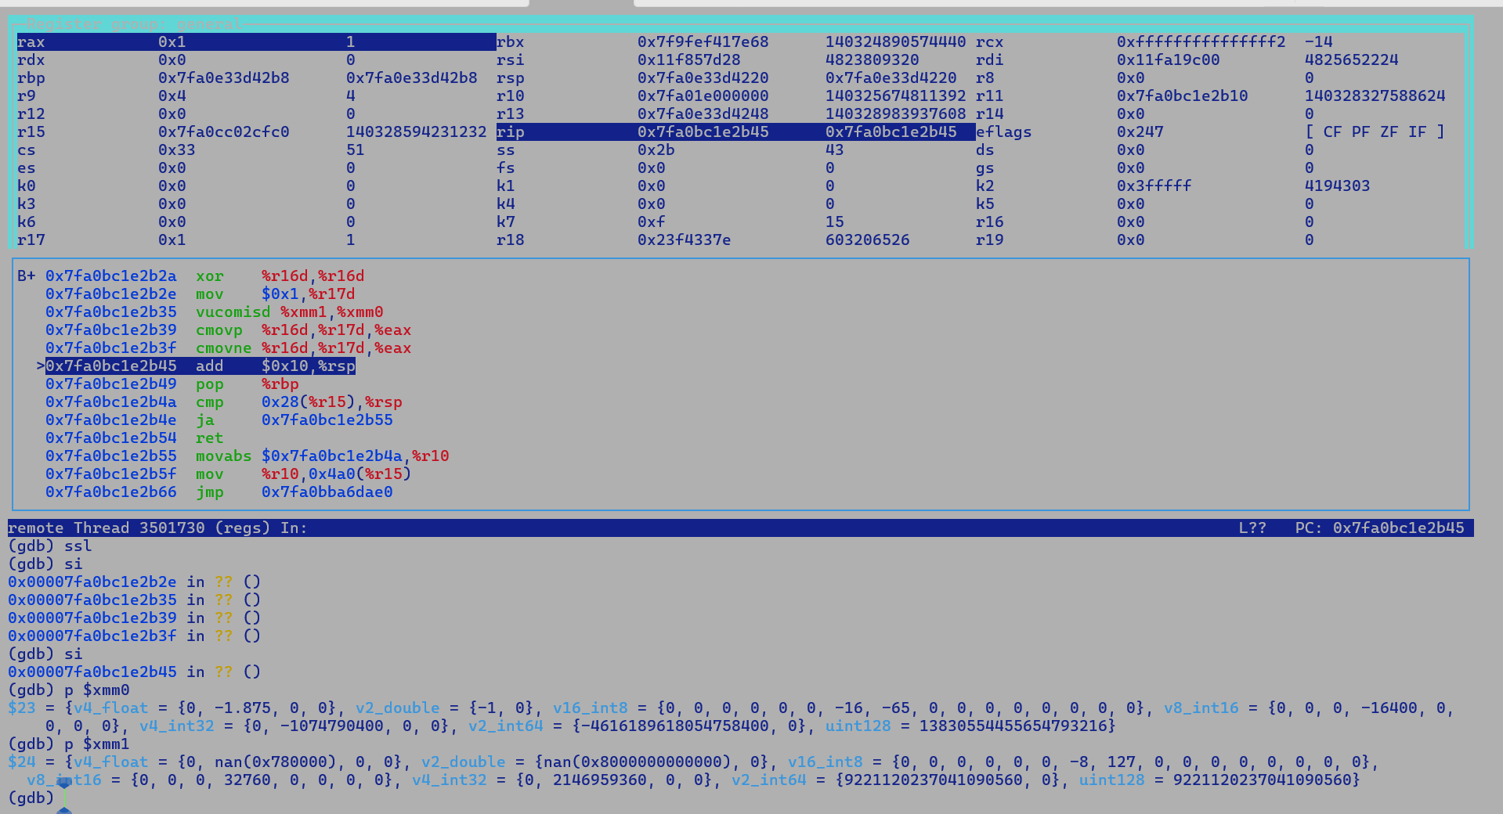

Xmm1 = -1

Xmm0 = NaN

Nan != -1 is true i.e. fcmp returns a 0 and ZF flag is set, also PF flag is set since its an unordered compare.

Non-Equality Comparison F1 != F2

Non-APX

-------

CMOVE DST , SRC if FLAG is PF

CMOVE DST , SRC if FLAG is NE

With APX

CMOVE DST, DEF_DST, SRC if FLAG is PF

CMOVE DST, DEF_DST, SRC if FLAT is NE

Root cause:

So in back-to-back CMOVEs we end up updating the DST with DEF_DST if ZF is set since NE is false and not retain the DST value updated by prior CMOVE, this is not the case with Non-APX case since second DST is not executed is ZF is set and DST retains the value set by prior CMOVE.

Equality Comparison F1 == F2 => ! (F1 != F2)

Non-APX

-------

Flip the inputs.

CMOVE DST, SRC, PF

CMOVE DST, SRC, NE

Since equality comparison returns a true i.e. a zero value only when both the operands are non-NAN values and are truly equal.

So Nan == -1 if false ie. Result should be a non-zero value, in other words, if it’s an unordered comparison then we return a non-zero value.

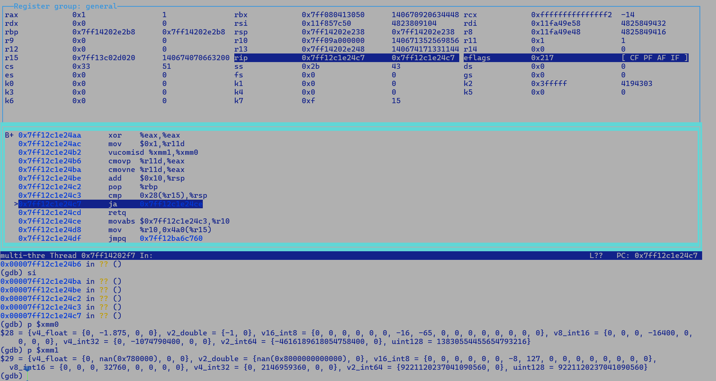

FCMP f1 f2

* Zero if f1 == f2
* 1 if f1 > f2
* -1 if f1 < f2

REX2 vs REX encode cmoves

4: d5 98 44 c1 cmove %r17,%rax

* Prefix d5 98
* Opcode 44
* ModRM c1

8: 49 0f 44 c3 cmove %r11,%rax

* Prefix (REX) 49
* Primary two byte opcode (Map1) sub-prefix 0f 44
* Modrm c3

4: d5 90 44 c1 cmove %r17d,%eax

8: 0f 44 c2 cmove %edx,%eax

**APX Validation – NDD demotion patch**

Functional JTREG:-

Test Dir : compiler/c2

# newfailures.txt

compiler/c2/Test6603011.java

compiler/c2/Test6792161.java

compiler/c2/Test6877254.java

compiler/c2/Test7125879.java

compiler/c2/TestPrintIdealNodeCount.java

compiler/c2/TestStressRecompilation.java

compiler/c2/TestUnsignedByteCompare.java

compiler/c2/TestVerifyGraphEdges.java

compiler/c2/TestVerifyIterativeGVN.java

compiler/c2/cr6663854/Test6663854.java

compiler/c2/cr6711117/Test.java

compiler/c2/cr6712835/Test6712835.java

compiler/c2/cr6714694/Tester.java

# other_errors.txt

compiler/c2/Test6880034.java

compiler/c2/Test6885584.java

compiler/c2/Test6905845.java

compiler/c2/TestMergeStores.java#id0

compiler/c2/TestMergeStores.java#id1

compiler/c2/TestMergeStores.java#id2

compiler/c2/TestShiftRightAndAccumulate.java#id0

compiler/c2/TestShiftRightAndAccumulate.java#id1

compiler/c2/TestUnsignedByteCompare1.java

Root cause:

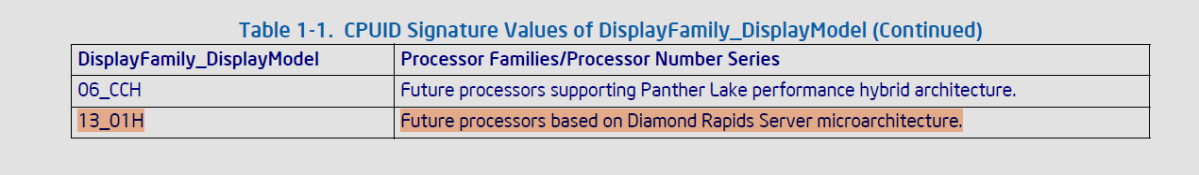

Latest SDE 9.55 has updated CPUID family for upcoming Xeons, hence UseAddressNop enabling check needs extension

GTEST – X86

* PASS

Code review suggestions:-

* NDD
  + Supported through a new matcher pattern with additional NDD operand
    - This is correct as each pattern is translated into a MachNode and pattern argument are translated into schedulable MachOpers.
    - Do we have a quick check to identify a NDD MachNode?
      * This can be done through ideal_Opcode based check.
      * We can extend NodeFlags with two additional flags
        + Flag_is_ndd
        + Flag_is_noflag
      * Extend AD syntax with a new pragma
        + pattern_flags(Flag_is_ndd);
        + pattern_flags(Flag_is_noflag)
      * Emit additional set_flag() calls in MachNodeGenerator.

We already have such infra in place check ***addI_rReg_mem***

flag(PD::Flag_sets_overflow_flag, PD::Flag_sets_sign_flag, PD::Flag_sets_zero_flag, PD::Flag_sets_carry_flag, PD::Flag_sets_parity_flag);

**MachNodeGenerator:-**



* + - The main advantage of this is to support future NF_ND to ND and NonNF to NF demotions. Otherwise, it will complicate the assembler if we handle special cases.
      * Once the flags are annotated to the MachNode, it will also help us in handling these demotions in a separate peephole pass.
* 11: 62 f4 fc 18 03 43 10 add 0x10(%rbx),%rax,%rax
* 18: 62 f4 fc 18 01 43 10 add %rax,0x10(%rbx),%rax
* 1f: 48 03 43 10 add 0x10(%rbx),%rax
  + Being a commutative operation, both the above instructions

are demotable to add 0x10(%rbx), %rax, but there is a change in instruction opcode for instruction 18 from 01 to 03.

* + This will not be tractable currently, since opcode and prefix emission is completely decoupled.
    - One suggestion is to canonicalize commutative IR such that memory operand is always the second operand, ADLC automatically handles them in DFA.

Demotion Testing

* None of the tests which I ran even the basic ones are showing EVEX to legacy demotions.
* After inclusion of second operand we may see a true effect..

Note from LLVM compressEVEXEncoding pass

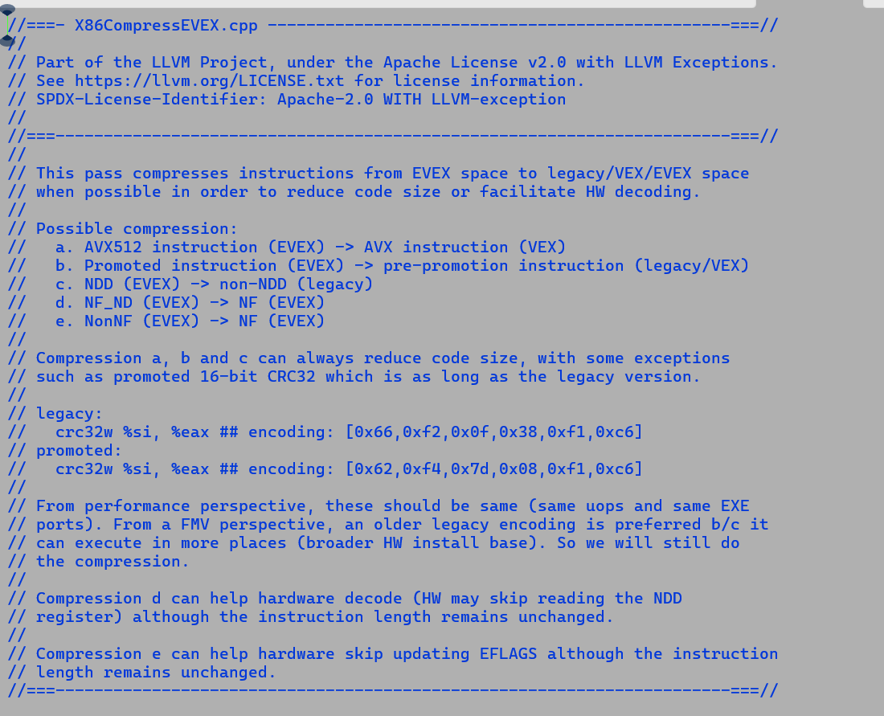

[Verified Entry Point]

# {method} {0x00007f3cd84003a0} 'micro' '(III[I)I' in 'test_add_demotion'

# parm0: rsi = int

# parm1: rdx = int

# parm2: rcx = int

# parm3: r8:r8 = '[I'

#

# int ( int, int, int, int[int:>=0] (java/lang/Cloneable,java/io/Serializable):exact * )

#

000 N1: # out( B1 ) <- in( B5 B4 B3 ) Freq: 1

000 B1: # out( B5 B2 ) <- BLOCK HEAD IS JUNK Freq: 1

000 # stack bang (152 bytes)

pushq rbp # Save rbp

subq rsp, #32 # Create frame

01a movl R17, [R8 + #12 (8-bit)] # range

01f NullCheck R8

01f B2: # out( B4 B3 ) <- in( B1 ) Freq: 0.999999

01f eaddl R16, RSI, RDX # int ndd

025 eaddl RBP, RCX, R16 # int ndd

02b testl R17, R17 # unsigned

02f jbe,us B4 P=0.000001 C=-1.000000

031 B3: # out( N1 ) <- in( B2 ) Freq: 0.999998

031 eaddl RAX, RBP, [R8 + #16 (8-bit)] # int ndd

(gdb) p nm->print()

$1 = void

(gdb) disassemble 0x00007f2896570e00,+1000

Dump of assembler code from 0x7f2896570e00 to 0x7f28965711e8:

0x00007f2896570e00: mov %eax,-0x18000(%rsp)

0x00007f2896570e07: push %rbp

0x00007f2896570e08: sub $0x20,%rsp

0x00007f2896570e0c: cmpl $0x0,0x20(%r15)

0x00007f2896570e14: jne 0x7f2896570eba

0x00007f2896570e1a: mov 0xc(%r8),%r17d

0x00007f2896570e1f: add %edx,%esi,%r16d // NDD

0x00007f2896570e25: add %r16d,%ecx,%r18d // NDD

0x00007f2896570e2b: test %r17d,%r17d

0x00007f2896570e2f: jbe 0x7f2896570e4e

0x00007f2896570e31: mov %r18d,%r17d // copyspill prior to two address instruction

0x00007f2896570e35: add 0x10(%r8),%r17d

-instruct addI_rReg_rReg_mem_ndd(rRegI dst, rRegI src1, memory src2, rFlagsReg cr)

+instruct addI_rReg_rReg_mem_ndd(r17_RegI dst, r17_RegI src1, memory src2, rFlagsReg cr)

47 Region === 47 8 [[ 47 25 ]]

R16 31 addI_rReg_ndd === _ 35 36 [[ 32 30 ]]

RFLAGS 32 MachProj === 31 [[ ]] #1

R18 30 addI_rReg_ndd === _ 34 31 [[ 33 56 53 ]] !jvms: test_add_demotion::micro @ bci:4 (line 9)

RFLAGS 33 MachProj === 30 [[ ]] #1

RFLAGS 26 testU_reg === _ 27 [[ 25 ]] #0/0x00000000

25 jmpConU_short === 47 26 [[ 38 24 ]] P=0.000001, C=-1.000000

BB#003:

48 Region === 48 38 [[ 48 37 39 ]]

R17 53 BoundSpillCopy === _ 30 [[ 39 ]]

R17 39 addI_rReg_rReg_mem_ndd_0 === 48 15 13 53 [[ 40 37 55 ]] #16/0x0000000000000010 !jvms: test_add_demotion::micro @ bci:8 (line 9)

#

# int ( int, int, int, int[int:>=0] (java/lang/Cloneable,java/io/Serializable):exact * )

#

000 N1: # out( B1 ) <- in( B5 B4 B3 ) Freq: 1

000 B1: # out( B5 B2 ) <- BLOCK HEAD IS JUNK Freq: 1

000 # stack bang (152 bytes)

pushq rbp # Save rbp

subq rsp, #32 # Create frame

01a movl R17, [R8 + #12 (8-bit)] # range

01f NullCheck R8

01f B2: # out( B4 B3 ) <- in( B1 ) Freq: 0.999999

01f eaddl R16, RSI, RDX # int ndd

025 eaddl R18, RCX, R16 # int ndd

02b testl R17, R17 # unsigned // R18 is live beyond ADD with memory, intersects with R17.

02f jbe,us B4 P=0.000001 C=-1.000000

031 B3: # out( N1 ) <- in( B2 ) Freq: 0.999998

031 movl R17, R18 # spill

035 eaddl R17, R17, [R8 + #16 (8-bit)] # int ndd

03a movl RAX, R17 # spill

03e addq rsp, 32 # Destroy frame

popq rbp

cmpq rsp, poll_offset[r15_thread]

ja #safepoint_stub # Safepoint: poll for GC

04d ret

04e B4: # out( N1 ) <- in( B2 ) Freq: 9.99999e-07

04e movl RSI, #-28 # int

053 movq RBP, R8 # spill

056 movl [rsp + #0], R18 # spill

05b call,static wrapper for: uncommon_trap(reason='range_check' action='make_not_entrant' debug_id='0')

# test_add_demotion::micro @ bci:7 (line 9) L[0]=_ L[1]=_ L[2]=_ L[3]=_ STK[0]=rsp + #0 STK[1]=RBP STK[2]=#0

# OopMap {rbp=Oop off=96/0x60}

068 stop # ShouldNotReachHere

07c B5: # out( N1 ) <- in( B1 ) Freq: 1.01328e-06

07c movl RSI, #-10 # int

nop # 2 bytes pad for loops and calls

083 call,static wrapper for: uncommon_trap(reason='null_check' action='maybe_recompile' debug_id='0')

# test_add_demotion::micro @ bci:7 (line 9) L[0]=_ L[1]=_ L[2]=_ L[3]=_ STK[0]=_ STK[1]=#null STK[2]=#0

# OopMap {off=136/0x88}

090 stop # ShouldNotReachHere

Latest Validation: NDD Demotion patch.

**# other_errors.txt**

**compiler/c2/Test6866651.java**

**compiler/c2/TestLWLockingCodeGen.java**

**compiler/c2/TestMergeStores.java#id0**

**compiler/c2/TestMergeStores.java#id1**

**a**

**compiler/c2/TestShiftRightAndAccumulate.java#id0**

**compiler/c2/TestShiftRightAndAccumulate.java#id1**

**compiler/c2/TestUnsignedByteCompare1.java**

**All timeouts, no newfailure.txt**

**Q. Are there instruction in REX / REX2 space whose opcode changes when promoted to Extended EVEX space for NDD ?**

**A. Yes, shld , shrl have opcode AC, A4 in REX and REX2, while their EEVEX counterparts have a different opcode 2C and 24.**

[**8357267**](https://bugs.openjdk.org/browse/JDK-8357267)**: ZGC: Handle APX EGPRs spilling in ZRuntimeCallSpill using PPX instructions**

**Just saving an restoration of legacy caller saved GPRs resulting in following crash in ZGC**

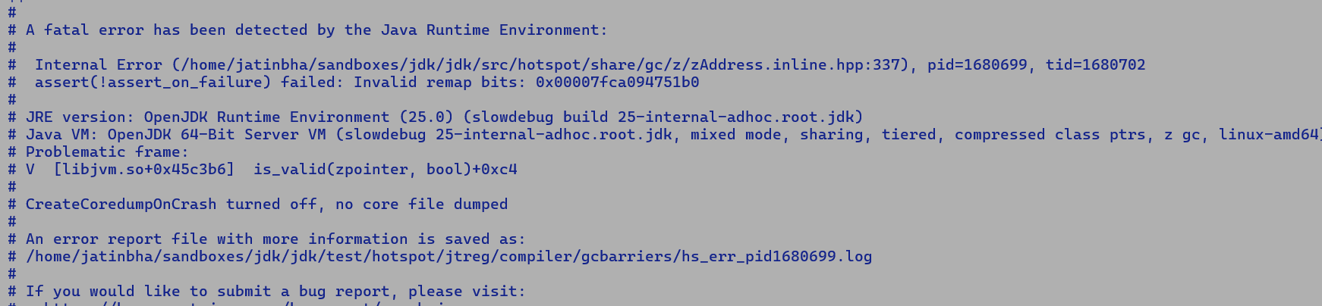

**We are currently not touching 16 new EGPRs.**

**Root cause: -**

**ZRuntimeCallSpill pushes are agnostic to live register and push all the caller-saved registers on the stack, it then moves the src value to carg, thus any modification to src will pollute the input argument of barrier which is why in some case zPoint value is not a valid oop refence.**

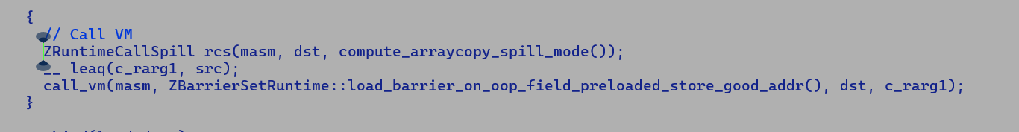

**Root cause of failing AndnTestI.java**

**Non-APX**

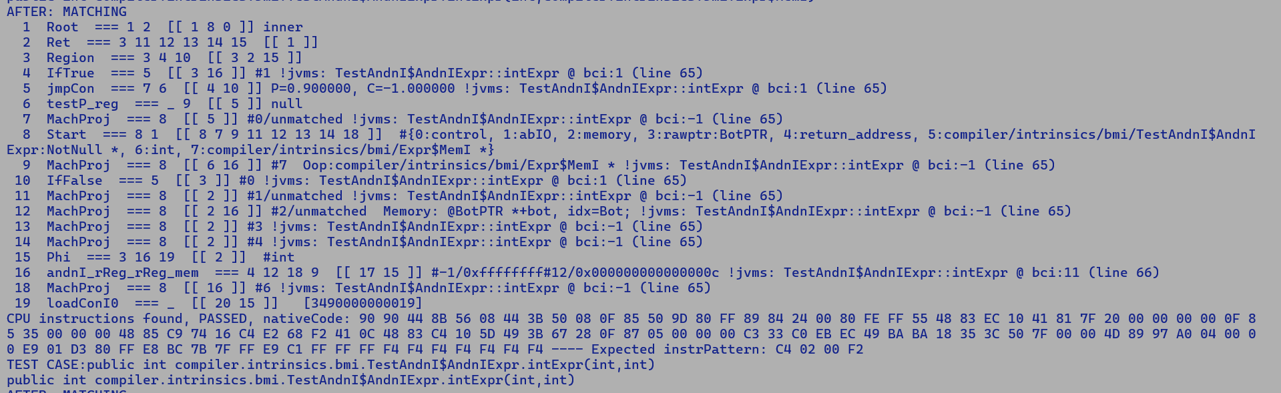



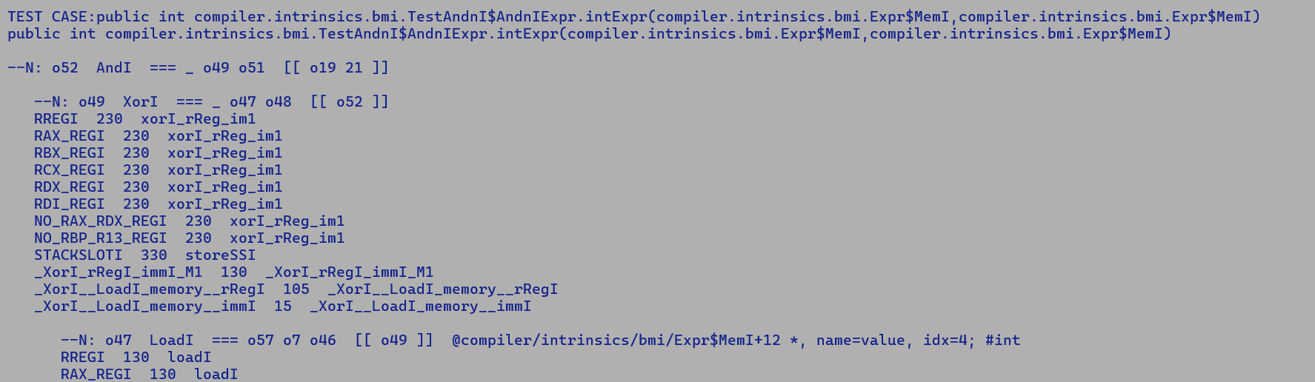

**APX**

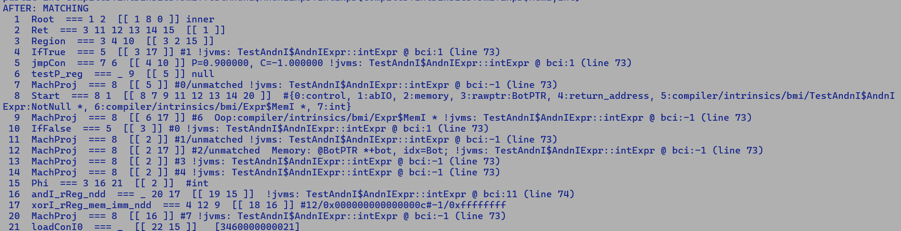



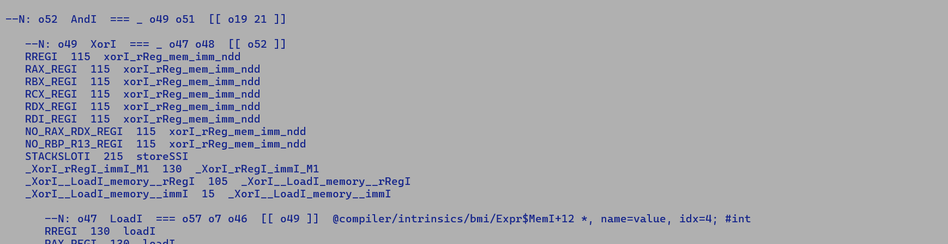

**Cost of patterns.**

**xorI_rReg_rReg_mem_ndd -> 255**

**xorI_rReg_mem_imm_ndd -> 115**

**xorI_rReg_im1_ndd -> 230**

**Latest Validation Status of VectorAPI test.**

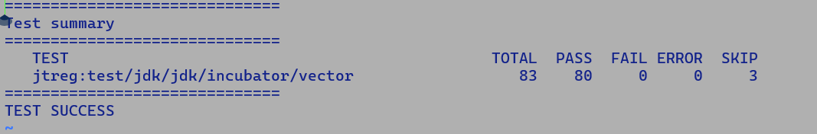

**Code Buffer overflow with latest SDE 9.57:-**

**SDE 9.54**

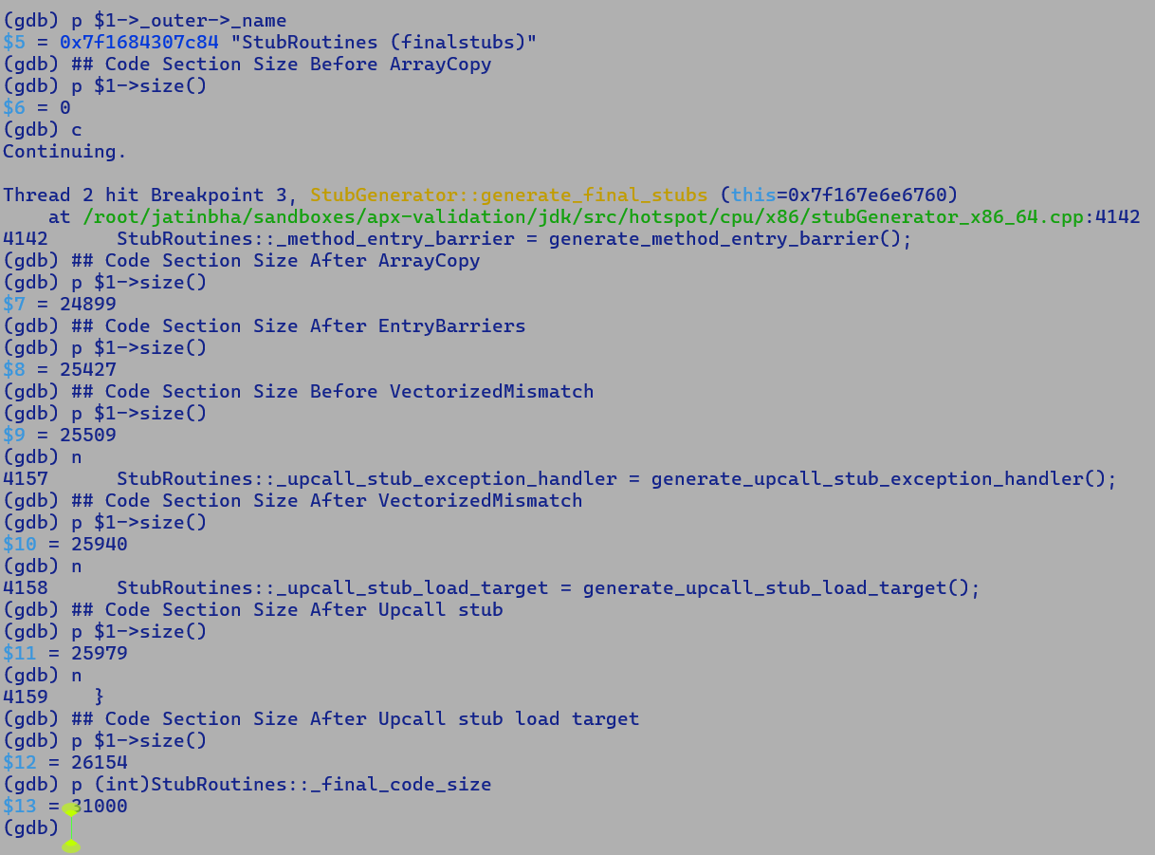

**SDE 9.57**

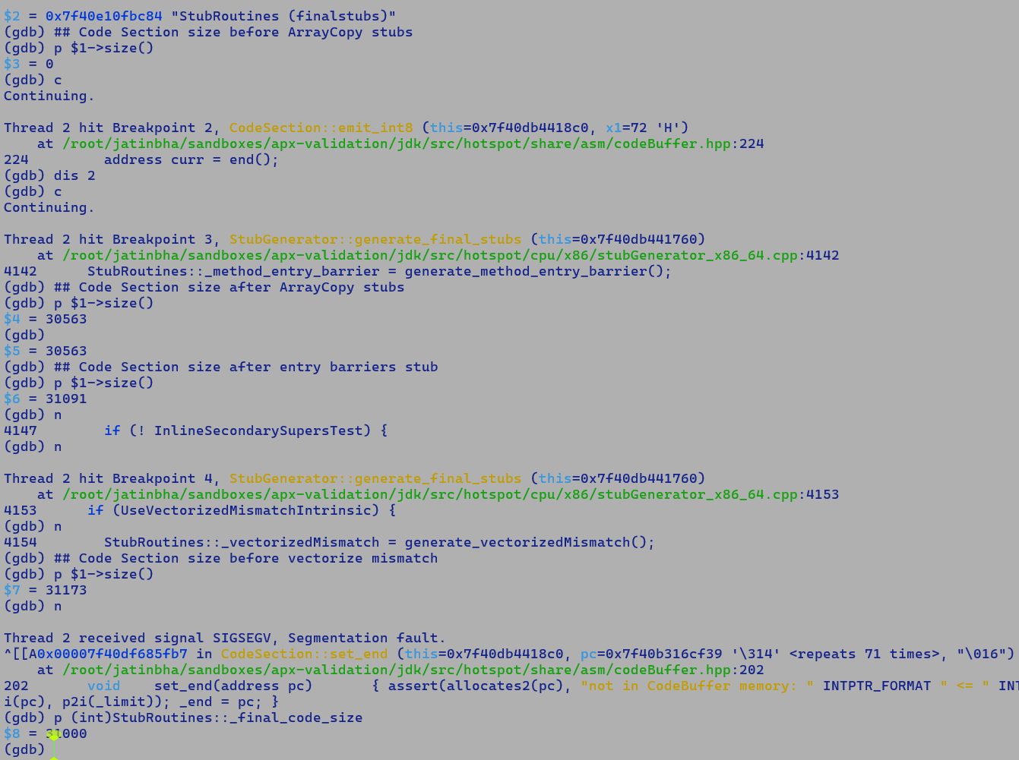

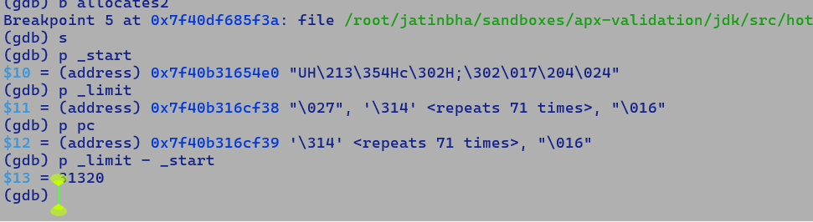

**Probable cause:**

* **GC Barries emitted around reference array copies are increasing the size of array copy stubs…**

**9.54**

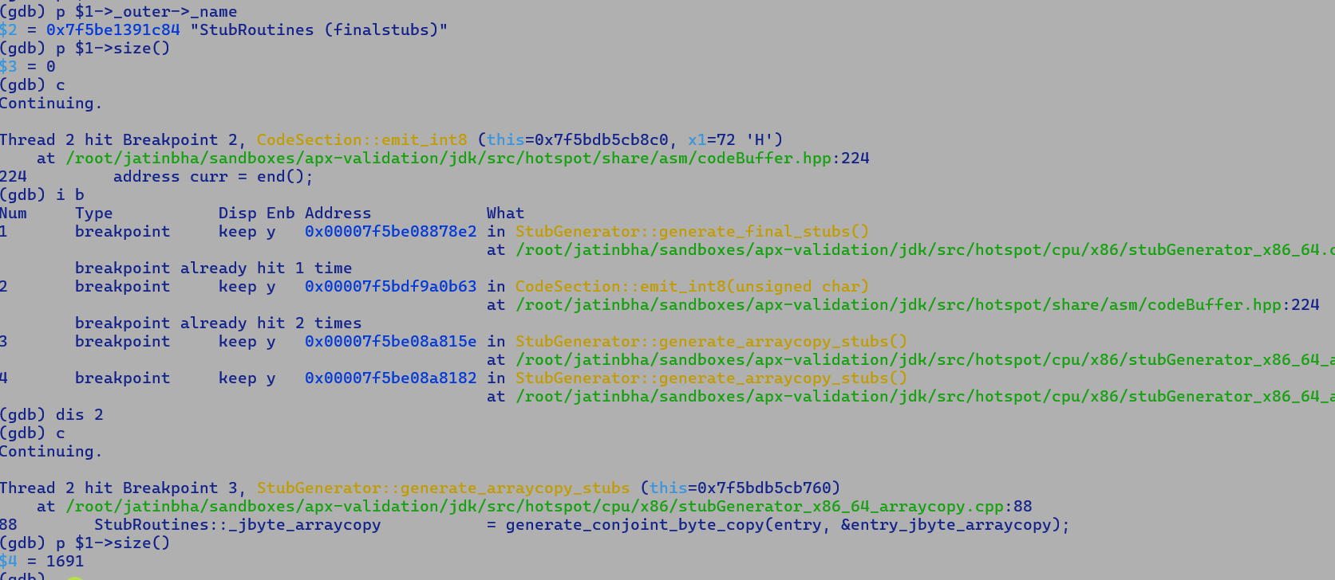

**9.57**

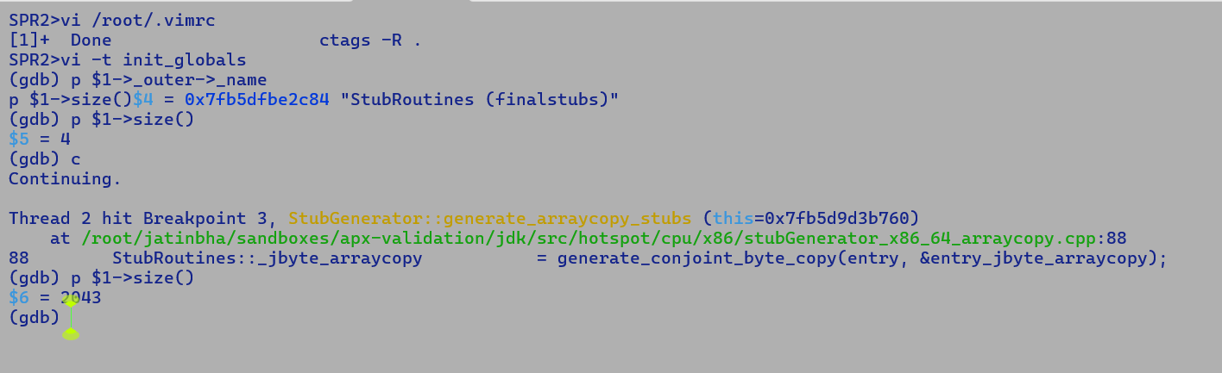

**15/6/2025**

**Latest APX validation status:-**

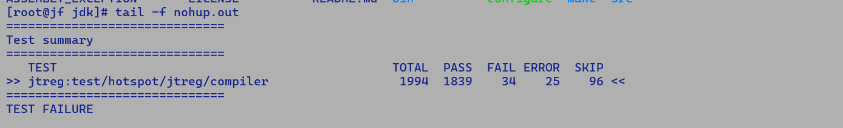

**# newfailures.txt**

**compiler/blackhole/BlackholeIntrinsicTest.java**

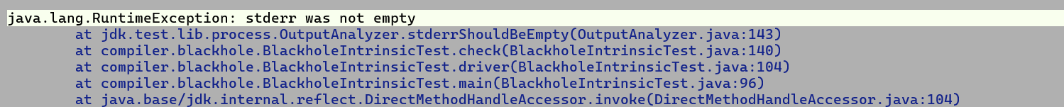

**SDE output emitted on STDERR is causing failure.**

**compiler/c2/irTests/ProfileAtTypeCheck.java**

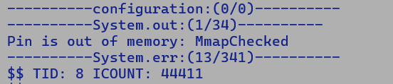

**compiler/c2/irTests/SubINodeIdealizationTests.java**

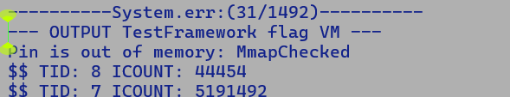

**compiler/c2/irTests/TestCountedLoopSafepoint.java**

**compiler/c2/irTests/TestDebugInfo.java**

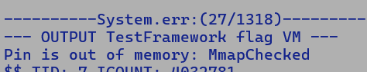

**compiler/c2/irTests/TestGetAndAdd.java**

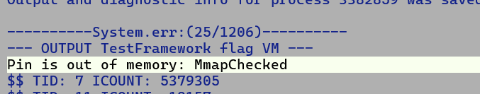

**compiler/c2/irTests/TestScalarReplacement.java**



**compiler/intrinsics/klass/CastNullCheckDroppingsTest.java**

**compiler/jvmci/TestInvalidJVMCIOption.java**



**SDE output emitted on STDERR is causing failure.**

**Timeouts**

**compiler/loopopts/superword/TestDependencyOffsets.java#avx1-v016-A**

**compiler/loopopts/superword/TestDependencyOffsets.java#avx1-v016-U**

**compiler/loopopts/superword/TestDependencyOffsets.java#avx1-v032-A**

**compiler/loopopts/superword/TestDependencyOffsets.java#avx1-v032-U**

**compiler/loopopts/superword/TestDependencyOffsets.java#avx2-v016-A**

**compiler/loopopts/superword/TestDependencyOffsets.java#avx2-v016-U**

**compiler/loopopts/superword/TestDependencyOffsets.java#avx2-v032-A**

**compiler/loopopts/superword/TestDependencyOffsets.java#avx2-v032-U**

**compiler/loopopts/superword/TestDependencyOffsets.java#avx512-v032-A**

**compiler/loopopts/superword/TestDependencyOffsets.java#avx512-v032-U**

**compiler/loopopts/superword/TestDependencyOffsets.java#avx512-v064-A**

**compiler/loopopts/superword/TestDependencyOffsets.java#avx512-v064-U**

**compiler/loopopts/superword/TestDependencyOffsets.java#avx512bw-v032-A**

**compiler/loopopts/superword/TestDependencyOffsets.java#avx512bw-v032-U**

**compiler/loopopts/superword/TestDependencyOffsets.java#avx512bw-v064-A**

**compiler/loopopts/superword/TestDependencyOffsets.java#avx512bw-v064-U**

**compiler/loopopts/superword/TestDependencyOffsets.java#sse4-v004-A**

**compiler/loopopts/superword/TestDependencyOffsets.java#sse4-v004-U**

**compiler/loopopts/superword/TestDependencyOffsets.java#sse4-v008-A**

**compiler/loopopts/superword/TestDependencyOffsets.java#sse4-v008-U**

**compiler/loopopts/superword/TestDependencyOffsets.java#sse4-v016-A**

**compiler/loopopts/superword/TestDependencyOffsets.java#sse4-v016-U**

**compiler/loopopts/superword/TestDependencyOffsets.java#vanilla-A**

**compiler/loopopts/superword/TestDependencyOffsets.java#vanilla-U**

**compiler/stringopts/TestStringObjectInitialization.java**

**#**

**# A fatal error has been detected by the Java Runtime Environment:**

**#**

**# SIGSEGV (0xb) at pc=0x00007fbecc270d05, pid=3704141, tid=3704211**

**#**

**# JRE version: OpenJDK Runtime Environment (26.0) (fastdebug build 26-internal-adhoc.root.jdk)**

**# Java VM: OpenJDK 64-Bit Server VM (fastdebug 26-internal-adhoc.root.jdk, mixed mode, tiered, compressed class ptrs, parallel gc, linux-amd64)**

**# Problematic frame:**

**# J 249 c2 compiler.stringopts.TestStringObjectInitialization.run(Ljava/lang/String;[Ljava/lang/String;)V (31 bytes) @ 0x00007fbecc270d05 [0x00007fbecc270700+0x0000000000000605]**

**#**

**# Core dump will be written. Default location: Core dumps may be processed with "/usr/lib/systemd/systemd-coredump %P %u %g %s %t %c %h %e" (or dumping to /root/jatinbha/sandboxes/apx-validation/jdk/build/linux-x86_64-server-fastdebug/test-support/jtreg_test_hotspot_jtreg_compiler/scratch/25/core.3704141)**

**#**

**# An error report file with more information is saved as:**

**# /root/jatinbha/sandboxes/apx-validation/jdk/build/linux-x86_64-server-fastdebug/test-support/jtreg_test_hotspot_jtreg_compiler/scratch/25/hs_err_pid3704141.log**

**[295.735s][warning][os] Loading hsdis library failed**

**#**

**# If you would like to submit a bug report, please visit:**

**# https://bugreport.java.com/bugreport/crash.jsp**

**# other_errors.txt**

**compiler/c2/TestLWLockingCodeGen.java**

**compiler/c2/irTests/DivLNodeIdealizationTests.java**

**compiler/c2/irTests/OrLNodeIdealizationTests.java**

**compiler/c2/irTests/SubLNodeIdealizationTests.java**

**compiler/c2/irTests/TestIRAbs.java**

**compiler/c2/irTests/TestLSMMissedEmptyLoop.java**

**compiler/c2/irTests/TestMinMaxIdentities.java**

**compiler/c2/irTests/TestMulNodeIdealization.java**

**compiler/c2/irTests/TestPadding.java**

**compiler/c2/irTests/TestPostParseCallDevirtualization.java**

**compiler/c2/irTests/TestPrunedExHandler.java**

**compiler/c2/irTests/TestPushAddThruCast.java**

**compiler/c2/irTests/TestRemixAddressExpressions.java**

**compiler/c2/irTests/TestVectorizationNotRun.java**

**compiler/c2/irTests/UDivLNodeIdealizationTests.java**

**compiler/c2/irTests/UModINodeIdealizationTests.java**

**compiler/intrinsics/SortingDeoptimizationTest.java**

**compiler/loopopts/TestPartialPeelAtUnsignedTestsNegativeLimit.java#Xbatch**

**compiler/loopopts/TestPartialPeelAtUnsignedTestsNegativeLimit.java#Xcomp-compile-test**

**compiler/loopopts/TestPartialPeelAtUnsignedTestsNegativeLimit.java#Xcomp-run-inline**

**compiler/loopopts/TestPartialPeelAtUnsignedTestsNegativeLimit.java#vanilla**

**compiler/loopopts/superword/TestLargeScaleAndStride.java#AlignVector**

**compiler/loopopts/superword/TestLargeScaleAndStride.java#StoreToLoadForwardingFailureDetection**

**compiler/loopopts/superword/TestLargeScaleAndStride.java#vanilla**

**compiler/vectorization/TestVectorZeroCount.java**

**30/6/2025**

**---------**

**Shenandoah GC failure analysis**

* **Shenandoah GC quick revision: -**
  + **Concurrent, parallel, regional, generational, low pause (min tail latency)**
  + **Modes**
    - **Passive: (degenerated)**
      * **STW**
    - **STAB**
      * **Concurrent marking, concurrent evacuation.**
      * **Fall back to passive in high allocation failure scenarios.**
    - **Generational**
  + **Heuristics**
* **Barriers**
  + **Generational**
    - **Write barrier to update CardTable (cross-generational references)**
  + **STAB**
    - **Load Address Barrier**
      * **Evacuates the referent during GC if it lies in CSET (collection set) and not FORWARDED**
    - **Write barrier to take the snapshot of the object graph at the beginning of the marking cycle.**
      * **A reference updated with a new instance records the old referent into the SATBTable.**
  + **Passive:**
    - **Fully STW phase like ParallelGC, it only needs write barriers to record cross-generational references in generational mode.**
  + **Q. How do we make sure that new object allocation assignments to the reference field after the initial marking phase are not swept out?**
  + **A. Write barrier will ensure to record these are recorded separately. A quick STW re (final) -marking before CSET identification will ensure that we mark these new allocations in CSET before evacuation begins. We also need to make sure that immediately reclaimed regions with no live objects were subjected to re-marking, else new allocation will be swept out. Anything allocated in a non-CSET region will remain unmarked but will not be swept out. Object graph traversal during the next collection will mark these objects.**

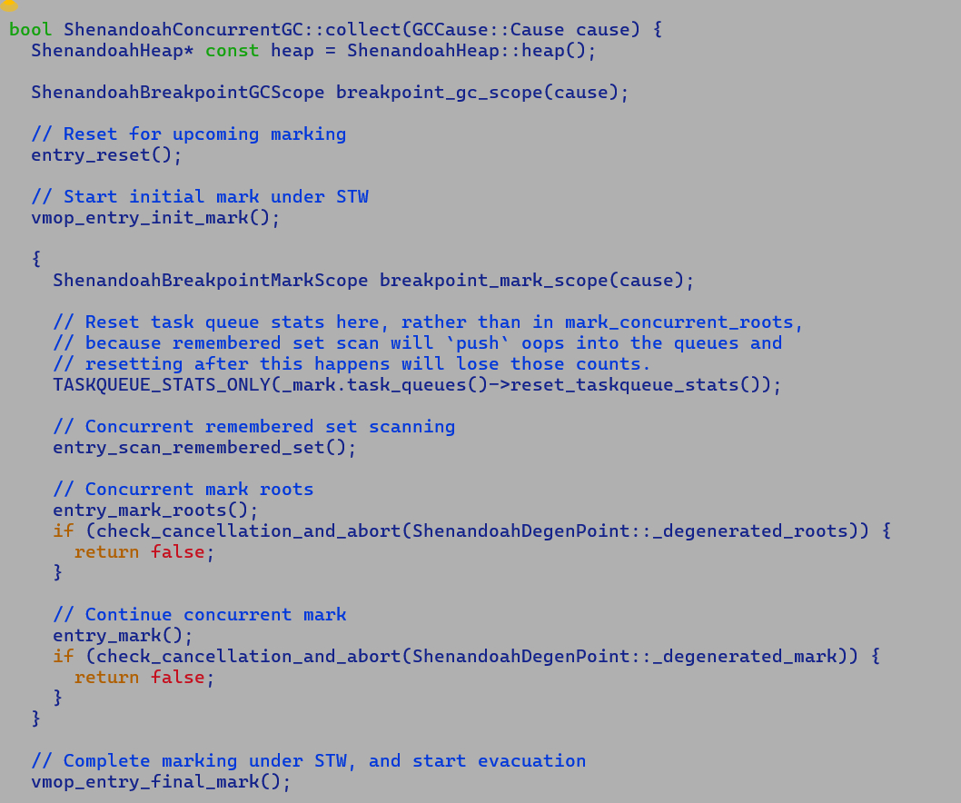

* **Flags**
  + **-XX:ShenandoahGCMode=passive, stab, generational**
  + **-XX:ConcGCThreads=<num of concurrent marking threads>**
  + **-XX:ParallelGCThreads=<number of parallel threads>**
* **Top-level phases**
  + **Marking** 
    - **Makes use of MarkingContext Bitmap per region.**
  + **CSET identification**
  + **Evacuation**
    - **Unlike ZGC, which maintains explicit forwarding tables, Shenandoah records forwarding addresses in the mark work of the object. Load barrier makes sure to update the reference with the forwarded address.**
* **-Xlog:vmoperations=trace , dumps the GC VM operations**

**Important code pointer**

* + **oop_do_frames**
  + **oop_do_no_frames**
* **Bug**
  + **Reproducible with Interpreter mode.**
  + **This guarantees, no oop get ever gets assigned an EGPR.**
    - **Problem around RAX, holding oop pointer, which was used as a scratch register, getting corrupted.**

**9/7/2025**

**--------**

[**JDK-8351016**](https://bugs.openjdk.org/browse/JDK-8351016)

* EEVEX to NDD demotion – RA tunings.
* Bias the colour of the NDD instruction definition towards the first source operand
* If the first source is not live beyond the NDD instruction, i.e., its live range ends at the NDD instruction, then the NDD live range should be coalesced with the first source live range.
* The assembler layer always has a mechanism in place to perform EEVE to REX2/REX demotion, if the dst and first source are the same registers.

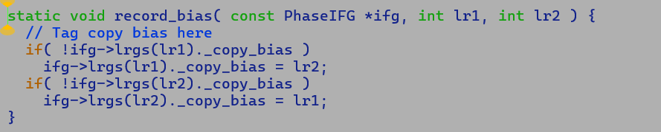

Q. How do we enforce this only for NDD MachInst?

A. I used a technique based on MachNode names to infer REG2REG moves for generic operands; all NDD patterns of interest can be identified by their MachName. Alternatively, we can also set a flag over MachNode.

**PoC for NDD demotion colour biasing.**

Currently, while picking the colour for a DST, we pick the first available colour and may miss out on demotion opportunities. Instruction encoding size is reduced by 2 bytes with a REX2 demotion and 3 bytes with REX demotion. Thus, it's an effective code size-oriented optimisation.

***if (operation is commutative) {***

***Bias dst with src1 or src2***

***} else {***

***Bias dst with src1***

***}***

Original Opto assembly

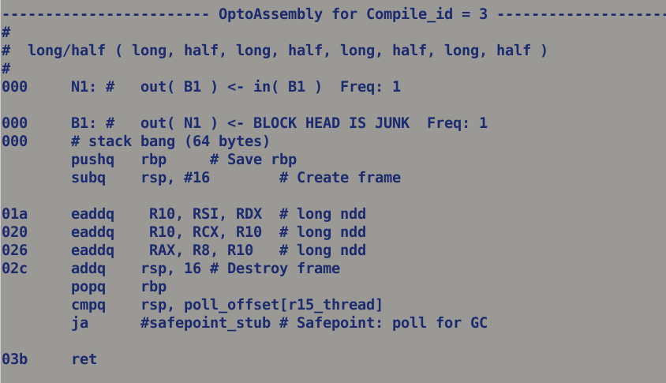

New Opto assembly

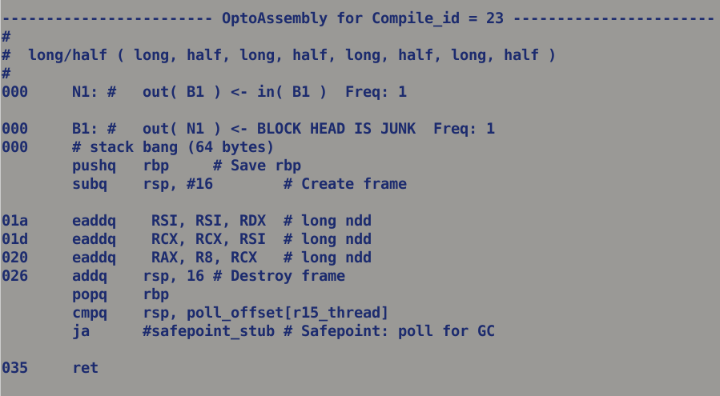



Print Assembly showing EEVEX to REX demoted instruction.

